LEARNING SUPPORT ASSISTANT –

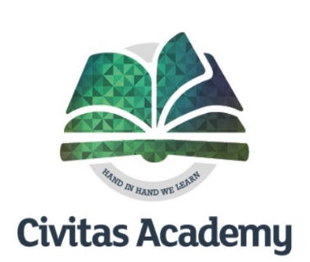
PE and Classroom

Required for September 2022

Location – Civitas Academy, Reading

Employer - REAch2 Academy Trust

Part Time – Permanent, 37 hours per week, Term + INSET days

Salary – RG3 NJC SCP 5-11 Actual Salary £16,657 - £18,758

Applications considered upon receipt

This isn’t just any job. This is the opportunity to be part of something amazing and to improve the life chances of children.

Civitas Primary Academy opened in 2015 and is part of the REAch2 Academy Trust and together with our other schools in the area we are looking to change the face of education.

Civitas Primary Academy caters for children from the ages of 4 to 11, and is an inclusive school, open and accessible, working in partnership with parents and carers and our community to ensure that all of our pupils are able to achieve their best. We value the roles of each individual within our school community - staff, pupils, parents, carers, governors and visitors - in achieving the best for all of our children.
We continue our journey of transformation in developing a learning community where pupils are engaged in developing the knowledge and skills needed for life in the 21st Century.

We can offer:

- The opportunity to make a difference to children’s lives both through physical education and in the classroom
- The opportunity to work as part of a collaborative, experienced, supportive team.
- The chance for your skills to flourish and develop with practical support and encouragement.
- High quality training and development through one of the country’s leading Multi-Academy Trusts.
- Enthusiastic, responsive children who are ready to learn.
- A caring, hard-working and committed staff team.
- The opportunity to work with children from diverse ethnicities and cultures.
- An inclusive ethos where every child is valued and supported to achieve their potential.
- The opportunity to develop an outstanding career and balanced life

We are looking for a passionate and energetic team member who will:

- inspire our children as a pro-active Learning Support Assistant
- Have a “can do” attitude and go that extra mile
- Engage with team members and the children

For an informal discussion, please contact Celia Frain – Assistant Headteacher on 0118 467 6720

An Application Pack is available from the School Business Manager at: finance@civitasacademy.co.uk

Interview – To be confirmed with Candidate if shortlisted

Completed Application forms should be returned to Emma Lelliott, the School Business Manager at: finance@civitasacademy.co.uk

