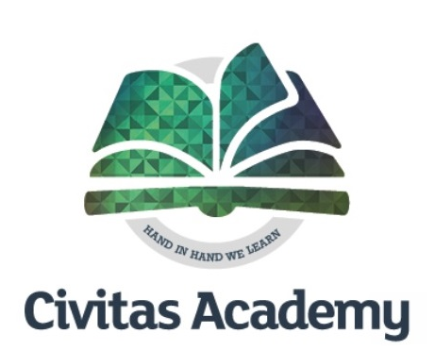
Great Teachers Needed KS1 and KS2
We need YOU, to make the difference!
This is an exciting opportunity to be part of our new school.
We have amazing facilities, a great team ethos,
and all within a 5-minute walk from the centre of Reading.

Civitas Academy is part of the REAch2 family of Schools in Reading. We are looking for enthusiastic and passionate teachers to join our collaborative and growing Academy team.
We need:
- Teachers with high expectations of all pupils, who can engage and inspire the learning behaviours that will support all in achieving their best.

We can offer you:
- A Leadership Team dedicated to helping you develop an outstanding career and balanced life.
- Exciting, accelerated leadership development and early promotion opportunities for the right candidates across the Trust.
- The chance to work with a fantastic team, with the best possible opportunities to share ideas.
- The chance to use / develop personal curriculum strengths.
- An excellent CPD training programme.
- A dynamic, creative staff, dedicated to achieving whole-school improvement and building lifelong friendships.
- Kind, curious and enthusiastic pupils.
- Enthusiastic and proactive parents.
- The chance to bring your own strengths to the school and make a difference.

About REAch2:
Founded in 2012, REAch2 Academy Trust is the largest primary-only academy trust in the country. It is a growing charitable organisation currently supporting 60 primary academies across England, including 4 in Reading. REAch2 is a community connected by a common desire to learn from each other, share experiences and be mutually supportive across the entire academy community. We work as a team to deliver exceptional learning opportunities for all pupils in REAch2.

What next?
We want to hear from great teachers with a genuine commitment to improving the life chances of the children they teach. Give us a call if you're interested, come in and visit the school.

MPS or UPS • Suitable for NQTs or experienced teachers • Full-time/Part-time • Permanent • Job start: September 2022

Visits to our school are warmly encouraged and can be arranged at your convenience – you need to meet our brilliant children! If you wish to discuss the roles further, then please contact the Executive Headteacher, Salima Ducker, on 0118 467 6720. For application forms, please email finance@civitasacademy.co.uk.

Applications are considered on receipt and interviews will follow shortly afterwards for shortlisted candidates.
This school is committed to safeguarding and promoting the welfare of children and expect all staff and to share this commitment. The successful candidate will be subject to all necessary pre-employment checks, including: an enhanced DBS; Prohibition check; Childcare Disqualification (where applicable); qualifications (where applicable); medical fitness; identity and right to work. All applicants will be required to provide two suitable references.

Civitas Academy
90a Great Knollys Street
Reading
RG1 7HL
Executive Headteacher: Salima Ducker

