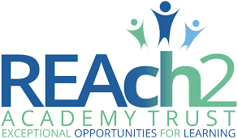

Our Curriculum Vision for ‘Our Civitas Child’ September 2021

“The curriculum is a framework for setting out the aims of a programme of education, including the knowledge and understanding to be gained at each stage (intent); for translating that framework over time into a structure and narrative, within an institutional context (implementation) and for evaluating what knowledge and understanding pupils have gained against expectations (impact/achievement)” OFSTED – working definition of curriculum

Our aim is to provide an excellent education for all our children, helping them develop the confidence, skills, curiosity and understanding to grow and progress academically, socially, and emotionally. Our curriculum is one which values teamwork, creativity and the diversity of opinion held within our classrooms. We need to educate our children to think more critically, more ethically and become more geo-politically aware. (Global Challenges Insight Report: The Future of Jobs 2017).
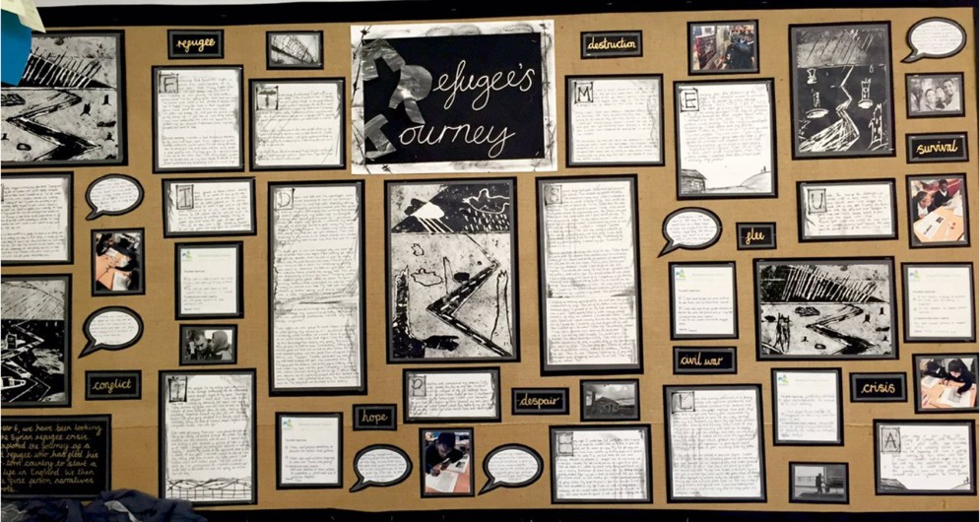
Alongside the need to ensure our education system is preparing children for the future sits the desire to make our world a better place. You can’t have a good education system in a bad world. Key findings from the Varkey Foundation Generation Z Report shows that young people in the United Kingdom have amongst the lowest levels of physical and emotional well-being in the world and are amongst the least likely to think it is important to contribute to wider society. Importantly, however, young people want schools to provide the skills to help them make a bigger difference and have faith in education to create a better world.

We want our children to understand and be present in the world.
Our curriculum for ‘Our Civitas Child’ is underpinned by education for global citizenship. We believe that learners are entitled to an education that equips them with the knowledge, skills, and values they need to embrace the opportunities and challenges they encounter, creating a future they want to live in. Learning is brought to life through current contexts that connects to our children’s lives – who they are, how they fit into the world and how they contribute back.

Our curriculum connects to real life, promotes thinking as a global citizen and develops character skills for young people to make meaningful contributions to society. Even very young children are trying to make sense of a world marked by division, conflict, environmental change and extreme inequality and poverty.
We enable children to make meaningful relationships with their learning, see patterns and apply skills into a context where learning can make a difference. Children see that their learning has human significance. They understand that their global learning is relevant to future decisions and the active contribution they can make to the world. Our aim is to teach our children how to live, as well as how to learn, with collaboration being at the heart of our design for learning as is our school motto of ‘hand in hand we learn.’ Deep learners connect what they learn with a bigger cause.
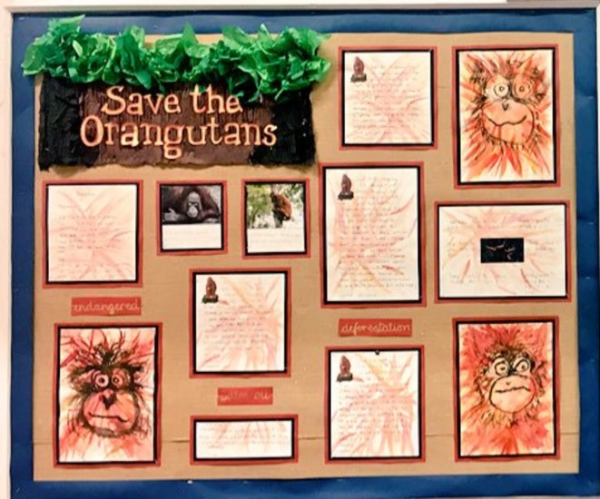

Our Approach
Six global learning themes underpin our curriculum, and each theme is broken down into knowledge and understanding, skills and attitudes:
- Social justice and equity
- Identity and diversity
- Sustainable development
- Peace and conflict
- Human rights
- Power and governance
In order to achieve depth of thinking and learning, we plan for children to focus on three of these themes per year. Across each year a number of high-quality core texts are used to bring the themes to life for our children and to promote a connectedness with the learning. The six global themes are explored through all areas of the curriculum and across the subject disciplines.
Sequences of lessons are carefully crafted around a final project outcome which allows children to become agents of change. The learning journeys are active, engaging, and inspiring, leading to a deeper understanding of the global themes and curriculum areas. Carefully crafted sequences allow children the opportunity to develop 21st century skills such as research, collaboration, innovation, presentation, evaluation, and reflection.
The curriculum promotes critical thinking skills; children are able to explore different approaches and ultimately become risk takers.
When designing sequences of learning across the curriculum, we use a teaching backwards approach. At the heart of teaching backwards is a thinking process that enables our teachers to plan and teach from a clear and well-defined destination. We believe that teaching backwards is a journey that starts with the end very clearly in mind. With this knowledge, our staff design learning that focuses on small steps of progression. By slowing learning down, we ensure that our focus remains on depth. Our journeys are supported at all times by high expectations.
In his book, ‘The Talent Code’, Daniel Coyle argues that deliberate practice, alongside struggle promotes the growth of myelin in our brains. Struggle and practice are both key components of our teaching sequences. Well-structured modelling, high effective questioning and carefully designed learning tasks enable children to both struggle and practice. Multiple opportunities to fail and learn from these mistakes are also central to our practice and encourage growth mindset.
Our three golden threads which evolved at the earliest stages of our curriculum design continue to feature throughout our curriculum. These include VOR (Vocabulary, Oracy and Reading), Powerful Knowledge and Community, Charity, and Citizenship.
Vocabulary – We understand that developing children’s vocabulary is a vital part of their learning. It allows them to improve their reading, writing, listening, and speaking skills. We have a lot of children from diverse backgrounds who are multilingual so this will be celebrated at Civitas Academy. Teaching across all subjects places key emphasis on the vocabulary learners require to successfully communicate their thinking.
Oracy skills – The importance of proficiency and skill in verbal communication cannot be overstated in the modern world, and our children will benefit from daily structured opportunities to develop these skills and regular formal opportunities to demonstrate these skills at school.
Reading skills – Our curriculum provides learners with daily opportunities to develop and apply their reading skills in a variety of contexts. It supports the way in which learners access new knowledge and secure knowledge in their long-term memory. The curriculum is strengthened at every opportunity by reading high quality texts which enhance children’s knowledge and experience of the world.
Powerful Knowledge: Our curriculum ensures that every child has access to the best that has been said, thought and done through human history in every subject area, which is illustrated on the long-term plans for each curriculum area. We want to ensure that children develop their knowledge of subjects, topics and concepts that are rich, powerful and cause children to develop their thinking skills.
Community, Charity, and Citizenship: Civitas is the Latin word for community, and we feel it is important for the children to have a sense of belonging and enable them to develop their identity at Civitas. We are fortunate to be a part of a culturally diverse community full of opportunities for children to feel represented and celebrated. Reading is also a place full of history, geography and science, which allows our children to build upon their learning outside of our school.
10 Good Deeds is part of our REAch2 11 Before 11 initiative which seeks to support our community and charities that are important to our children. These charities are decided annually and include a charity within our community of Reading.
Our school’s core values are at the heart of all we do and are interwoven into all learning opportunities along with a strong emphasis on teamwork and cooperation. We believe learning is brought to life through current contexts, connected to a Civitas’ child’s life – who they are, how they fit into the world and how they contribute back. Our curriculum extends beyond the formal requirements of the National Curriculum as we recognise that this is only part of what our children need. Of paramount importance within our curriculum are the values, skills and abilities we feel our children will require to take their place in the world; these will enable our children to be compassionate and driven leaders and citizens of our future. We have a student leadership team that enables children to develop their personal and leadership qualities. The student leadership team consists of school councillors, house captains, E-Safety ambassadors, librarians and 11B411 ambassadors. The student leadership team are voted in by their peers, which links to one of the British Values, democracy.

Learning is inherently a social experience. Therefore, our teaching experiences promote richly dialogic contexts that support co-construction and collaboration. Discussion and debate and communication are all valuable currency in an increasing complex world and so we plan opportunities for children to express a point of view, understanding that people have different points of view and engaging with these. Children are able to consider different perspectives and points of views on global issues and we explore the potential of being able to change one’s point of view.
Metacognition plays a pivotal role with our sequences through explaining and reasoning, thinking about evidence, evaluating, and making judgements or decisions. Through deeper thinking and reflection, children are able to make links between topics so they are learning to think systematically. Teaching children how to reflect, explain, justify and question is key to lesson design.
Feedback is integrated into our curriculum design, and a range of feedback types are provided throughout the sequences. Provocative prompts are used to deepen the connection with the learning and encourage children to reflect at a deeper level.

Across our school and wider Trust, we use regular and robust triangulated monitoring to gauge the impact of our curriculum design. Leaders at all levels review learning, talk with our children, and provide feedback to move practice forward. We ensure that our children’s attainment and progress are in line or exceeding their potential. We measure this using national data (where appropriate), our curriculum maps, KPI documents and monitoring evidence. Our curriculum ensures that we develop well-rounded citizens with a clear understanding of values such as love, responsibility, and friendship. Our new curriculum addresses negative stereotyping through investigating similarities and differences, and promoting acceptance, diversity, citizenship, and human rights.
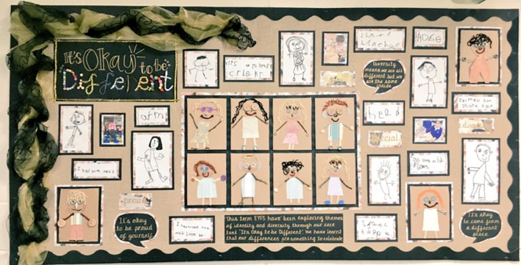

Our children will be motivated by a strong personal sense of morality. They will be able to make sense of an increasingly globalised, complex, and rapidly changing world. They will make decisions for the right reasons and in the best interests for our community. The children become confident in speaking about current issues through collaborative learning activities. They will be able to decide what is right and what is wrong and will be resilient to the influence of others. The children develop an awareness of how their own actions can impact others and the wider community. They will go out into the world and make a difference in their own life and to others.

