Wednesday
English | Starter: correct grammar and spelling  erik turned to ragnor and said we are travelin to were the sun goes at night it will be a terrifying quest but I believe we can do it  Ragnor looked at erik ok he said I will go with you  IALT: use subordinating conjunctions  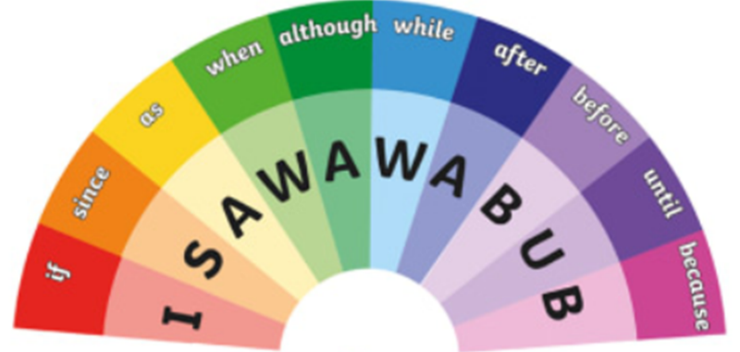  Watch: What are subordinating conjunctions? - BBC Bitesize.  Task: Create sentences using ISAWAWABUB in the same way you did coordinating conjunction words. Also present your as you did with your coordinating conjunction work.  This is recap, remember. You’ve done these words before.  Remember to go through and check your spelling, capital letter, adjectives and adverbs.  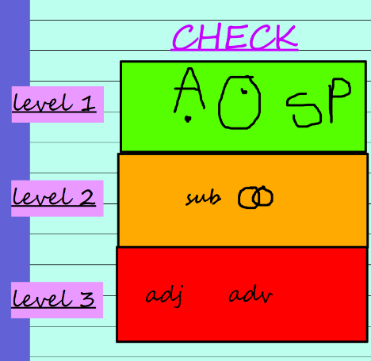  Extensions: Brain bubble: Why are the two conjunction and why are they different?

Maths | Starter  Daily 10: https://www.topmarks.co.uk/maths-games/daily10  IALT: subtract fractions from whole numbers.  Recap:  Can you remember the method from yesterday?  Use it to solve these 3 subtractions:  Today we will be practising our problem-solving skills. Remember, we ANSWER, we PROVE it and we EXPLAIN.  Problem 1  Do you agree? Why? What should the answer be?  Problem 2  Solve each one using our bar model method. Which one is the odd one out? Why?  Problem 3  Can you solve the word problem? Clues:  - How many WHOLE cakes are there to start with? How many PARTS is each one cut into? This will help you draw your bar model.  - Now, look at how many were eaten. Subtract this by crossing that fraction out.  - How many is left? Can you answer as an improper and mixed number fraction?

Wednesday
Guided Reading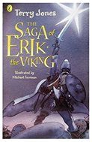 | The Giant’s Harp  Read the chapter again, p141-150  Activity:  Do you think the Giant was a good or bad person?  Can you explain your reasons why?  Can you use evidence from the text?  Did you opinion change throughout the chapter? How?  At the end of the chapter, how does the author leave us feeling about the giant? Has he had a positive or negative effect on Erik and his men?  Thinking about the questions above, write a few paragraphs about your own opinion on the giant’s character throughout this chapter.

Topic | IALT: Create a fact file on your teeth.  Use pictures from the internet or draw them.  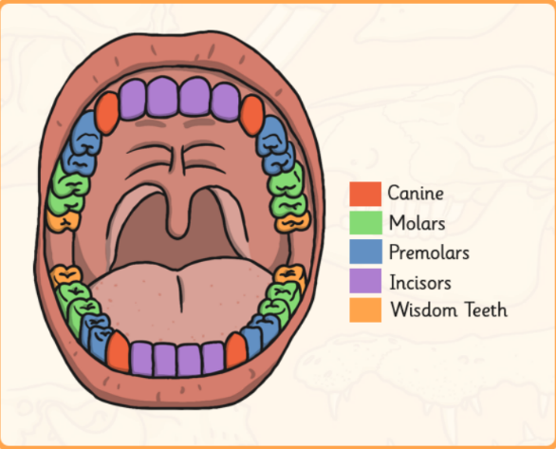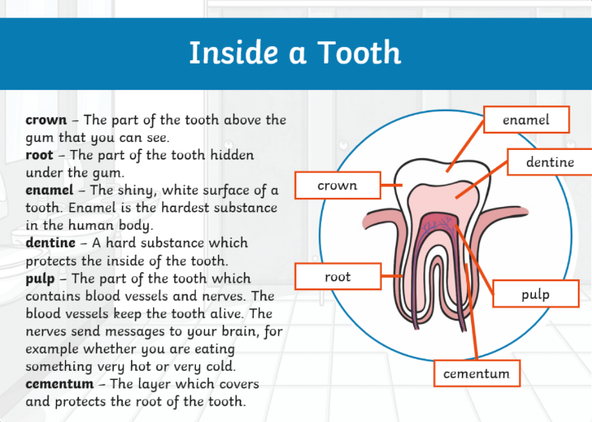  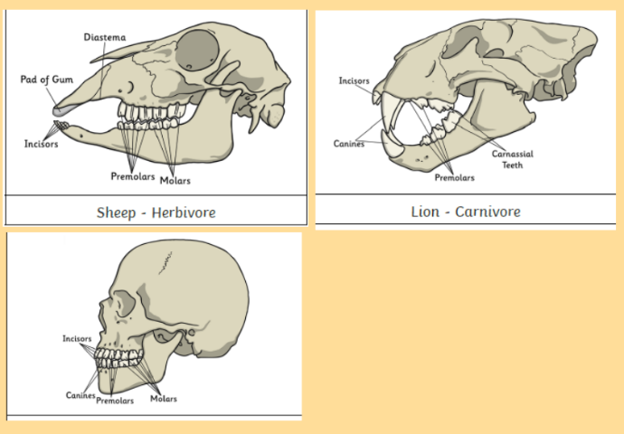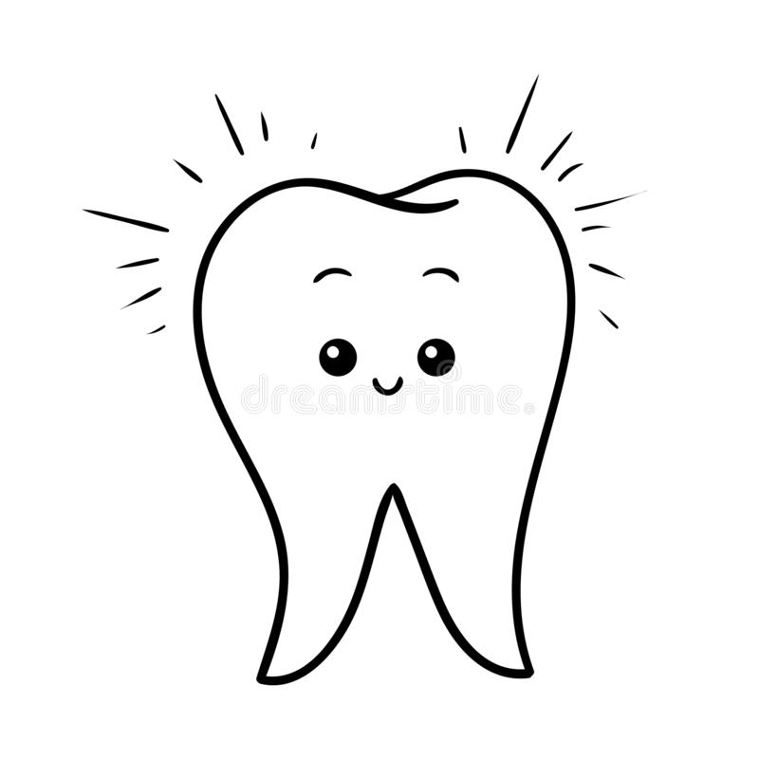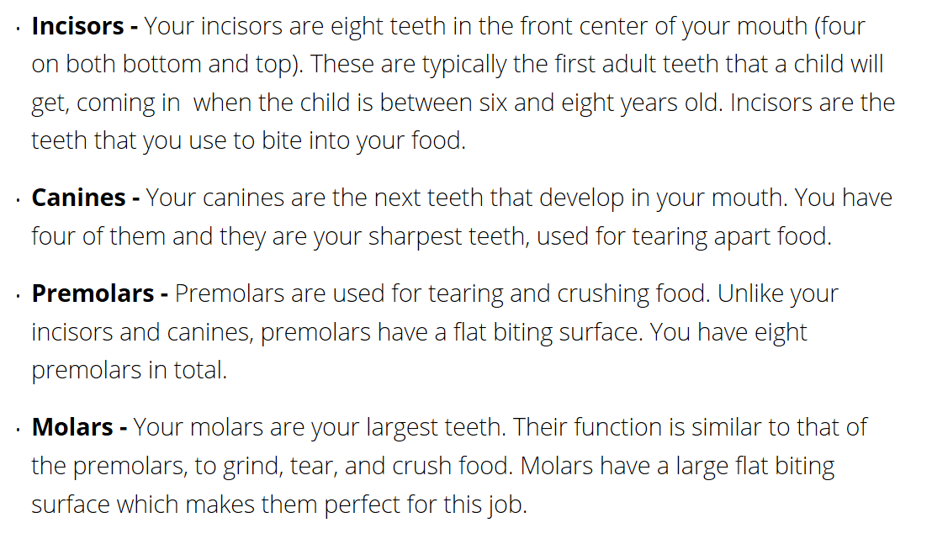  Use all the information you have learn to create this fact file for next year’s Year 4.  What are your teeths names?  What are each of your teeth's function?  Is the similarities between animals teeth and humans?  What is inside your tooth?

