Tuesday
English | Starter: correct grammar and spelling  Erik the viking looked out of golden dragon and wondered where the sun went at night  Erik ragnor forkbeard shouted where are we going  IALT: use coordinating conjunctions  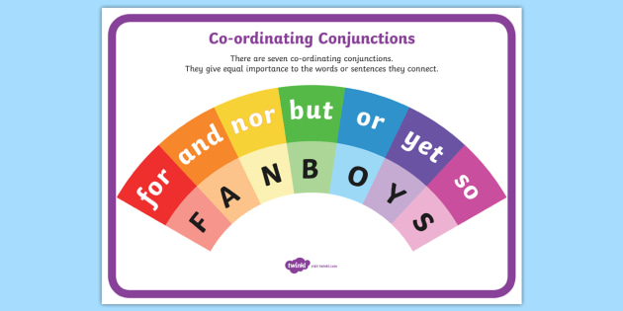  Watch: What are coordinating conjunction? - BBC Bitesize.  Task: Create sentences using FANBOYS and include for, and, nor, but, or, yet and so.  Here is an example for you:  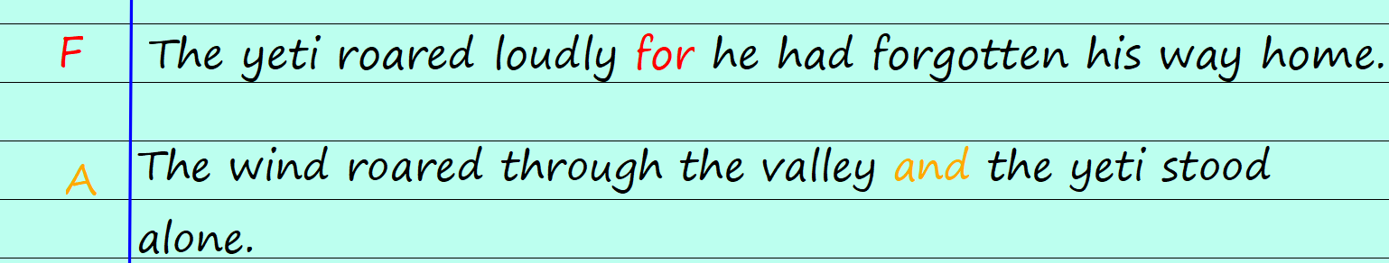  Extensions: Brain bubble: What other type of conjunction is there and why is it different to coordinating conjunctions?

Maths | Starter  Daily 10: https://www.topmarks.co.uk/maths-games/daily10  IALT: subtract fractions from whole numbers.  We will use our work on whole numbers from yesterday.  Remember: the denominator tells you how many parts make the whole.  In this example, I know we are working in quarters because the denominator is 4 so each whole needs 4 equal parts.  We are taking away. I can use the method we learnt at school by crossing out the number of parts I am taking away. I am taking away 3 quarters so I cross out 3 parts.  My answer is 9 quarters, because there are 9 parts left that have not been crossed out.  I could write this as a mixed number fraction: 2 wholes and 1 quarter.  TASK: solve these subtractions. Represent them using bar models as I did above.  Challenge: Can you write your answers as improper fractions and as mixed number fractions?  Problem Solve:  Who do you agree with? Why? Can you prove it with a bar model?

Tuesday
Guided Reading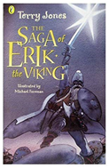 | The Giant’s Harp  Read p144-150 (Second Half of the Chapter)  Answer these questions in full sentences:  P144 Why won’t they ‘never listen to any music ever again’!?  P144 What do you think enraptured means?  P144 Why does Erik slap Ulf Sigfusson?  P144 How do they escape from the net?  P145 What makes the Giant roar?  P145 What does Erik do to stop himself hearing the music?  P149 Why was the giant so lonely?  P150 Why don’t the men need to worry about having enough water?  Activity: Draw the harp with the creatures around it. Can you label all the different types listed on p146?  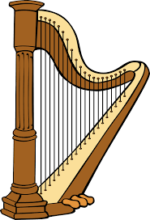

Topic | IALT: Create a fact file on the Digestive system.  Use pictures from the internet or draw them.  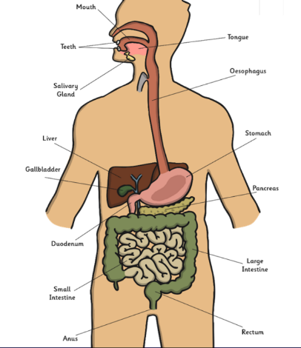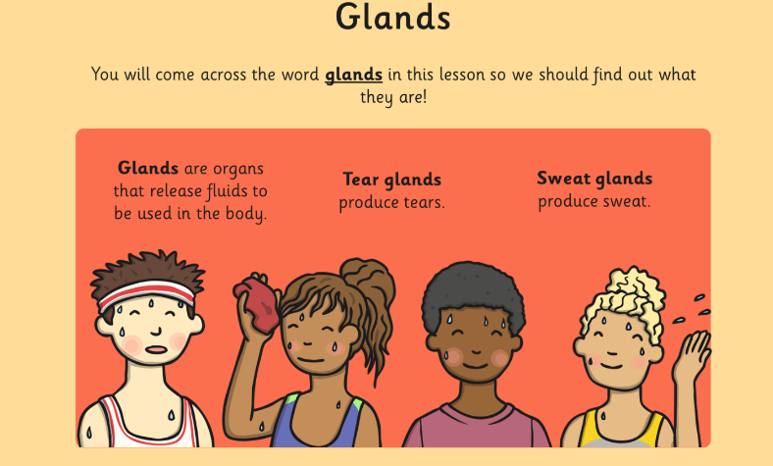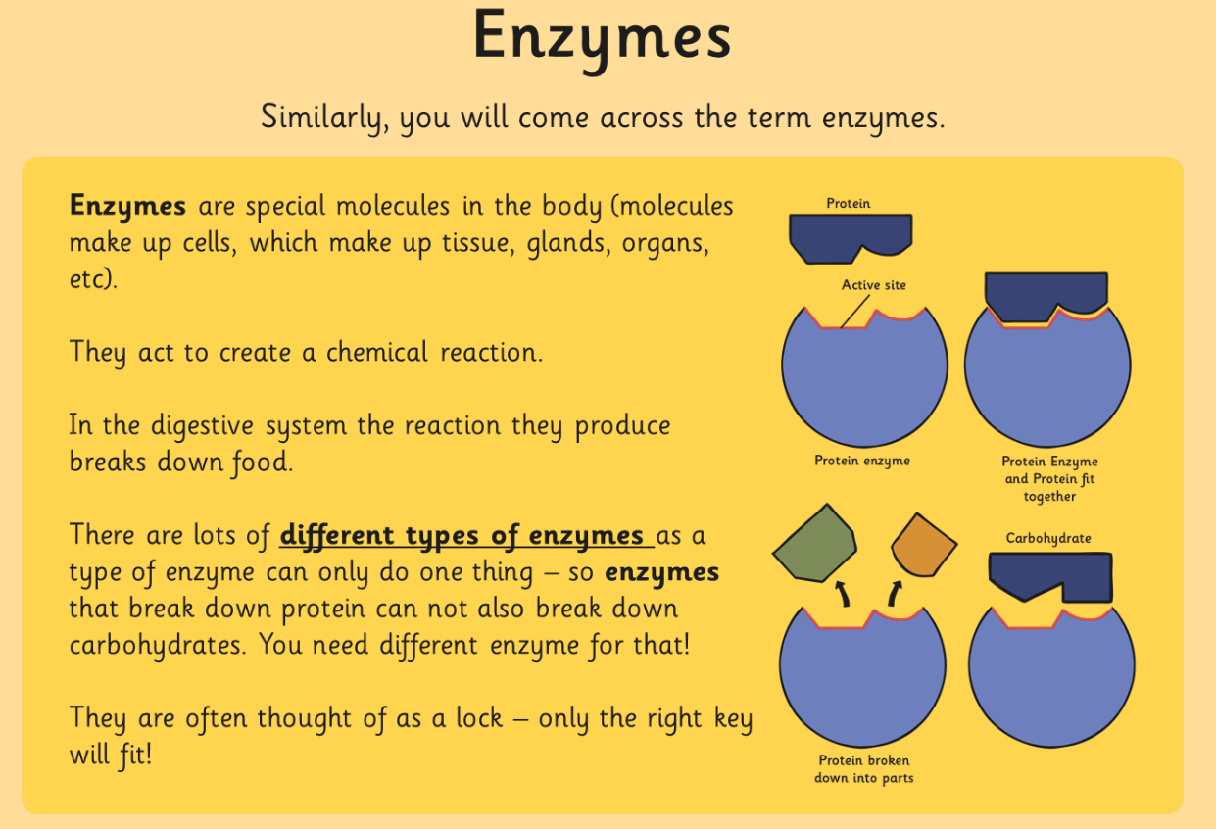  Use this as a model if you would like, to set out your fact file over a 2 page spread.  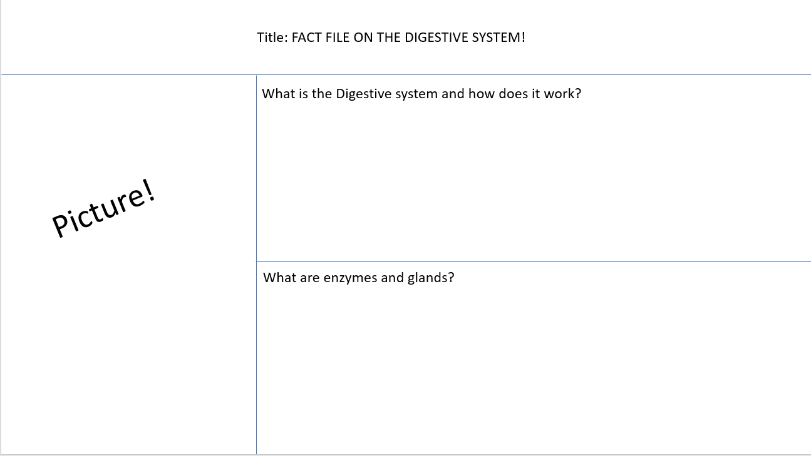  Use all the information you have learn to create this fact file for next year’s Year 4.  What is the Digestive system and how does it work?  What are enzymes?  What are Glands?  What are the functions of each part of the digestive system?

