Thursday
English | Starter: underline the relative clause  Erik, who was a strong and noble Viking, ruled over the land.  The little girl, who was Hel in disguise, tricked Erik into help her.  The plan, that was evil and would destroy the world, was planned out by Hel.  IALT: use adjective to describe nouns.  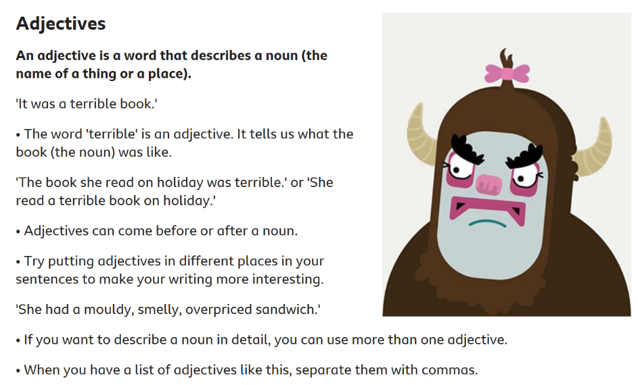  Adjective gives us more information about the noun. A noun is the name of things, so adjectives describes the name.  Adjectives can come before or after a noun, it does not matter.  Using more adjectives can create a more interesting story and can sometimes create an expanded noun phrase.  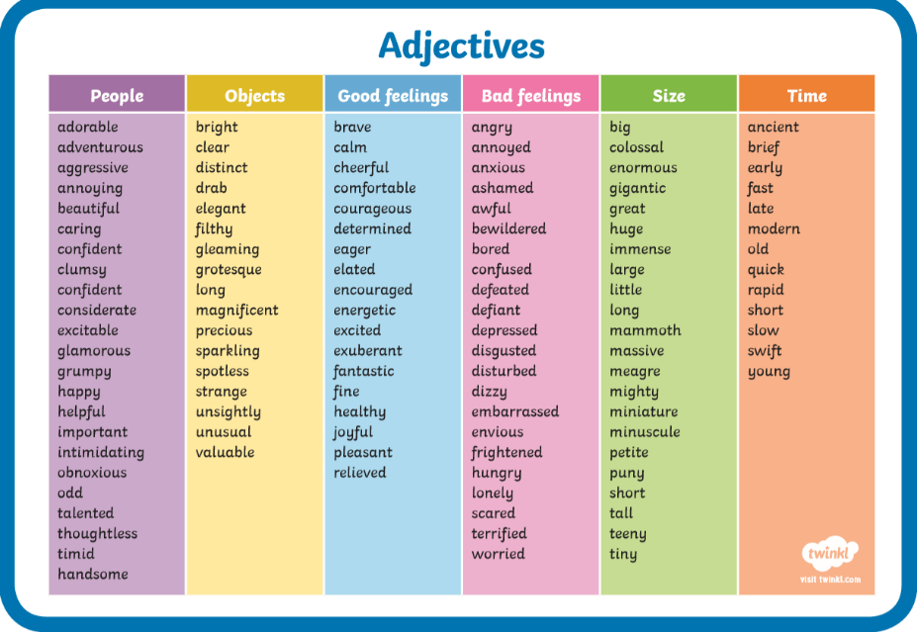  Task: Create a poster about what adjectives are and create some sentences in the poster to help people viewing the poster understand exactly how adjectives work.  Here are so describing words.  Extensions: Create a couple of sentences about the book you are reading at home using adjectives to describe the main noun.

Maths | Starter  Daily 10: https://www.topmarks.co.uk/maths-games/daily10  IALT: subtract fractions on a number line.  We have spent lots of time using bar models this week. Today we are going to use the number line method. We will be focussing on subtracting by finding the difference.  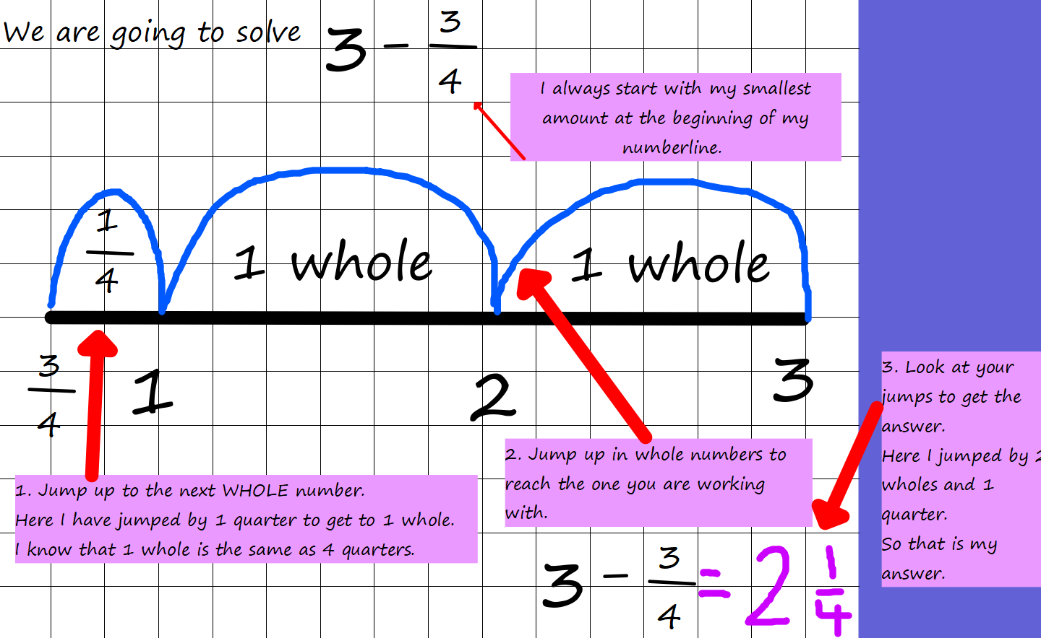Use this method to solve:  Extension: Explain whether you prefer the bar model or the number line method.

Thursday
Guided Reading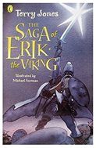 | How Death Challenged Erik  Read p151-153  Answer these questions in full sentences:  P151 What woke the men up?  P152 What is strange about how the men they see are travelling?  P152 Who does Death want to take?  P153 How will Erik save Sven?  Activity: The author uses good imagery in this chapter Imagery is when the author uses very descriptive language.  Read p152 again about the death walking past. Use the description to help you draw a picture of what you imagine this to look like. Add the key words and phrases underneath.

Topic | IALT: Create a fact file on food webs and food chains.  Use pictures from the internet or draw them.  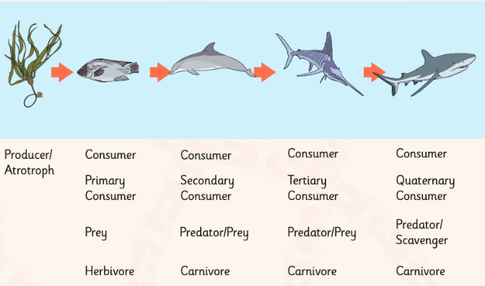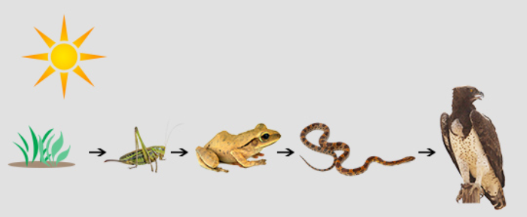  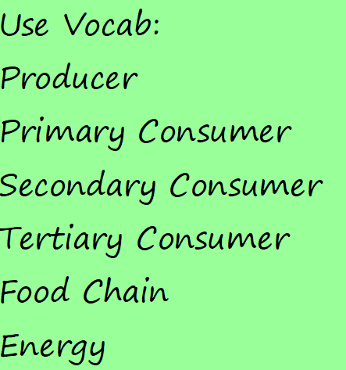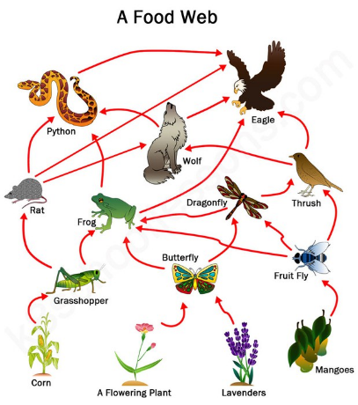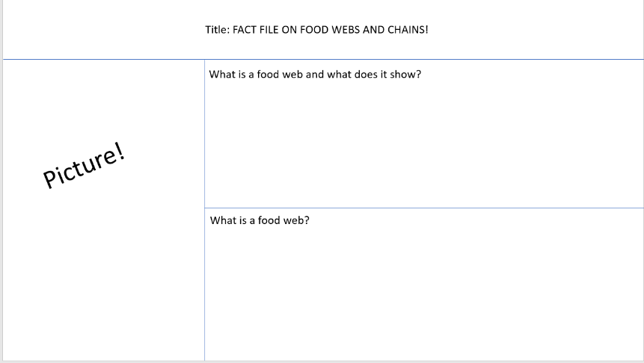  Use all the information you have learn to create this fact file for next year’s Year 4.  What is a food web?  What is a food chain?  How does it link to each other?  Why does the arm point in a certain way?  What is a producer?  What is a consumer?

