Monday
English | Starter: Correct spellings and grammar.  When the vikings came to lindisfarne they went into churchs and took all the gold and food they also took the monks as slaves  IALT: use fronted adverbials  A fronted adverbial is at the beginning of a sentence with a comma and gives information on WHEN, HOW and WHERE!  Watch What are fronted adverbials? | Oxford Owl on YouTube.  Turn these sentences to have fronted adverbials.  Remember to say: HOW, WHEN and WHERE.  When it is sunny, my cat likes to go outside.  Your turn: ........................ , my cat likes to go outside.  On Friday 3rd August, I got into my car and drove on holiday.  Your turn: ................ , I got into my car and drove on holiday.  ................................, I had a Doctor's appointment  ……………………………… , the men sat on Golden Dragon and waited.  Task:  Write some sentences in your book with fronted adverbials about Erik the Vikings journey to the place where the sun goes at night.  Remember, your fronted adverbials tells the reader HOW, WHEN and WHERE.  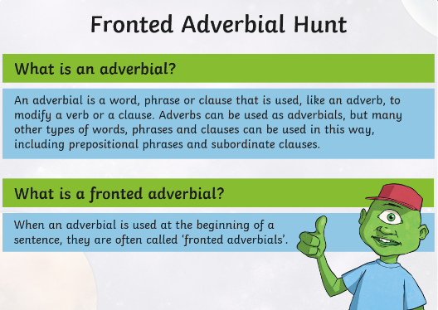  Extension: Brain bubble, how can I remember what a fronted adverbial does?

Maths | 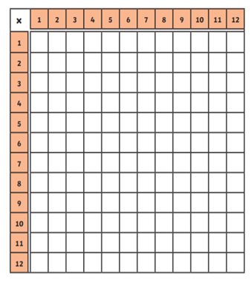  Starter  We will start every home learning week with a time tables recap!  Complete the multiplication grid below. Can you time yourself? Keep track of your times and see if you can beat it.  IALT: represent whole numbers.  We can use bar models to represent fractions.  The DENOMINATOR tells us how many equal parts we need to have:  Can you complete the examples?  What do you notice about 2 wholes?  The numerator is DOUBLE the denominator.  What do you notice about 3 wholes?  The numerator is 3 times the denominator.  TASK:  Represent each of the numbers as a bar model.  Complete the missing parts.  Example:  Now, using the pattern we found, can you work out how many WHOLES these fractions represent?  REMEMBER: How many times does the DENOMINATOR go into the NUMERATOR?

Monday
Guided Reading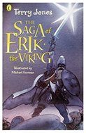 | The Giant’s Harp  Before you read...  What is a harp?  What might the giant do with it?  Do you think the giant will be a positive or negative thing?  Read page 141-143 (First part of chapter)  Answer these questions in full sentences:  P141 What do the men hear?  P141 Why doesn’t Erik want to find out where it is coming from?  P141 What kind of person does Erik think is making the music?  P142 Can you remember another time when Erik was in a cave...?  P142 How do they try to escape?  Activity: Draw a picture of the giant. Write adjectives and key phrases around the edge to describe him.

Topic | Monday is our PE day! Try these Easter Exercises at home.  