Friday
English | Spelling Test.  Test children on spelling from last Friday when new spellings where set.  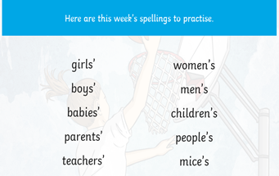  Your New spellings are this:  IALT: understand sc makes a s sound.  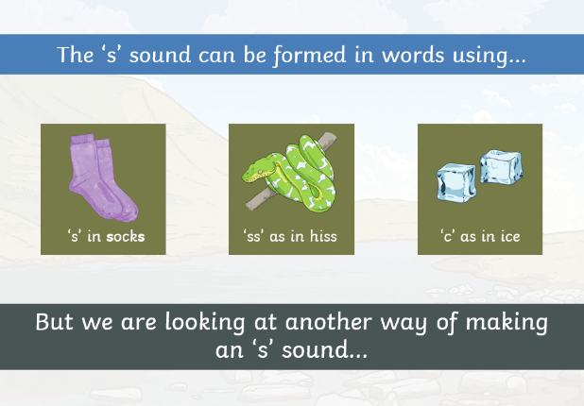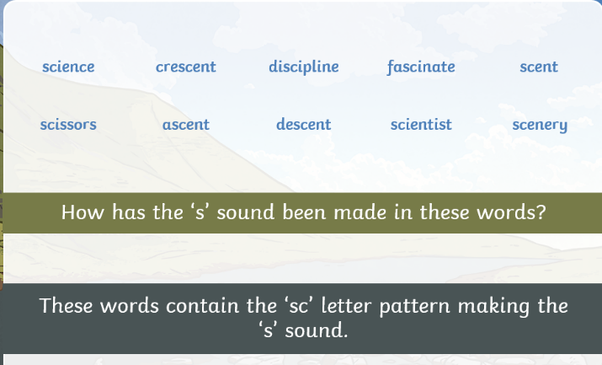  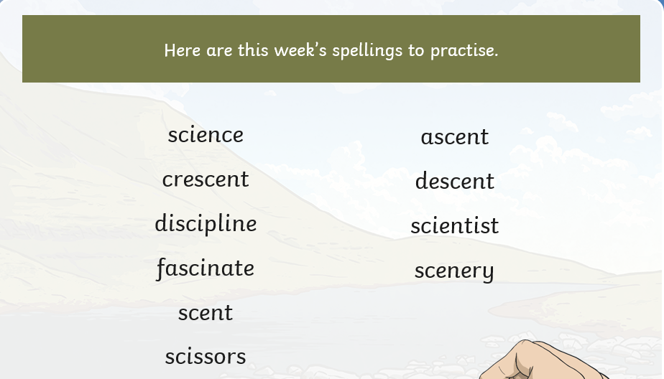  TASK: Practice using the spellings above in a sentence.

Friday
Maths | Starter  Daily 10: https://www.topmarks.co.uk/maths-games/daily10  IALT: summarise my learning.  We have done lots of learning on adding and subtracting fractions.  Create a poster about what you had learnt!  You could include examples of how you would solve problems.  You could include bar models and number lines.  You could include instructions about how to solve fraction problems.  You could fold paper to cut out fractions and decorate your poster.  ***Our fraction work may continue after Easter.***

Friday
Guided Reading | Accelerated Reader  Try to complete an accelerated reader quiz once a week if you can. You can check if your books at home are on Accelerated Reader by logging in and searching for them or using www.arbookfind.co.uk  On the school website, there are some useful links in the ‘home learning’ section to websites where you can read or listen to free ebooks.

Topic | IALT: conduct experiments in my home  Here are some experiments you can try at home which go along side our Digestion and Teeth topic.  Experiment showing what happens in your stomach when you eat:  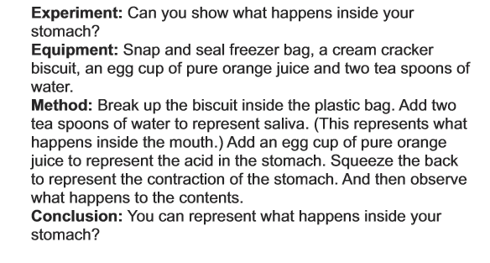  Experiment to show how we use our teeth. *Do think at home and not with a friend*.  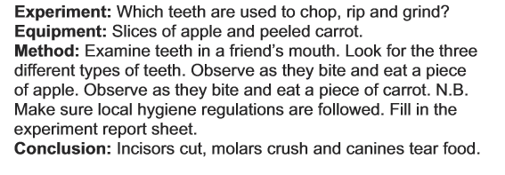  This experiment shows what sugar can do to our teeth.  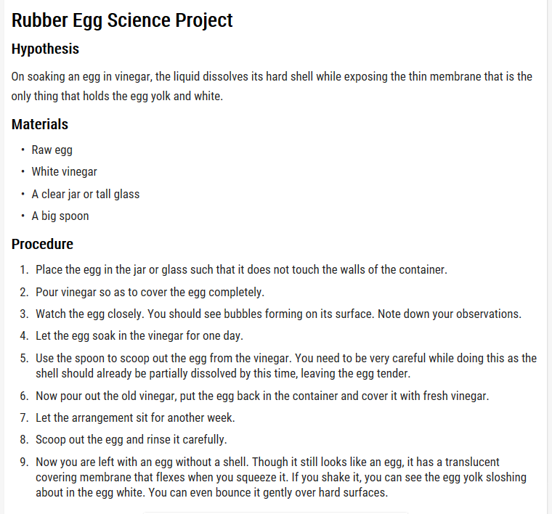  Take pictures of your experiment to stick in your book or email to Miss Parry and Miss Frain at Year4@civitasacademy.co.uk  We would love to see your learning!

