Monday
Guided Reading | The Secret Lake 1 The Fourteenth Orb  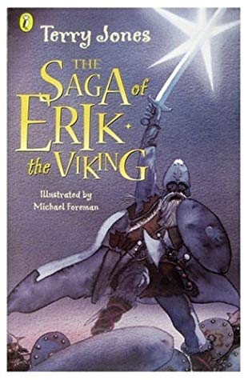  Read page 124-127 (First Part of Chapter)  Answer these questions in full sentences:  P124 How did the men see in the darkness?  P125 What was special about the roof of the cave?  P125 What strange thing appears in the water?  P126 What does the creature travel on?  P127 How many orbs are there altogether?  Task: Use the illustration to help you. Draw the orb opening up and the creature sitting inside.  Extension: Write some sentences describing the scene.

Tuesday
Guided Reading | The Secret Lake 1 The Fourteenth Orb  Read page 127-131 (Second Part of Chapter)  Answer these questions in full sentences:  P128 Who is the master of the Secret Lake?  P128 How long did it take Kobold to build the cavern?  P129 What kinds of food do you imagine to be on the table?  P129 What excuses does Kobold use to stop them from leaving the cave?  P130 Why is Kobold crying?  Task: Write a persuasive letter to Kobold to persuade him to go with Erik and his men. Use your persuasive techniques! (Rhetorical questions, +er +est suffix, imperative verbs).  Extension: Include description about what Kobold could do if he left.

Wednesday
Guided Reading | The Secret Lake 2 Viper Rain  Read page 132-134  Answer these questions in full sentences:  P132 Where do the snakes come from?  P132 What does the snake look like that bites Ragnar?  P133 What is ‘viper rain’?  P133 What do the snake bites make the men want to do?  P134 Why does Erik tell them they can stay?  P134 Why does Sven look at Erik in ‘amazement’?  Task: Look at the illustration of the rainbow of snakes on page 134. Draw your own rainbow of snakes over Golden Dragon. Write some describing words around it.  Extension: Write a first person recount from Erik telling his wife about what he saw happen with the snakes.

Thursday
Guided Reading | The Secret Lake 3 The Mermaid’s Garden  Read page 135-139  Answer these questions in full sentences:  P135 How has Kobold changed?  P136 What does the mermaids’ song do to the men?  P136 What is an antidote?  P137 What evidence is there of the mermaid’s beauty?  P137 Why is the mermaid a fast swimmer?  P137-138 What does the palace look like?  P138 Where have we met this character before?!?!  P138 What would happen if Erik couldn’t get to the surface?  P139 What was the comb made of?  Task: Use the illustration to help you. Draw the orb opening up and the creature sitting inside.  Extension: Have a go at making up the lyrics to the song the Mermaids sang!

Friday
Guided Reading | Accelerated Reader  Try to complete an accelerated reader quiz once a week if you can. Please access Accelerated Reader by click on ‘class pages’ on the school website.  You can check if your books at home are on Accelerated Reader by logging in and searching for them or using www.arbookfind.co.uk  On the school website, there are some useful links in the ‘home learning’ section to websites where you can read or listen to free ebooks.

