Monday
English | Starter: Correct the spelling and punctuation.  there was once a man named erik he lived in norway with his wife and son  he was a great worrier erik was a fierce as a tiger  IALT: revise expanded noun phrases.  What is an expanded noun phrase?  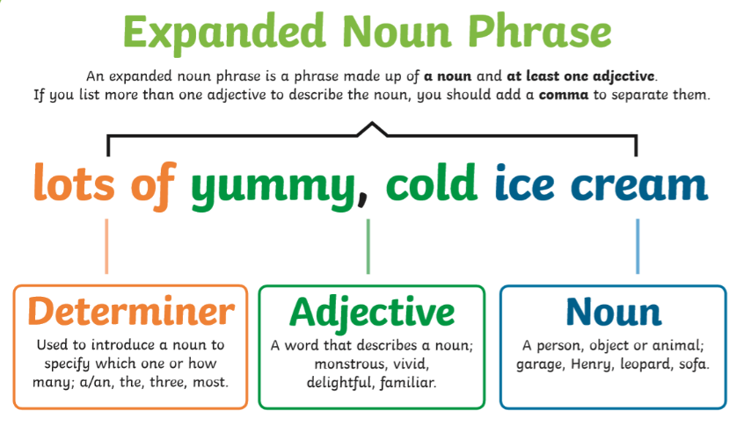  An expanded noun phrase is a way to describe the noun by adding more information.  Example:  All of the tired, weary warriors fell asleep in the boat.  The powerful, shining sword that Erik carried was called Blueblade.  Watch ‘The Expanded Noun Phrase Song’ on Youtube.  Task: Write some sentences with expanded noun phrases about Erik the Viking and what he looks like and draw a picture of him.  Extension: Brain Bubble why you would use commas to separate the adjectives.

Tuesday
English | Starter: Correct the spelling and punctuation.  How did I get here asked the confused man  You cam here by your longboat gold dragon dont you remember asked the young beautiful girl  IALT: use similes.  What is a simile?  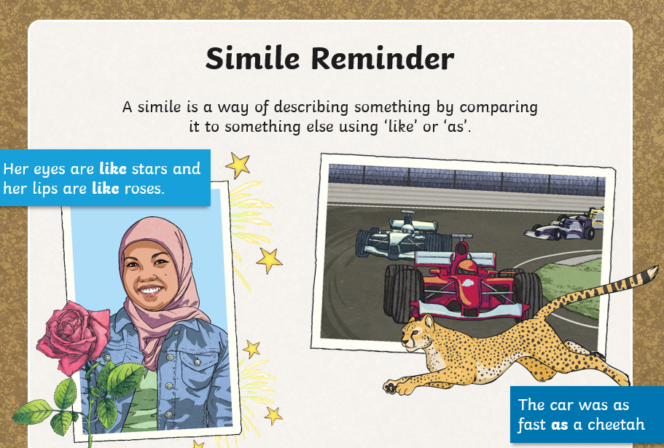  A Simile is a way of describing by comparing one thing to something else using “like” or “as”.  Example:  The girl was as tall as a tree.  (The girl was not really as tall as a tree, but it makes the reader believe and visualise that she is a very tall girl.)  Task: Write some sentences with similes in them about the Longboat Golden Dragon. Describes what she looks like. How fast does she go?  How does Erik steer the boat?  Extension: Brain Bubble why it is important to use description in your writing.

Wednesday
English | Starter: Correct the spelling and punctuation.  Erik the Viking wondered throu the lonely woods  How did this happen he said as he turned to Ragnar forkbeard  I can not say Ragnar responded  IALT: punctuate a playscipt.  What is a colon in a play script and why do we use them?  The colon is commonly used to introduce speech in a dialogue (such as a script). Here is an example:  Teacher: Why did you use a colon here?  Student: I thought it looked good.  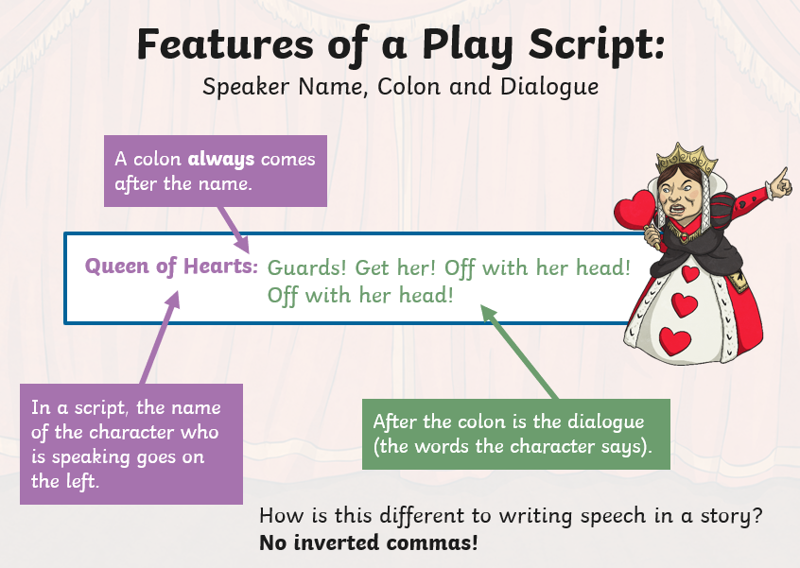  REMEMBER!! Do we use inverted commas in a script? NO!  We use colons to show there is dialog in this form.  Task: Write a script about Erik the Viking and Ragnar Forkbeard walking through a cold, dark forest to find Golden Dragon. You can also use brackets to show HOW they are speaking.  Erik: (Loudly) Where are you, Ragnor?  Extension: Brain Bubble why we use colons instead of inverted commas in a script.

Thursday
English | Starter: Correct the spelling and punctuation.  Erik do you konow where we are going to find golden dragon  Ragnar no I do not but we can follow the map the magic enchanterer gave us  IALT: use inverted commas  Our previous lesson was on colons which are commonly used to introduce speech in a dialogue but now we are going to move onto inverted commas.  What are inverted commas?  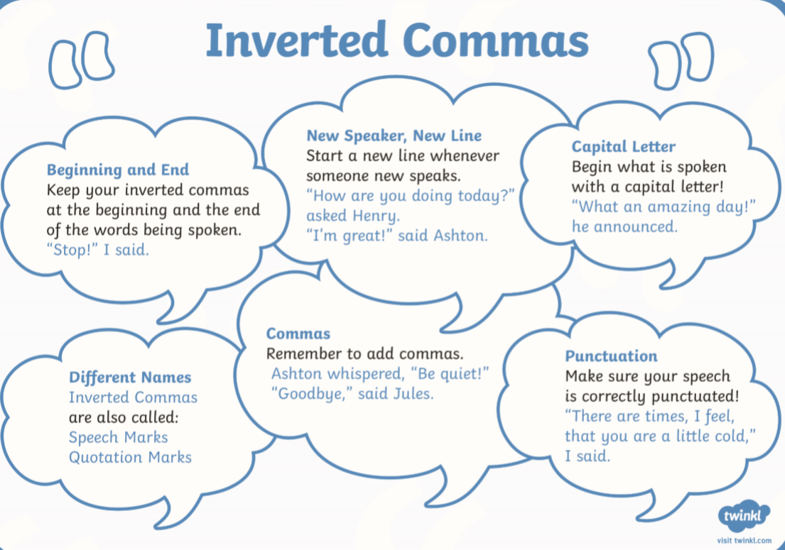  They are used to show when someone in the story is talking, but there are a lot of rules that come with inverted commas such as:  - They go at the beginning and end of the part where a person is talking.  - New speaker – new line!  - We always use a capital letter after an Inverted comma in speech!  - Make sure you use commas after you have put in your inverted commas and used correct punctuation.  - Inverted commas might have a different name such as speech marks or quotation marks but it all means the same thing.  Task: Using your script yesterday now write the same story but using inverted commas and description to describe the settings. Remember to use the rules of inverted commas.  Extension: Include adverbs- you can use the words you put in brackets yesterday.

Friday
English | Starter: Correct the spelling and punctuation.  Suddenly golden dragon appeared out of the distant alas shouted erik we have found our long boat  They ran down the mountain as fast as lions  Test yourself on these spellings.  IALT: use plural possessive apostrophes with plural words  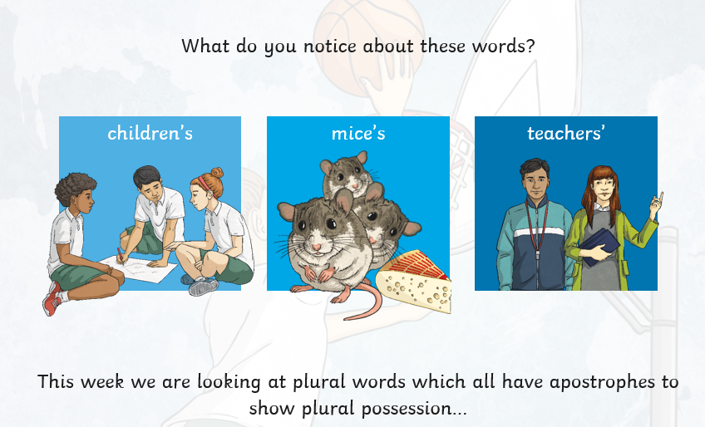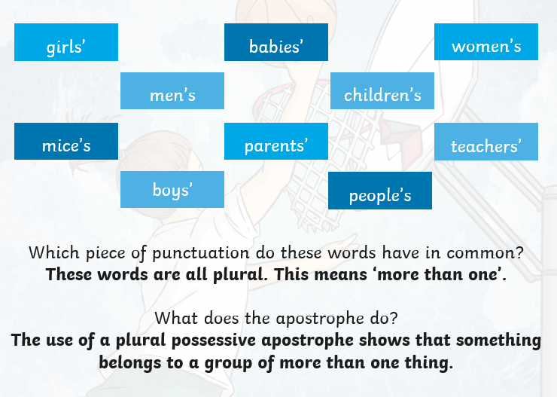  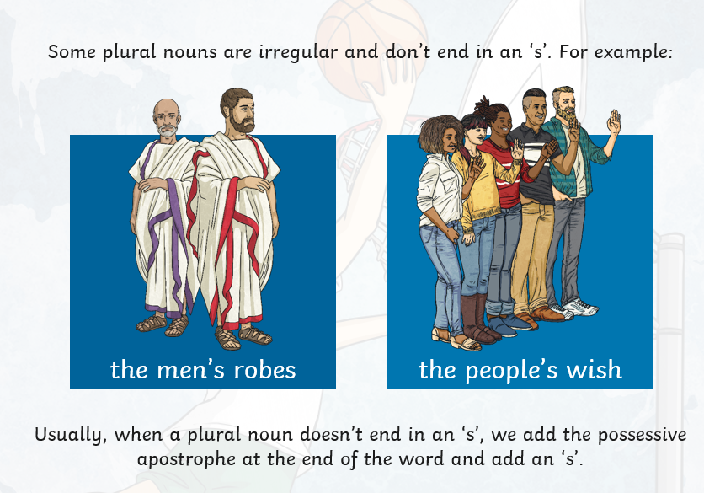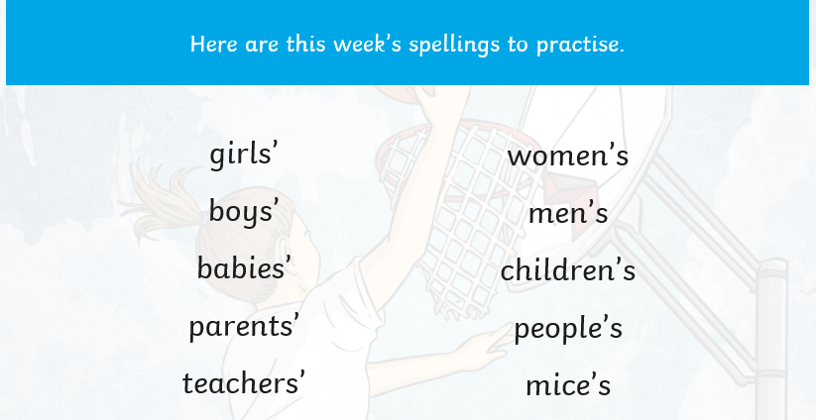  TASK: Practice using the spellings above in a sentence.

