Complaints Policy

Audience: | Parents  REAch2 Staff  Local Governing Bodies  Cluster Boards  Trustees
Ratified: | REAch2 Trust Board  October 2022
Other related policies: | Grievance Policy  Exclusion Policy  Whistleblowing Policy  Safeguarding Policy
Policy owner: | Gill Ellyard, Director of Education
Review: | Every 3 years

At REAch2, our actions and our intentions as school leaders are guided by our Touchstones.

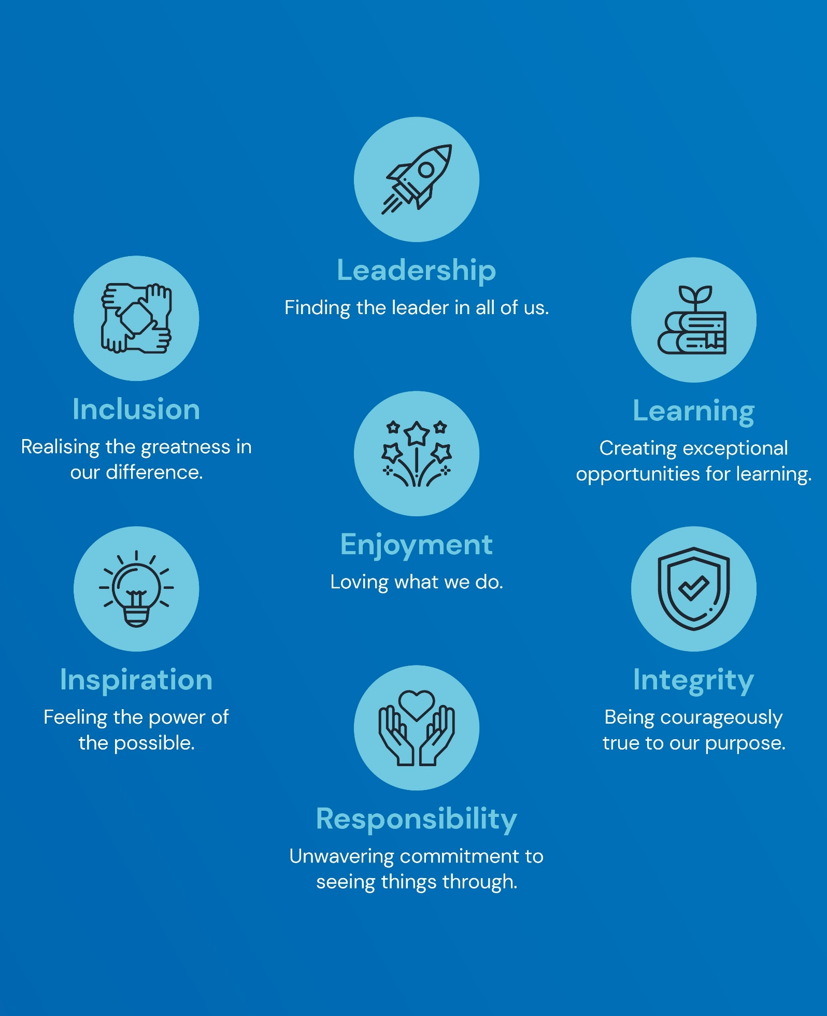

Policy Overview 4
Definitions 4
Policy In Detail 5
Roles and Responsibilities 5
Making a complaint 7
Complaints Procedure 8
Exceptional circumstances 12
Managing unreasonable requests 13
Complaints campaigns 15
Barring from the premises 15
Standard of fluency complaints 15
Role of the school complaints unit (SCU) 16
Transferring data 16
Availability 17
Policy Review 17
Appendix 1 – REAch2 Formal complaint form 18
Appendix 2 - Stage 3 complaint appeal panel agenda 19
Appendix 3 - Timeline diagram 20
Appendix 4 - Guide to interviewing 21
Appendix 5 – Complaints not in scope 23

Policy Overview

REAch2 prides itself on the quality of teaching and pastoral support provided to its children. However, we recognise that parents, may from time to time, have concerns about the progress, achievement, behaviour or well-being of their child. We would like to encourage you to make those concerns known to staff so that we have the opportunity to address these in partnership with you.
We aim to resolve all complaints at the earliest possible time, and where possible, informally.
This policy has been created to deal with any complaint against a member of staff, school or the Trust itself, relating to any aspects of the provision of facilities or services the Trust provides. It is designed to ensure that the complaints procedure is straightforward, impartial, non-adversarial, allows a full and fair investigation, respects confidentiality and delivers an effective response and appropriate redress.
Any person, including a member of the public, is able to make a complaint about the provision of facilities or services that the Trust provides. This policy outlines the procedure that the complainant and those receiving the complaint, must follow. Once a complaint has been made, it can be resolved or withdrawn at any stage.

Definitions

For the purpose of this policy, a “complaint” can be defined as ‘an expression of dissatisfaction’ towards the actions taken or a perceived lack of action taken.
A “concern” can be defined as ‘an expression of worry or doubt’ where reassurance is required. For the purpose of this policy, concerns will not be classed and addressed as complaints. Concerns should be addressed through communicating with school/Trust leaders.
Complaints can be resolved formally, through this procedure, or informally dependent on the complainant’s choice. Any complaint will be taken seriously, whether formally or informally, and the appropriate procedures will be implemented.
A “grievance” is an issue raised by a member of staff where they feel the school/ Trust has not implemented a policy or process fairly or properly. Grievances will be dealt with in line with the Trust’s Grievance Policy.
For the purpose of this policy, “unreasonable complaints” include:
- Vexatious complaints, which:
  - Are obsessive, persistent, harassing, prolific, repetitious.
  - Insist upon pursuing unmeritorious complaints and/or unrealistic outcomes beyond all reason.
  - Insist upon pursuing meritorious complaints in an unreasonable manner.
  - Are designed to cause disruption or annoyance.
  - Demand for redress which lacks any serious purpose or value.
- Serial or persistent complaints, which:
  - Are duplicated, sent by the same complainant once the initial complaint has been closed.
  - Are new complaints that are submitted additionally, as part of an existing open complaint, by the same complainant.
Serial or persistent complaints will only be marked as ‘serial’ once the complainant has completed the complaints procedure. It is the complaint that will be marked as ‘serial’, meaning the complainant can complain about a separate issue if necessary.
For the purpose of this policy, “duplicate complaints” are identical complaints received from a complainant’s spouse, partner, grandparent or child. These complaints will not be addressed again, the individual making the second complaint will be informed that the complaint has been dealt with on a local level and if they are dissatisfied with the result, they can appeal to the DfE.
Any new details provided by a complainant’s spouse, partner, grandparent or child, will be investigated and dealt with in line with the complaints procedure.

Policy In Detail

Roles and Responsibilities
The complainant will:
- Cooperate with the school/Trust in seeking a solution to the complaint.
- Express the complaint and their concerns in full at the earliest possible opportunity.
- Promptly respond to any requests for information or meetings.
- Ask for assistance as needed.
- Treat any person(s) involved in the complaint with respect.
The complaint investigator will:
- Ensure that all parties involved in the complaint are fully updated throughout each stage of the procedure.
- Guarantee that all parties involved in the procedure are aware of any relevant legislation, including the Equality Act 2010, UK GDPR, Data Protection Act 2018 and Freedom of Information Act 2000.
- Keep up-to-date records throughout the procedure – these records will be kept securely on the school’s/Trust’s ICT system and retained in line with the Records Management Policy.
- Liaise with all parties involved to ensure the complaints procedure runs smoothly
- Ensure, where the complainant is dissatisfied with the response, they are allowed to escalate it to the next formal stage and are provided the opportunity to complete the complaints procedure in full.
- Be aware of issues with regards to sharing third party information.
- Understand the complainant’s need for additional support, including interpretation support, and will be aware of any issues concerning this.
- Provide a sensitive and thorough interviewing process of the complainant to establish what has happened and who is involved.
- Consider all records, evidence and relevant information provided.
- Interview all parties that are involved in the complaint, including staff and pupils.
- Analyse all information in a comprehensive and fair manner.
- Liaise with the complainant to clarify an appropriate resolution to the problem.
- Identify and recommend solutions and courses of actions to take.
Be mindful of timescales and ensure all parties involved are aware of these timescales.
- Respond to the complainant in a clear and understandable manner.
The panel chair will:
- Ensure that minutes of the meetings are taken on every occasion.
- Explain the remit of the panel to the complainant.
- Ensure that all issues are addressed and that outcomes are reached based on facts and evidence.
- Help to put at ease and console individuals involved who are not used to speaking at such hearings, particularly any pupils involved.
- Ensure that everyone is treated with respect and courtesy.
- Confirm that no member of the panel has previously been involved in the earlier stages of the procedure or has an external interest in the outcome of the proceedings.
- Give both the complainant and the school/Trust the opportunity to state their case and seek clarity without undue interruption.
- Organise a short adjournment of the hearing if required.
- Continuously liaise with the panel clerk and complaint investigator to ensure the procedure runs smoothly.
- Help to provide the support necessary where the complainant is a child.
All panel members will be aware that:
- The review panel meeting is independent and impartial.
- No individual with prior involvement in the complaint, or the circumstances surrounding it, is permitted to sit on the panel.
- The aim of the panel is to achieve a reasonable resolution and, ultimately, attain a harmonious reconciliation between the parties involved.
- Reconciliation between the school /Trust and complainant is not always achievable, and that it may only be possible to establish facts and make recommendations to reassure the complainant that their case has been taken seriously.
- The panel can:
  - Dismiss the complaint, in whole or in part
  - Uphold the complaint, in whole or in part.
- The panel can also include making recommendations on actions to be taken including e.g. the review or a clarification of a school policy.
- When a child is present at the hearing, extra care needs to be taken to ensure that the child does not feel intimidated, as well as ensuring the child’s view is represented equally.
The panel clerk will:
- Continuously liaise with the complaint investigator
- Collate and provide copies of any written material or evidence to everyone in attendance of the meeting, ensuring that everyone has seen the necessary material in advance of the hearing
- Take written notes during the Appeal meeting
- Liaise with all parties to set the date, time and venue of all hearings, ensuring that this is appropriate, convenient and accessible to all parties involved.
- Put into place and share a Zoom/Teams link and waiting room area for the meeting.
- Ensure that the minutes of the panel hearing are circulated.
- Notify all relevant parties of the panel’s decision in writing and any other actions to be taken.

Making a complaint

Complaints are not restricted to parents of attending pupils – the school/Trust will consider all complaints, providing they are not anonymous.
The school/Trust will ensure the complaints procedure is:
- Easily accessible and publicised on the school’s website.
- Simple to understand and put into practice.
- Impartial and fair to all parties involved.
- Respectful of confidentiality duties.
- Continuously under improvement, using information gathered during the procedure to inform the school’s and the Trust’s SLT.
- Fairly investigated, by an independent person when necessary.
- Used to address all issues to provide appropriate and effective responses where necessary.
Complaints are expected to be made as soon as possible after an incident arises to address the issue in an appropriate timescale. The school/Trust upholds a two-month time limit in which a complaint can be lodged regarding an incident. Complaints made outside this time limit will not be automatically refused and exceptions will be considered. In the case of any timescales changing, all parties involved will be informed of the changes in a timely manner.
Complaints should be made using the appropriate channels of communication, including the use of the Complaints Procedure Form. All complaints shall be considered, whether they are made in person, by telephone, in writing, electronically via email, or via a third party (such as the Citizen’s Advice Bureau), providing they are not anonymous.
A complaint can progress to the next stage of the procedure even if it is not viewed as “justified”. All complainants are given the opportunity to fully complete the complaints procedure.
In school any complaint made against a member of staff will be initially dealt with by the headteacher, and then by a panel hearing if not resolved. Any complaint made against the headteacher shall be initially dealt with by the chair of governors and then by a panel hearing if necessary.
Any complaint made against the chair of governors, any other member of the governing board or against the entire governing board should be made in writing to the clerk to governors. The clerk to governors will inform the Chair of the Cluster Board. A non-executive will investigate the complaint, and if required, will then set up a panel hearing, if not resolved.
A complaint made against the Trust or a member of its central team will be initially dealt with by the appropriate line manager and then by a panel hearing formed of members of the appropriate Cluster Board /Trustees if not resolved.
Under some circumstances, it may be necessary to deviate from the complaint’s procedure. Any deviation will be documented, along with the reasons for this.
Information about a complaint will not be disclosed to a third party without written consent from the complainant. However, we reserve the right to consult staff within the school or Trust if that will help resolve the complaint and we may decide to seek expert advice.

Complaints Procedure

Stage one – Informal Resolution
The sooner concerns are raised the easier it is for an appropriate resolution to be found. In the first instance you are encouraged to raise your concern or complaint with the following members of staff:
Complaint regarding another child. | Please speak to the class teacher.
Complaint regarding a school policy or procedure | Please speak to the Assistant/Deputy Headteacher
Complaint regarding a member of staff | Please speak to the Headteacher who may delegate this to a member of SLT
Complaint regarding a member of the Local Governing Body | Please e-mail the clerk to the LGB …….
Complaint regarding the Headteacher | Please e-mail the clerk to the LGB …….
Complaint regarding the Chair of Governors | Please e-mail the clerk to the LGB …….
Complaint regarding the Trust | Please contact complaints@reach2.org

A complaint at Stage 1 may be made in person, by telephone, e-mail or in writing. Details of the complaint will be taken including a summary of the issues, the date of occurrence. The complaint will normally be acknowledged in writing within 3 school days of its receipt. The complaint will be directed to the most relevant person who can address it. Any notes are kept securely on the school’s/Trust’s ICT system and, where appropriate, encrypted.
Where a complaint is made initially to a governor, the governors should ensure that the complainant is referred to the appropriate person. The individual governor in question should not act alone on a complaint outside the procedure; if they do, they cannot be involved if the complaint is subject to a hearing at a later stage of the procedure.
As soon as is practicable, but within 15 school days after the complaint has been received, the complainant and the relevant member of staff should discuss the issue in a respectful and informal manner to seek a mutual resolution. Notes must be taken during this discussion and will be shared with both parties, along with a written note of the actions taken to resolve the complaint/concern (this must be dated).
At this stage, the complainant will be asked what they think might resolve the issue – any acknowledgement that the school/Trust could have handled the situation better is not an admission of unlawful or negligent action.
If an appropriate resolution cannot be sought at this informal level, or if the complainant is dissatisfied with the outcome following the initial discussions, the complainant may wish to proceed to the next level of the procedure.
Stage two – Formal Resolution
If the complainant remains dissatisfied the complaint can be considered at stage two. Where the complaint is about a member of staff, the Headteacher will investigate or will delegate responsibility to investigate to a senior member of staff or the Trust. If the complaint is specifically about the Headteacher, the formal stage 2 process will then commence. At this stage the complaint must be put in writing to the Headteacher, or in the case of a complaint against the Headteacher, in writing to the clerk to the Local Governing Body.
If the complaint is against the Trust, then the complaint must be put in writing to complaints@reach2.org. This should be done within 15 school days of the conclusion to the Stage 1 complaint (Informal).
Stage two of the process will be completed within 15 school days of the request being received. Where the situation is recognised as complex, and it is deemed to be unable to be resolved within this timescale, the headteacher or clerk to governors will contact the complainant to inform them of the revised target date via a written notification.
An appointment with the headteacher/REAch2 line manager, or the person nominated to investigate the complaint, should be made as soon as reasonably practical, to avoid any possible worsening of the situation.
If the complaint is against the headteacher, the complainant will initially need to write, in confidence, to the clerk to governors. The clerk to governors will then pass the complaint to the chair of governors, who will seek to resolve the issue informally, e.g. by arranging a meeting with the complainant within 15 school days.
Where the headteacher or chair of governors has made reasonable attempts to accommodate the complainant with dates for a complaint meeting and they refuse or are unable to attend, the meeting will be convened in their absence and a conclusion will be reached in the interests of drawing the complaint to a close.
If the complaint is against the Trust, the complainant will initially need to write, in confidence, to complaints@reach2.org. This will then be passed on to the relevant line manager who will seek to resolve the issue informally, e.g. by arranging a meeting with the complainant within 15 school days. This meeting can be in person or remote.
Where the REAch2 line manager has made reasonable attempts to accommodate the complainant with dates for a complaint meeting and they refuse or are unable to attend, the meeting will be convened in their absence and a conclusion will be reached in the interests of drawing the complaint to a close.
Where there are communication difficulties, the complaint may be made in person or via telephone and a written record of the complaint will be made, with a copy sent to the complainant.
To prevent any later challenge or disagreement over what was said, brief notes of meetings and telephone calls are kept, and a copy of any written response is added to the record. Provided that the complaint is not against a headteacher, these notes are kept securely on the school’s/Trust’s ICT system and, where appropriate, encrypted. Where complaints are against the headteacher, notes are kept centrally by the REAch2 HR department.
In terms of a complaint being made against a member of staff, the headteacher will discuss the issue with the staff member in question. Where necessary, the headteacher will conduct interviews with any relevant parties, including witnesses and pupils, and take statements from those involved.
In terms of a complaint being made against the Trust, the line manager will discuss the issue with the staff member in question. Where necessary, the line manager will conduct interviews with any relevant parties, including witnesses and pupils, and take statements from those involved.
All discussions shall be recorded by the headteacher/REAch2 line manager or the clerk to governors, and findings and resolutions will be communicated to the complainant in writing.
Once all facts are established, the headteacher/ REAch2 line manager shall contact the complainant in writing with an explanation of the decision.
The possible outcome at Stage 2 can be:
  - Dismiss the complaint, in whole or in part
  - Uphold the complaint, in whole or in part.
The investigator can also include making recommendations on actions to be taken including e.g. the review or clarification of a school policy.
The complainant will be advised of any escalation options (e.g. escalation to stage three) and will be provided with details of this process. The complainant will also be provided with copies of of the notes of their meeting with the investigator, subject to any necessary redactions under the Data Protection Act 2018 and the UK GDPR.
Any further action the school plans to take to resolve the issue will be explained to the complainant in writing. If the complainant is not satisfied with the outcome suggested, the procedure will progress to stage three.
Stage Three – Complaints Appeal Panel (CAP)
Following receipt of a stage two outcome, if the complainant remains dissatisfied with the outcome of Stage two, they should write to complaints@reach2.org within 10 school days. Where there are communication difficulties the stage 3 complaint can be made by contacting the REAch2 central office on 01283 246433.
The panel hearing is designed to review the complaint investigation process and outcomes at previous stages and to assess whether these have been conducted with fairness, regard to all legal and regulatory requirements and with a view to resolving the complaint. The panel are not, as this stage, obliged to reinvestigate the original complaint. The panel hearing will be held remotely (via zoom/Teams) unless there are accessibility issues.
To prevent any later challenge or disagreement over what was said, brief notes of meetings and telephone calls are kept, and a copy of any written response is added to the record. These notes are kept securely by the clerk to governors/REAch2 line manager.
Written acknowledgement of the request for a panel hearing will be made within 3 school days. This will inform the complainant that a complaints appeal panel will hear the complaint within 25 school days.
Neither the school/Trust nor the complainant should bring legal representation to the Complaints appeal panel proceedings; however, there are occasions where legal representation may be appropriate, e.g, where a school employee is a witness in a complaint, they may be entitled to bring union or legal representation.
The Clerk to the Local Governing Body will convene a complaints appeal panel comprising:
The panel will comprise of:
- 2 school governors (of the school concerned)
- 1 school governor from another school within the Trust who will serve as the independent panel member.
No panel member should have prior knowledge of the details of the complaint or be an employee of the Trust.
A minimum of five days’ notice will be given to all parties attending the Complaints Appeal Panel, including the complainant.
Prior to the hearing, the Clerk to the LGB will have written to the complainant informing them of how the review will be conducted. The headteacher/central staff member will also have a copy of this letter.
Papers relating to the panel hearing will be distributed to all parties attending the meeting (electronically if possible) no later than 4 school days before the panel hearing. If the panel requires further information to assist them in understanding the complaint, copies will be sent out prior to the meeting, but no later than 4 school days before the hearing panel.
The agenda for the hearing will be agreed with the Chair of the Complaints Appeals Panel and the Clerk to the LGB, using the proforma provided.
At the hearing, all participants will be given the opportunity to put their case across and discuss any issues.
The Complaint Appeals Panel will consider issues raised in the original complaint and any issues which have been highlighted during the complaint’s procedure.
The meeting will take place virtually (via zoom/Teams), unless there are accessibility issues, and a link for this meeting will be sent to all participants.
The school should be represented by the Stage 2 investigator and the Headteacher.
The Complaints Panel Hearing should allow for:
- The complainant to be provided access to a laptop within the school or other REAch2 Academy if they do not have these facilities at home.
- The complainant and Headteacher can be accompanied at the hearing if they wish by a friend, relative or colleague. (If the complainant wishes to be accompanied, they are required to notify the Clerk of the name and occupation of such a person).
- Enabling all parties to summarise their position and outline key concerns with a focus on resolving the issue.
These panel hearings are not a form of legal proceedings and panel members are not legally training. Therefore, no parties should bring legal representation to the meeting.
After due consideration of all the facts that the Panel considers relevant, the Panel will decide to do one or more of the following:
- Dismiss the complaint in whole or in part
- Uphold the complaint in whole or in part
- Recommend appropriate action to be taken to resolve the complaint
- Recommend changes to the School’s/Trust’s systems or procedures where appropriate
The Panel has no power to compel the School/Trust to act.
The complainant and the person complained about where relevant, will receive a written response, via email or otherwise, explaining the panel’s findings and recommendations within 15 school days. This response will also explain whether there are any further rights of appeal and to whom they need to be addressed. They will also receive a copy of the minutes, subject to any necessary redactions under the Data Protection Act 2018 and the UK GDPR.
A copy of the panel’s findings and recommendations will be made available for inspection on the academy premises/Trust by the board of trustees and the headteacher.
Final stage – Appeal
If a complainant has exhausted the academy’s/Trust’s complaints procedure, they will be advised that they can submit a complaint to the ESFA using the online form or in writing to:
Academy Complaints and Customer Insight Unit
Education and Skills Funding Agency
Cheylesmore House
Coventry
5 Quinton Road
Coventry
CV1 2WT

The ESFA will not overturn the panel’s decision or re-investigate the original complaint. The ESFA will only intervene following a complaint if it believes the school has:
- Breached a clause in its funding agreement.
- Failed to comply with education law or acted unreasonably when exercising related education functions.
There are exceptional circumstances to the provisions above. These are outlined in the exceptional circumstances section of this policy.

Exceptional circumstances

The DfE expects complainants to have completed the school’s complaints procedure before directing a complaint to them. The exceptions to this include when:
- Pupils are at risk of harm.
- Pupils are missing education.
- A complainant is being prevented from having their complaint progressed through the school’s/Trust’s complaints procedure.
- The DfE has evidence that the school/Trust is proposing to act or is acting unlawfully or unreasonably.
If a social services authority decides to investigate a situation, the headteacher/Trust or governing board may postpone the complaints procedure but should inform the complainant of any revised timescale
Where a matter can be resolved through a legal appeal, it will not be considered as a formal complaint. The key areas are: admissions decisions, certain decisions relating to formal assessment of SEND, and decisions to permanently exclude a child.
If a complainant commences legal action against the school/Trust in relation to their complaint, the school/Trust will consider whether to suspend the complaints procedure, until those legal proceedings have concluded.
If a complaint is raised at the same time as a safeguarding concern which relates to the complaint, the safeguarding investigation will take precedence and the complaint procedure may be suspended.

Managing unreasonable requests

The school/Trust is committed to dealing with all complaints fairly and impartially, and to providing a high-quality service to those who complain. We will not normally limit the contact complainants have with the school/Trust; however, we do not expect our staff to tolerate unacceptable behaviour and will take action to protect staff from that behaviour, including that which is abusive, offensive or threatening.
A complaint may be regarded as unreasonable when the person making the complaint:
- Refuses to articulate their complaint or specify the grounds of a complaint or the outcomes sought by raising the complaint, despite offers of assistance.
- Refuses to cooperate with the complaints investigation process while still wishing their complaint to be resolved.
- Refuses to share relevant information or for relevant information to be shared with those involved in the procedure
- Refuses to accept that certain issues are not within the scope of a complaints procedure.
- Insists on the complaint being dealt with in ways which are incompatible with the adopted complaints procedure or with good practice.
- Introduces trivial or irrelevant information which the complainant expects to be taken into account and commented on, or raises large numbers of detailed but unimportant questions, and insists they are fully answered, often immediately and to their own timescales.
- Makes unjustified complaints about staff who are trying to deal with the issues and seeks to have them replaced.
- Changes the basis of the complaint as the investigation proceeds.
- Repeatedly makes the same complaint (despite previous investigations or responses concluding that the complaint is groundless or has been addressed).
- Refuses to accept the findings of the investigation into that complaint where the school’s complaints procedure has been fully and properly implemented and completed including referral to the DfE.
- Seeks an unrealistic outcome.
- Makes excessive demands on school time by frequent, lengthy, complicated and stressful contact with staff regarding the complaint in person, in writing, by email and by telephone while the complaint is being dealt with.
A complaint may also be considered unreasonable if the person making the complaint does so either face-to-face, by telephone, in writing or electronically:
- Maliciously.
- Aggressively.
- Using threats, intimidation or violence.
- Using abusive, offensive or discriminatory language.
- Knowing it to be false.
- Using falsified information.
- By publishing unacceptable information in a variety of media, e.g. social media websites and newspapers.
Complainants should limit the numbers of communications with a school/Trust while a complaint is being progressed. It is not helpful if repeated correspondence is sent (either by letter, phone, email or text) as it could delay the outcome being reached.
Whenever possible, the headteacher/REAch2 line manager or chair of governors will discuss any concerns with the complainant informally before applying an ‘unreasonable’ marking.
If the behaviour continues, the headteacher/REAch2 line manager will write to the complainant explaining that their behaviour is unreasonable and asking them to change it. For complainants who excessively contact the school/Trust causing a significant level of disruption, the school/Trust may specify methods of communication and limit the number of contacts in a communication plan. This will usually be reviewed after six months.
A decision to stop responding will only be considered in circumstances where the following statements are true:
- Every reasonable step has been taken to address the complainant’s concerns.
- The complainant has been given a clear statement of the school’s/Trust’s position and their options.
- The complainant contacts the school/Trust repeatedly, making substantially the same points each time.
If the above criteria are met, in making a decision to stop responding the school/Trust will also consider if the complainant is often abusive or aggressive in their communication, makes insulting personal comments about or threats towards staff, and if the school/Trust believes their intent is to disrupt or inconvenience the school/Trust. If the decision is taken to stop responding to the complainant, they will be informed in writing and no further correspondence will be entered into at school level.
The Trust will not stop responding to a complainant on the basis that they are difficult to deal with or they ask complex questions.
In response to any serious incident of aggression or violence, the concerns and actions taken will be put in writing immediately and the police informed. This may include banning an individual from the premises.

Complaints campaigns

For the purposes of this policy, “complaints campaigns” are where the school/Trust receives large volumes of complaints that are all based on the same subject.
Where the school/Trust becomes the subject of a complaints campaign from complainants who are not connected with the school/Trust, a standard, single response will be published on the school’s/Trust’s website. If the school/Trust receives a large number of complaints about the same subject from complainants who are connected to the school/Trust, e.g. parents, each complainant will receive an individual response.
If complainants remain dissatisfied with the school’s/Trust’s response, they will be directed to the DfE.

Barring from the premises

School premises are private property and therefore any individual may be barred from entering the premises.
If an individual’s behaviour is cause for concern, the headteacher or chair of governors will ask the individual to leave the premises.
The headteacher will notify the parties involved in writing, explaining that their implied licence for access to the premises has been temporarily revoked and why, subject to any representations that the individual may wish to make.
The individual involved will be given the opportunity to formally express their views regarding the decision to bar them. This decision to bar will be reviewed by the chair of governors or a committee of the governing board, taking into account any discussions following the incident. If the decision is made to continue the bar, the individual will be contacted in writing, informing them of how long the bar will be in place, and when the decision will be reviewed.
Anyone wishing to make a complaint regarding a barring order can do so in writing, including email, to the headteacher or chair of governors.
Once the school’s complaints procedure is completed, the only remaining avenue of appeal is through the Courts.

Standard of fluency complaints

As members of a public authority, all staff are subject to the fluency duty imposed by the Immigration Act 2016, which requires staff members to have an appropriate level of fluency in English in order to teach pupils.
The school is free to determine the level of spoken communication necessary in order for staff members to develop effective performance, but it will be matched to the demands of the role in question.
The school will be satisfied that an individual has the necessary level of fluency appropriate for the role they will be undertaking, whether this is an existing or potential new member of staff. If a member of the school community feels that a staff member has insufficient proficiency in spoken English for the performance of their role, they are required to follow the complaints procedure outlined in the complaints procedure section of this policy.
For the purpose of this policy, a “legitimate complaint” is one which is about the standard of spoken English of a member of staff; complaints regarding an individual’s accent, dialect, manner or tone of communication are not considered legitimate complaints.
All legitimate complaints regarding the fluency duty will be handled in line with the processes outlined in this policy.
In addition to the processes outlined in this policy, the school/Trust will assess the merits of a legitimate complaint against the necessary standard of spoken English fluency required for the role in question. To assess the merits, the school will undertake an objective assessment against clear criteria set out in the role specification or, against the level of fluency descriptors relevant to the role in question. If the complaint is upheld, the school/Trust will consider what action is necessary to meet the fluency duty; this may include:
- Specific training
- Specific re-training
- Assessment
- Re-deployment
- Dismissal
Appropriate support will be provided to staff to ensure that they are protected from vexatious complaints and are not subjected to unnecessary fluency testing.
Records of complaints regarding fluency will be kept in accordance with the processes outlined in the recording a complaint section of this policy.

Role of the school complaints unit (SCU)

If a complainant remains dissatisfied once the complaint procedure has been completed, they have the right to refer their complaint to the ESFA.
If a complainant wishes to escalate a complaint of bias, the DfE will require evidence to be submitted with the complaint. The ESFA will only intervene when they believe that the governing board/Trustees have acted unlawfully or unreasonably.
The SCU will not overturn a school’s/Trust’s decision about a complaint except in exceptional circumstances, such as the school/Trust acting unlawfully.
When making a final decision about a complaint, the Trust reserves the right to seek advice from the SCU on whether they are acting reasonably and lawfully; however, they will not be able to advise on how to resolve the complaint.

Transferring data

When a pupil changes school, the pupil’s educational record will be transferred to the new school and no copies will be kept.
The school will hold records of complaints separate to pupil records, so that access to these records can be maintained.
Information that the school retains relating to a complaint will be stored securely and in line with the Trust’s Records Management Policy.

Availability

A copy of this policy will be made available on request. It will also be published on the school website, as recommended by the ESFA.

Policy Review
The complaints procedure will be reviewed every 3 years or sooner, taking into account any legislative changes and the latest guidance issued by the DfE.
Information gathered through reviewing the complaints procedure will be used to continuously improve and develop the process.
The monitoring and reviewing of complaints will be used to help evaluate the Trust’s performance.

Appendix 1 – REAch2 Formal complaint form

Please complete and return to the Academy who will provide you with a copy, acknowledge receipt and explain what action will be taken.

Your name:
Pupil’s name (if applicable):
Pupil’s year group:
Your relationship to the pupil:
Address for correspondence:

Contact telephone number:
Email address:
Please give details of your complaint:

What action, if any, have you already taken to try and resolve your complaint (for example, who have you spoken to and what was the response)?
What actions do you feel might resolve the problem at this stage?
Are you including any paperwork with this form? If so, please list:
Date: | Signature:

Appendix 2 - Stage 3 complaint appeal panel agenda

Convened on behalf of [School name] Primary Academy
To be held on [date] at [time]
Venue: [venue info here, with full address if alternative offered]

The Clerk to the Complaint Panel will greet the Complainant, the Complainant’s supporter and the Academy’s representative and welcome them into the room where the Complaint Panel has convened (witnesses will remain outside of the room until they are called in to give their account)

A G E N D A

- Introductions led by chair of the panel
- Complainant account of complaint
- Complainant to answer questions (if any) from:
- the Academy’s representative
- complaint panel members

Items 4 – 6 to be included if the complainant has witnesses attending

- Complainant’s first witness to be invited to join the meeting and give account
- Witness to answer questions (if any) from:
- the Academy’s representative
- complaint panel members
- Any further witnesses as in items 4 and 5
- Academy’s representative to respond to the complaint and make representations on behalf of
the Academy
- Academy’s representative to answer questions from:
- the complainants
- complaint panel members

Items 9 – 11 to be included if the academy has witnesses attending

- Academy’s first witness to be invited to join the meeting and give account
- Witness to answer questions (if any) from:
- the Academy’s representative
- complaint panel members
- Any further witnesses as in items 9 and 10
- Complainants’ summary of complaint
- Academy representative summary of their response to complaint and the Academy’s stance.
- Chair’s conclusions of proceedings

The Complaint Panel Hearing will conclude and the Complainant and the Academy’s representative will be asked to leave. The Complaint Panel will make their decision in private after the hearing.
The clerk to the Complaints Panel will write within 15 school days of the hearing, by [final possible date] to the complainant, the Academy’s representative and any person complained about with the findings and recommendations of the panel.

Appendix 3 - Timeline diagram
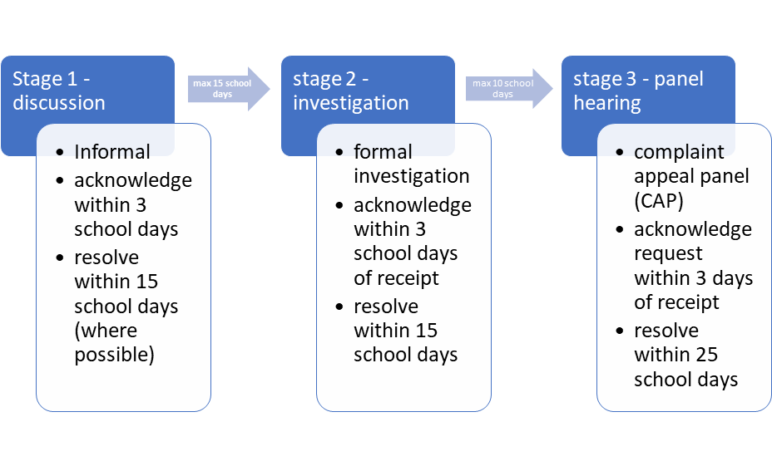

Appendix 4 - Guide to interviewing

REAch2 Complaints: Interviewing witnesses: Guidance for investigators

At Stage 2 of the complaints process you may be required to interview witnesses. There are some general points that should be considered before, during and after conducting interviews.

Interviewing a pupil/child

Before interviewing
- If the witness to an incident which has generated a complaint is a pupil/child, then parental
permission must be sought prior to any interviews
- A pupil/child must be accompanied by an appropriate adult at all times during the interview
- If an immediate statement is needed and a parent/carer/guardian cannot attend then the adult
should be the DSL or head teacher
- If a governor is conducting an investigation they should not be left alone with the child. It is
acceptable for a teacher/member of staff to be nominated to conduct the interview with questions which have been agreed beforehand
- Interviews with children should be kept brief and to the point and as informal as possible in an environment in which the child is comfortable
- Interviews should be conducted as soon as is practically possible after the event
- Questions should be age appropriate and planned beforehand to elicit factual evidence

During the interview
- Notes should be taken to record responses to planned questions
- Notes should be dated and signed on completion (if possible by the child/pupil) and the
interviewer
- Notes should record everyone present at the time of the interview
- If the interview becomes stressful or upsetting offer to pause or return at a later date if
necessary

After the interview
- Notes taken should be retained by the investigator for the purpose of concluding the
investigation; once recommendations have been written records should be retained by the school in a complaints folder, not in the child/pupil educational record

If it is not appropriate for interviews to take place, children can be asked to submit a written statement if it is necessary for the conducting of a complete investigation.

As a complaint investigator, you can make a decision in consultation with school staff, where appropriate, if you are unsure as to whether it is necessary to conduct interviews with children/pupils.

Interviewing a complainant

Before interviewing
- Read the complaint to make sure you understand the substance of the complaint and whether
the complainant has identified possible outcomes
- Identify areas which need further clarification and formulate questions in relation to these
- Plan where you will conduct the interview, ensuring that it is a space allowing for confidential
conversations. Consider whether you need to use a venue away from the school if the situation surrounding the complaint is difficult but ensure that you use a space such as an office or meeting room rather than a personal dwelling – another school in the cluster may be able to help out
- Ensure that the complainant can access the venue or consider using remote methods such as
Zoom to conduct the interview
- The complainant/witness can be accompanied by a supporter at this stage to offer comfort or
to help with e.g. interpretation of questions
- Legal representation should not be needed by either party as the investigation is not a legal
proceeding
- You can use a note taker if you think the situation may be difficult but ensure that the
complainant is aware of this.

During the interview
- Keep the conversation as informal as possible
- Clarify the purpose of the interview at the start to ensure that the complainant/witnesses
understand the process and what will happen to the information they give, and ensuring they understand that only factual information can be investigated
- If you are interviewing the complainant, clarify their expectation around the desirable outcomes
to their complaint. Use their written complaint to work through the issues and ensure that each one is addressed
- Take notes (or use a note taker) and ensure that they are a factual recording of the interview.
- Notes should be signed and dated by those present at the end of the interview and a copy
given to the complainant/witness
- If the interview becomes stressful or heated offer to pause or return at a later date if
necessary
- Take time to listen!
- Ensure, at the end, that the witness/complainant understands what happens next and the
possible time frame.

After the interview
- Ensure that notes are stored safely in accordance with our data protection policies
- Collate all notes to ensure a full pack of evidence.

Appendix 5 – Complaints not in scope

REAch2 Complaints Policy: Complaints not in the scope of the policy

Our policy is intended to enable the effective resolution of complaints by parents. However, there are a number of areas where specific processes or procedures are required to be followed because the complaint falls into specific areas of legislation. These are listed in the table below:

Admissions to schools | Covered by the REAch2 Admissions Policy and appeals process
Statutory assessments of special educational needs | Should be raised directly with your local authority
Matters likely to require a child protection investigation | These should be handled under the school safeguarding policy and in accordance with all relevant statutory guidance. Approach the Designated Safeguarding Lead (DSL) or your local authority designated officer (LADO)
Exclusions or suspensions | You can get guidance about raising concerns around exclusions or suspensions in the School Discipline and Exclusions guidance.
Whistleblowing | The Trust has an internal Whistleblowing Policy for all our employees and volunteers (including any temporary staff or contractors). You can also go directly to the Department for Education and use their contact form
Staff grievances | Complaints from staff concerning issues about their employment or circumstances at the school/Trust should be dealt with using the REAch2 Staff Grievance policy, available on the Trust intranet.
Complaints about services provided by other supplier who may use school premises or facilities | You should direct complainants to follow the external provider's own complaints procedure for those hiring the academy facilities.
Withdrawal from the curriculum | Parents and carers can withdraw their child from any aspect of Religious Education (RE), including the Daily Act of Collective Worship (DACW). They do not have to explain why.  If parents or carers are not satisfied with the handling of a request to withdraw their child from RE or the DACW, you should advise them to follow your complaints procedure.  The right of withdrawal does not apply to other areas of the curriculum where religious matters may be spontaneously raised by pupils or arise in other subjects such as history or citizenship.

