Weekly Planning Grid
Week 2- Monday
Lesson | Activity
Phonics | IALT: Recap my knowledge.  Read through the phase 2 and 3 sounds in the front of your learning pack (also on the website) and or watch the Jolly Phonics Song .  Write the tricky words: my, me, he Write the words: food, free, cat, hat  Printer required: Complete one page from the phonics work book resource on the website
Wake & Shake | Children to use this time to have an exercise break.
Literacy | IALT: Retell a story. (See document on the website, this does not need to be printed)
Choosing Time | Children can choose what to play with, this could be a creative activity, building, playing with dolls/ people etc.
Snack | Use this time to talk to your child, encourage healthy eating.
Morning Air | Go for a walk, play in the garden.
Maths | IALT: Talk about where I am in relation to objects.  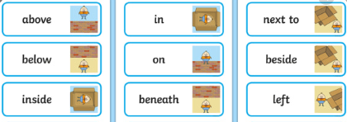  Watch the Preposition Song and then using a teddy and a box, practice prepositions: On top, under, inside, behind, next to, in between.  Challenge – learn which hand is your left and which hand is your write. Give directions to your Mum/Dad to get from one place to another in your house.
Quiet time | Puzzle, Zen Den, Reading
Hand-Writing | IALT: Correctly form the letter f  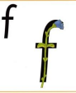  Dough Disco on YouTube, practice letter formation ditty: “down the flower across the flower” write out f f f f f
Topic | IALT: Create my own songs  Change the song “Down in the Jungle” and make your own version.  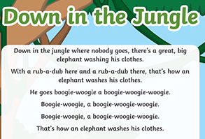
Choosing Time | Children can choose what to play with, this could be a creative activity, building, playing with dolls/ people etc.
Reading | We will upload two books to tapestry a week, please read one of the books uploaded.
We hope you enjoy these daily activities, there are links throughout (blue text) that will take you to YouTube or other useful websites. You may have noticed that I have put some general work on the website along with some helpful resources. Please feel free to use them as and when you need.

Week 2- Tuesday
Lesson | Activity
Phonics | IALT: Recap my knowledge.  Read through the phase 2 and 3 sounds in the front of your learning pack (also on the website) and or watch the Jolly Phonics Song .  Write the tricky words: my, me, he Write the words: hot, bit, deep, point  Printer required: Complete one page from the phonics work book resource on the website
Wake & Shake | Children to use this time to have an exercise break.
Literacy | IALT: draw a story map. (See document on the website, this does not need to be printed)
Choosing Time | Children can choose what to play with, this could be a creative activity, building, playing with dolls/ people etc.
Snack | Use this time to talk to your child, encourage healthy eating.
Morning Air | Go for a walk, play in the garden, bike ride.
Maths | IALT: Name 3D shapes and their properties.  3D shape hunt: start by watching the 3D shape video, then look for these shapes around your house.  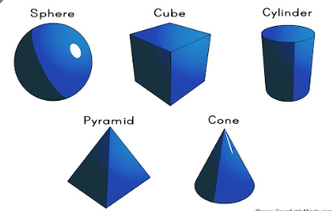  Challenge: Talk about their properties (faces, edges, corners)
Quiet time | Puzzle, Zen Den, Reading
Hand-Writing | IALT: Correctly form the letter g.  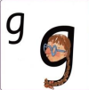  Dough Disco on YouTube, practice letter formation ditty: “around the girls face down her hair and give her a curl” write out: g g g
Topic | IALT: Use colour for a purpose.  Chameleon colour wheel: Look out for this topic activity on tapestry.  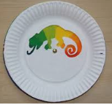
Choosing Time | Children can choose what to play with, this could be a creative activity, building, playing with dolls/ people etc.
Reading | We will upload two books to tapestry a week, please read one of the books uploaded.

Week 2- Wednesday
Lesson | Activity
Phonics | IALT: Recap my knowledge.  Read through the phase 2 and 3 sounds in the front of your learning pack (also on the website) and or watch the Jolly Phonics Song .  Write the tricky words: my, me, he Write the words: tap, mat, shop, this  Printer required: Complete one page from the phonics work book resource on the website, this should last two weeks.
Wake & Shake | Children to use this time to have an exercise break.
Literacy | IALT: write a sentence about Alan (See the word document on the website, this does not need to be printed)
Choosing Time | Children can choose what to play with, this could be a creative activity, building, playing with dolls/ people etc.
Snack | Use this time to talk to your child, encourage healthy eating.
Morning Air | Go for a walk, play in the garden, bike ride.
Maths | IALT: order a familiar event.  Talk about different events in the day and order them, watch this YouTube clip as an example. Try using time connectives when you talk such as: first, then, next, after that, finally.  Challenge: Draw a familiar event out in your exercise book.  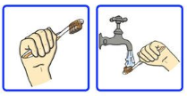
Quiet time | Puzzle, Zen Den, Reading
Hand-Writing | IALT: correctly form the letter h  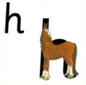  Dough Disco on YouTube, practice letter formation ditty: “down the horses head to his hooves and over his back” write out: h h
Topic | IALT: construct with a purpose in mind.  Junk mode or build an alligator with resources in your house, upload your work to tapestry.  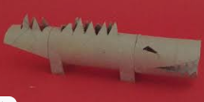  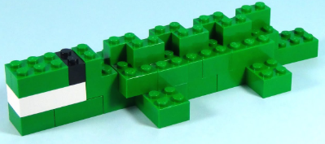  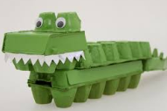
Choosing Time | Children can choose what to play with, this could be a creative activity, building, playing with dolls/ people etc.
Reading | We will upload two books to tapestry a week, please read one of the books uploaded.
Week 2- Thursday
Lesson | Activity
Phonics | IALT: Recap my knowledge.  Read through the phase 2 and 3 sounds in the front of your learning pack (also on the website) and or watch the Jolly Phonics Song .  Write the tricky words: my, me, he Write the words: moth, bot, jam, seed  Printer required: Complete one page from the phonics work book resource on the website, this should last two weeks.
Wake & Shake | Children to use this time to have an exercise break.
Literacy | IALT: draw a keep your teeth clean poster. (See document on the website, this does not need to be printed)
Choosing Time | Children can choose what to play with, this could be a creative activity, building, playing with dolls/ people etc.
Snack | Use this time to talk to your child, encourage healthy eating.
Morning Air | Go for a walk, play in the garden, bike ride.
Maths | IALT: count to 20 and beyond.  Start by watching this counting song on YouTube. Then count out different objects in your house for example: fruit, tooth brushes, tins, and packets of pasta. You could then sort the items for example: sort fruit into different categories, apples, bananas etc... Which has the most which has the least?  Challenge: Make a chart of what you have.  3  1  5
Quiet time | Puzzle, Zen Den, Reading
Hand-Writing | IALT: Correctly form the letter i  Dough Disco on YouTube, practice letter formation ditty: “down the insects body dot for his head” write out: i i i  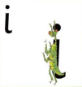
Topic | 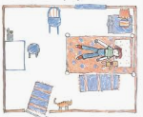  IALT: draw a map.  Draw out a map of your bedroom.
Choosing Time | Children can choose what to play with, this could be a creative activity, building, playing with dolls/ people etc.
Reading | We will upload two books to tapestry a week, please read one of the books uploaded.

Week 2- Friday
Lesson | Activity
Phonics | IALT: Recap my knowledge.  Read through the phase 2 and 3 sounds in the front of your learning pack (also on the website) and or watch the Jolly Phonics Song .  Write the tricky words: my, me, he Write the words: tap, mat, shop, this  Printer required: Complete one page from the phonics work book resource on the website, this should last two weeks.
Wake & Shake | Children to use this time to have an exercise break.
Literacy | IALT: describe Alan. (See document on the website, this does not need to be printed)
Choosing Time | Children can choose what to play with, this could be a creative activity, building, playing with dolls/ people etc.
Snack | Use this time to talk to your child, encourage healthy eating.
Morning Air | Go for a walk, play in the garden or go for a bike ride.
Maths | IALT: find a total and record using marks I can explain.  Using your fingers, find a total. Put different amounts of fingers up on each hand and add them together to find a total. Then write out the corresponding number sentence in your maths book. Do this several times.  + =  2 + 5 = 7  Challenge: use your fingers to learn your number bonds to ten.
Quiet time | Puzzle, Zen Den, Reading
Hand-Writing | IALT: Correctly form the letter j  Practice a Dough Disco on YouTube and then practice the letter formation ditty: “down his body, curl and a dot for his head” write out: j j j  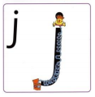
Topic | IALT: find out some facts about alligators.  Work out some facts and record yourself talking about them on tapestry. How are alligators different from crocodiles?  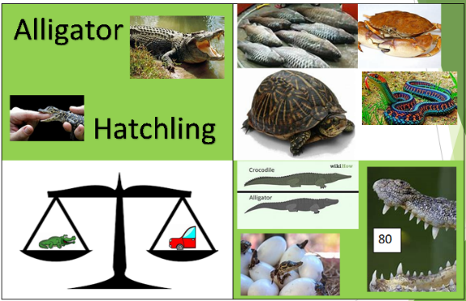
Choosing Time | Children can choose what to play with, this could be a creative activity, building, playing with dolls/ people etc.
Reading | We will upload two books to tapestry a week, please read one of the books uploaded.

