Term 6 Week 4 - Monday 22nd June
Lesson | Activity
Phonics | IALT: Recap my knowledge.  Phase 3:  Read through the phase 2 and 3 sounds in the front of your learning pack or watch the Jolly Phonics Song.  If you feel your child would benefit from recapping the phase 3 sounds, blend and segment the “ee” sound. Watch the lesson on YouTube.  Phase 4: If you feel your child is secure in the phase 3 sounds, please progress to the phase 4 sounds. Watch the lesson on YouTube.
Wake & Shake | Joe Wicks – daily workout
Literacy | IALT: Read and discuss the story Jolly Olly Octopus. See the literacy planning grid
Choosing Time | Children can choose what to play with, this could be a creative activity, building, playing with dolls/ people etc.
Snack | Use this time to talk to your child, encourage healthy eating.
Morning Air | Go for a walk, play in the garden.
Maths | 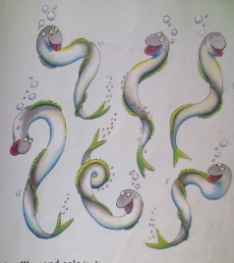  IALT: calculate one more and one less of a given number  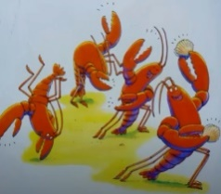  Can you count the number of animals in the pictures and then calculate one less and one more of the number?  Challenge: Can you work out one more and one less of any other numbers?
Quiet time | Puzzle, Zen Den, Reading
Hand-Writing | IALT: Correctly form letters with descenders  Watch and join in with the hand strengthening exercise by watching Dough Disco on YouTube.  Descenders are letters which hang below the line, for example: g, j, p, q and y. When we write these letters, they should hang down below the line on the page. If we imagine our paper has three sections: the sky, the grass and the dirt; our descenders are going to start in the grass and go down into the dirt. Please see this week’s video for demonstration.
Topic | 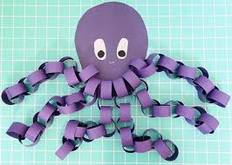  IALT: make a paper chain octopus  Cut out an oval shape for the body of the octopus. Then cut out small strips of paper, use glue to stick together the paper chains. Once you have made eight chains stick them to the body of the octopus to make the legs!  Watch the video.  Challenge: How can you make your work better?
Choosing Time | Children can choose what to play with, this could be a creative activity, building, playing with dolls/ people etc.
Reading | We will upload three books to tapestry a week, please read one of the books uploaded. Pink banded/ red banded/ yellow banded. Also, feel free to listen to BOOK read by Miss Pearse.
Weekly Planning Grid

Term 6 Week 4 – Tuesday 23rd June
Lesson | Activity
Phonics | IALT: Recap my knowledge.  Phase 3:  Read through the phase 2 and 3 sounds in the front of your learning pack or watch the Jolly Phonics Song.  If you feel your child would benefit from recapping the phase 3 sounds, blend and segment the “igh” sound. Watch the lesson on YouTube.  Phase 4: If you feel your child is secure in the phase 3 sounds, please progress to the phase 4 sounds. Watch the lesson on YouTube.
Wake & Shake | Joe Wicks – daily workout
Literacy | IALT: identify common themes in words: such as alliteration and rhyme. See the literacy planning grid
Choosing Time | Children can choose what to play with, this could be a creative activity, building, playing with dolls/ people etc.
Snack | Use this time to talk to your child, encourage healthy eating.
Morning Air | Go for a walk, play in the garden, bike ride. Has anything grown or changed since yesterday?
Maths | 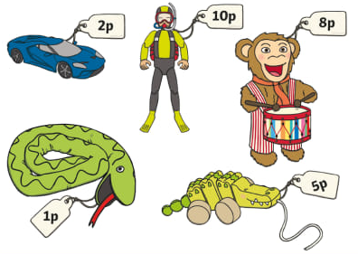  IALT: how to count money  Gather some toys and some 1p, 2p and 5p coins.  Make price tags for some of your toys and see if you can count out the right coins for the toy (don’t price anything higher than 10p).  Challenge: Have a go at ordering, sorting and counting coins on this money game.
Quiet time | Puzzle, Zen Den, Reading
Hand-Writing | IALT: Correctly form letters with descenders  Watch and join in with the hand strengthening exercise by watching Dough Disco on YouTube.  Descenders are letters which hang below the line, for example: g, j, p, q and y. When we write these letters, they should hang down below the line on the page. If we imagine our paper has three sections: the sky, the grass and the dirt; our descenders are going to start in the grass and go down into the dirt. Please see this week’s video for demonstration.
Topic | 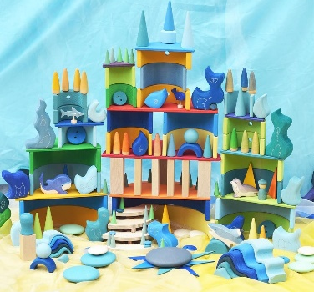  IALT: make an underwater kingdom  Make an underwater palace using things you can find in your house.  Try using Lego, dolls, playdoh, homemade creatures or small world toys. Make sure you make it as exciting as possible!  Challenge: Act out a story in your magic kingdom – make sure it has a beginning, a middle and an end.
Choosing Time | Children can choose what to play with, this could be a creative activity, building, playing with dolls/ people etc.
Reading | We will upload three books to tapestry a week, please read one of the books uploaded.

Term 6 Week 4 - Wednesday 24th June
Lesson | Activity
Phonics | IALT: Recap my knowledge.  Phase 3:  Read through the phase 2 and 3 sounds in the front of your learning pack or watch the Jolly Phonics Song.  If you feel your child would benefit from recapping the phase 3 sounds, blend and segment the “oa” sound. Watch the lesson on YouTube.  Phase 4: If you feel your child is secure in the phase 3 sounds, please progress to the phase 4 sounds. Watch the lesson on YouTube.
Wake & Shake | Joe Wicks – daily workout
Literacy | IALT: discuss octopus facts. See the literacy planning grid
Choosing Time | Children can choose what to play with, this could be a creative activity, building, playing with dolls/ people etc.
Snack | Use this time to talk to your child, encourage healthy eating.
Morning Air | Go for a walk, play in the garden, bike ride. Has anything grown or changed since yesterday?
Maths | 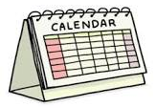  IALT: consider how to use appropriate measures of time  Think about how you would measure time for these different events? Will you time them in minutes, hours, days or weeks?  - How long does it take for a seed to grow into a plant?  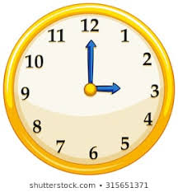  - How long until lunchtime?  - How long does it take for a rocket to reach the moon?  - How long does it take to run up the stairs?  Key words: minute, hour, day, week, time, measure  Challenge: Can you estimate (make a “sensible guess”) how long each of these things would take? Can you and a grown up research the answer?
Quiet time | Puzzle, Zen Den, Reading
Hand-Writing | IALT: Correctly form letters with descenders  Watch and join in with the hand strengthening exercise by watching Dough Disco on YouTube.  Descenders are letters which hang below the line, for example: g, j, p, q and y. When we write these letters, they should hang down below the line on the page. If we imagine our paper has three sections: the sky, the grass and the dirt; our descenders are going to start in the grass and go down into the dirt. Please see this week’s video for demonstration.
Topic | 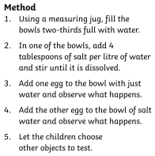  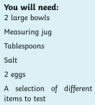  IALT: learn about water density  Watch this video. We will be exploring the difference between fresh water and salt water.  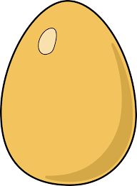
Choosing Time | Children can choose what to play with, this could be a creative activity, building, playing with dolls/ people etc.
Reading | We will upload three books to tapestry a week, please read one of the books uploaded.

Term 6 Week 4 – Thursday 25th June
Lesson | Activity
Phonics | IALT: Recap my knowledge.  Phase 3:  Read through the phase 2 and 3 sounds in the front of your learning pack or watch the Jolly Phonics Song.  If you feel your child would benefit from recapping the phase 3 sounds, blend and segment the “oo” sound. Watch the lesson on YouTube.  Phase 4: If you feel your child is secure in the phase 3 sounds, please progress to the phase 4 sounds. Watch the lesson on YouTube.
Wake & Shake | Joe Wicks – daily workout
Literacy | IALT: write about what a marine biologist does. See the literacy planning grid
Choosing Time | Children can choose what to play with, this could be a creative activity, building, playing with dolls/ people etc.
Snack | Use this time to talk to your child, encourage healthy eating.
Morning Air | Go for a walk, play in the garden, bike ride. Has anything grown or changed since yesterday?
Maths | IALT: count in twos to aid in addition  Find some pairs of socks, can you work out how many socks you have altogether by counting in 2s?  Challenge: How many pairs of socks would an octopus need?
Quiet time | Puzzle, Zen Den, Reading
Hand-Writing | IALT: Correctly form letters with descenders  Watch and join in with the hand strengthening exercise by watching Dough Disco on YouTube.  Descenders are letters which hang below the line, for example: g, j, p, q and y. When we write these letters, they should hang down below the line on the page. If we imagine our paper has three sections: the sky, the grass and the dirt; our descenders are going to start in the grass and go down into the dirt. Please see this week’s video for demonstration.
Topic | IALT: exploring ice  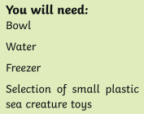  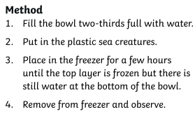  Watch this video. Observe what you can do with ice. Consider some of the questions:  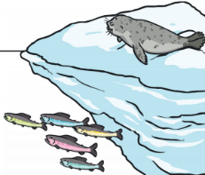  - What does it feel like?  - What does it look like?  - Can you balance anything on it?  - Can you make it melt faster?
Choosing Time | Children can choose what to play with, this could be a creative activity, building, playing with dolls/ people etc.
Reading | We will upload three books to tapestry a week, please read one of the books uploaded.

Term 6 Week 4 – Friday 26th June
Lesson | Activity
Phonics | IALT: Recap my knowledge.  Phase 3:  Read through the phase 2 and 3 sounds in the front of your learning pack or watch the Jolly Phonics Song.  If you feel your child would benefit from recapping the phase 3 sounds, blend and segment the “ar” sound. Watch the lesson on YouTube.  Phase 4: If you feel your child is secure in the phase 3 sounds, please progress to the phase 4 sounds. Watch the lesson on YouTube.
Wake & Shake | Joe Wicks – daily workout
Literacy | IALT: present a TV show about marine biology. See the literacy planning grid
Choosing Time | Children can choose what to play with, this could be a creative activity, building, playing with dolls/ people etc.
Snack | Use this time to talk to your child, encourage healthy eating.
Morning Air | Go for a walk, play in the garden, bike ride. Has anything grown or changed since yesterday?
Maths | IALT: measure everyday objects  Find 6 of your favourite toys (e.g. superhero figure, dolls, piece of lego) and order them from biggest to smallest.  Key Words: big, bigger, biggest, small, smaller, smallest  Challenge: Can you order them from lightest to heaviest?
Quiet time | Puzzle, Zen Den, Reading
Hand-Writing | IALT: Correctly form letters with descenders  Watch and join in with the hand strengthening exercise by watching Dough Disco on YouTube.  Descenders are letters which hang below the line, for example: g, j, p, q and y. When we write these letters they should hang down below the line on the page. If we imagine our paper has three sections: the sky, the grass and the dirt; our descenders are going to start in the grass and go down into the dirt. Please see this week’s video for demonstration.
Topic | IALT: make a piece of underwater artwork  Paint a piece of paper with different shades of blue – experiment with adding white and black to the blue to change the shade.  Cut out animals and seaweed shapes using black paper and stick on your painting to create an underwater scene  Challenge 1: How many different animals can you add to the picture?
Choosing Time | Children can choose what to play with, this could be a creative activity, building, playing with dolls/ people etc.
Reading | We will upload three books to tapestry a week, please read one of the books uploaded.

