Term 6 Week 3 - Monday 15th June
Lesson | Activity
Phonics | IALT: Recap my knowledge.  Phase 3:  Read through the phase 2 and 3 sounds in the front of your learning pack or watch the Jolly Phonics Song.  If you feel your child would benefit from recapping the phase 3 sounds, blend and segment the “sh” sound. Watch the lesson on YouTube.  Phase 4: If you feel your child is secure in the phase 3 sounds, please progress to the phase 4 sounds. Watch the lesson on YouTube.
Wake & Shake | Joe Wicks – daily workout
Literacy | IALT: Read and discuss the story The Rainbow Fish. See the literacy planning grid
Choosing Time | Children can choose what to play with, this could be a creative activity, building, playing with dolls/ people etc.
Snack | Use this time to talk to your child, encourage healthy eating.
Morning Air | Go for a walk, play in the garden.
Maths | 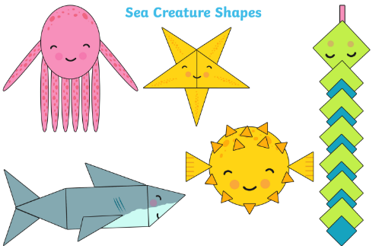  IALT: use shapes to make sea animals  Cut out various shapes of paper and glue them together to make a sea animal:  - Can you make a starfish out of triangles?  - Can you make a fish out of squares?  - Can you make an octopus out of circles?
Quiet time | Puzzle, Zen Den, Reading
Hand-Writing | IALT: Correctly form letters with descenders  Watch and join in with the hand strengthening exercise by watching Dough Disco on YouTube.  Descenders are letters which hang below the line, for example: g, j, p, q and y. When we write these letters, they should hang down below the line on the page. If we imagine our paper has three sections: the sky, the grass and the dirt; our descenders are going to start in the grass and go down into the dirt. Please see this week’s video for demonstration.
Topic | 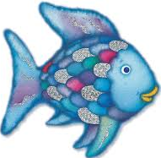  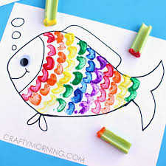  IALT: make some Rainbow Fish art using celery to stamp rainbow scales  Draw a basic outline of a fish. Use celery to stamp different colours in a rainbow pattern on the fish. They should look like scales!  Challenge: How can you make your work better?
Choosing Time | Children can choose what to play with, this could be a creative activity, building, playing with dolls/ people etc.
Reading | We will upload three books to tapestry a week, please read one of the books uploaded. Pink Banded Red banded/ yellow banded. Also, feel free to listen to BOOK read by Miss Pearse.
Weekly Planning Grid

Term 6 Week 3 – Tuesday 16th June
Lesson | Activity
Phonics | IALT: Recap my knowledge.  Phase 3:  Read through the phase 2 and 3 sounds in the front of your learning pack or watch the Jolly Phonics Song.  If you feel your child would benefit from recapping the phase 3 sounds, blend and segment the “ch” sound. Watch the lesson on YouTube.  Phase 4: If you feel your child is secure in the phase 3 sounds, please progress to the phase 4 sounds. Watch the lesson on YouTube.
Wake & Shake | Joe Wicks – daily workout
Literacy | IALT: write a thank you letter to the Rainbow Fish from the other fish. See the literacy planning grid
Choosing Time | Children can choose what to play with, this could be a creative activity, building, playing with dolls/ people etc.
Snack | Use this time to talk to your child, encourage healthy eating.
Morning Air | Go for a walk, play in the garden, bike ride. Has anything grown or changed since yesterday?
Maths | 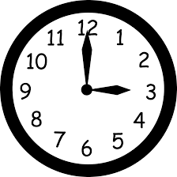  IALT: recognise different ways of telling time  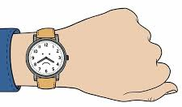  Search around your house for all the different clocks, watches and timers you can find!  Challenge: Draw a picture of an (analogue) clock, which numbers are on the clock? Why do you think the clock goes up to 12?
Quiet time | Puzzle, Zen Den, Reading
Hand-Writing | IALT: Correctly form letters with descenders  Watch and join in with the hand strengthening exercise by watching Dough Disco on YouTube.  Descenders are letters which hang below the line, for example: g, j, p, q and y. When we write these letters, they should hang down below the line on the page. If we imagine our paper has three sections: the sky, the grass and the dirt; our descenders are going to start in the grass and go down into the dirt. Please see this week’s video for demonstration.
Topic | 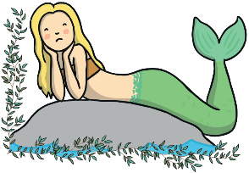  IALT: identify waterproof materials  Marissa the Mermaid has lost her waterproof scales. Can you find a material which is waterproof so she can cover her tail while her scales grow back?  Why don’t you try?  - Cling film - Swimming costume - Kitchen roll  - Tea towel - Tin foil - Plastic bag  Challenge: Can you write about and record your findings?
Choosing Time | Children can choose what to play with, this could be a creative activity, building, playing with dolls/ people etc.
Reading | We will upload three books to tapestry a week, please read one of the books uploaded.

Term 6 Week 3 - Wednesday 17th June
Lesson | Activity
Phonics | IALT: Recap my knowledge.  Phase 3:  Read through the phase 2 and 3 sounds in the front of your learning pack or watch the Jolly Phonics Song.  If you feel your child would benefit from recapping the phase 3 sounds, blend and segment the “th” sound. Watch the lesson on YouTube.  Phase 4: If you feel your child is secure in the phase 3 sounds, please progress to the phase 4 sounds. Watch the lesson on YouTube.
Wake & Shake | Joe Wicks – daily workout
Literacy | IALT: write about my most prized possession. See the literacy planning grid
Choosing Time | Children can choose what to play with, this could be a creative activity, building, playing with dolls/ people etc.
Snack | Use this time to talk to your child, encourage healthy eating.
Morning Air | Go for a walk, play in the garden, bike ride. Has anything grown or changed since yesterday?
Maths | 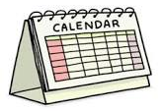  IALT: make my own calendar  Look at a calendar in your house, do you know how long a month is? How long is a week? Can you work out how many days since we were last in school?  Ask an adult to help draw a calendar for the month of June – focus on the different weeks. Can you label the different days?  Key words: today, tomorrow, week, month, day, next week
Quiet time | Puzzle, Zen Den, Reading
Hand-Writing | IALT: Correctly form letters with descenders  Watch and join in with the hand strengthening exercise by watching Dough Disco on YouTube.  Descenders are letters which hang below the line, for example: g, j, p, q and y. When we write these letters, they should hang down below the line on the page. If we imagine our paper has three sections: the sky, the grass and the dirt; our descenders are going to start in the grass and go down into the dirt. Please see this week’s video for demonstration.
Topic | 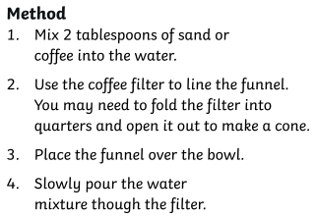  IALT: learn about how fish breathe underwater  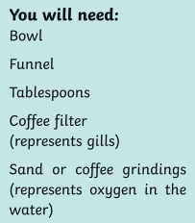  Watch this video to learn about how fish live underwater.  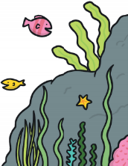  Talk about how you think fish can breathe underwater. Then conduct an experiment to see how fish can breathe:
Choosing Time | Children can choose what to play with, this could be a creative activity, building, playing with dolls/ people etc.
Reading | We will upload three books to tapestry a week, please read one of the books uploaded.

Term 6 Week 3 – Thursday 18th June
Lesson | Activity
Phonics | IALT: Recap my knowledge.  Phase 3:  Read through the phase 2 and 3 sounds in the front of your learning pack or watch the Jolly Phonics Song.  If you feel your child would benefit from recapping the phase 3 sounds, blend and segment the “ng” sound. Watch the lesson on YouTube.  Phase 4: If you feel your child is secure in the phase 3 sounds, please progress to the phase 4 sounds. Watch the lesson on YouTube.
Wake & Shake | Joe Wicks – daily workout
Literacy | IALT: complete a sentence about a picture. See the literacy planning grid
Choosing Time | Children can choose what to play with, this could be a creative activity, building, playing with dolls/ people etc.
Snack | Use this time to talk to your child, encourage healthy eating.
Morning Air | Go for a walk, play in the garden, bike ride. Has anything grown or changed since yesterday?
Maths | 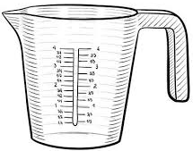  IALT: sort objects by capacity  Conduct an experiment to see which of the following holds the most water (has the greatest capacity):  - A jug - A teaspoon - A cup  - A bowl - A sink - A plate  Key words: empty, full, capacity, more, less
Quiet time | Puzzle, Zen Den, Reading
Hand-Writing | IALT: Correctly form letters with descenders  Watch and join in with the hand strengthening exercise by watching Dough Disco on YouTube.  Descenders are letters which hang below the line, for example: g, j, p, q and y. When we write these letters, they should hang down below the line on the page. If we imagine our paper has three sections: the sky, the grass and the dirt; our descenders are going to start in the grass and go down into the dirt. Please see this week’s video for demonstration.
Topic | 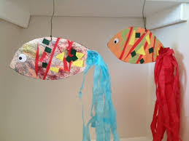  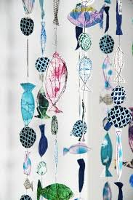  IALT: make a fish mobile  Use a variety of different materials (hopefully you can recycle some things from around your house)
Choosing Time | Children can choose what to play with, this could be a creative activity, building, playing with dolls/ people etc.
Reading | We will upload three books to tapestry a week, please read one of the books uploaded.

Term 6 Week 3 – Friday 19th June
Lesson | Activity
Phonics | IALT: Recap my knowledge.  Phase 3:  Read through the phase 2 and 3 sounds in the front of your learning pack or watch the Jolly Phonics Song.  If you feel your child would benefit from recapping the phase 3 sounds, blend and segment the “ai” sound. Watch the lesson on YouTube.  Phase 4: If you feel your child is secure in the phase 3 sounds, please progress to the phase 4 sounds. Watch the lesson on YouTube.
Wake & Shake | Joe Wicks – daily workout
Literacy | IALT: write about what makes a good friend. See the literacy planning grid
Choosing Time | Children can choose what to play with, this could be a creative activity, building, playing with dolls/ people etc.
Snack | Use this time to talk to your child, encourage healthy eating.
Morning Air | Go for a walk, play in the garden, bike ride. Has anything grown or changed since yesterday?
Maths | IALT: make and describe 3D shapes  Use playdoh, plasticine or modelling clay to make different 3D (“fat” shapes”). Can you make:  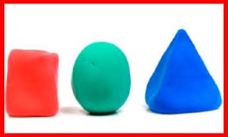  - A sphere  - A cube  - A cuboid  - A pyramid  - A cone  Top Tip: Look at an object of the shape you are trying to make to help you (e.g. look at a dice to help you make a cube)  Challenge: Can you could the sides, corners and faces of the shapes?
Quiet time | Puzzle, Zen Den, Reading
Hand-Writing | IALT: Correctly form letters with descenders  Watch and join in with the hand strengthening exercise by watching Dough Disco on YouTube.  Descenders are letters which hang below the line, for example: g, j, p, q and y. When we write these letters they should hang down below the line on the page. If we imagine our paper has three sections: the sky, the grass and the dirt; our descenders are going to start in the grass and go down into the dirt. Please see this week’s video for demonstration.
Topic | IALT: see how colours mix to make a rainbow  Place jelly beans in a circle around the edge of a plate. Put them in a pattern: red, orange, yellow, green, blue, purple.  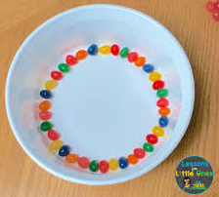  Then add a small amount of warm water, ensuring it touches the jelly beans. Wait patiently to see what happens!  Challenge 1: Write a sentence predicting what will happen when you add the water to the jelly beans.
Choosing Time | Children can choose what to play with, this could be a creative activity, building, playing with dolls/ people etc.
Reading | We will upload three books to tapestry a week, please read one of the books uploaded.

