This week we will be completing, week commencing 8th June
The maths topics we are covering this week are, measuring and comparing height, length, mass and weight. The lesson can be found on: Https://whiterosemaths.com/homelearning/year-1/

Monday 13th July
Maths | Lesson 1 - IALT: count in 2’s  Starter: - Daily count Count forwards and backwards to 26. Can you count to 52?  How many number bonds to 20 can you make?  Let’s think? Why is it important to know how to count in 2’s?  YouTube: https://www.youtube.com/watch?v=OCxvNtrcDIs  Lesson: https://whiterosemaths.com/homelearning/year-1/  Activity:  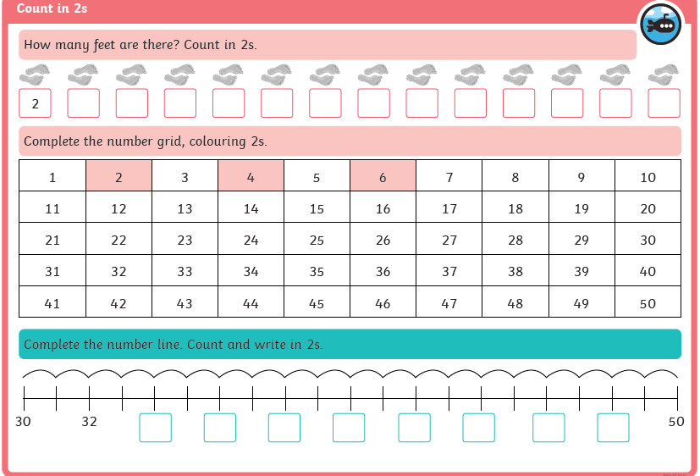  Can you make your own song about counting in 2’s? Use youtube to help.
Tuesday 14th July
Maths | Lesson 2 - IALT: Count in 5’s  Starter: - Daily count Count forwards and backwards to 25.  Complete the sequence, What number comes next? 25 30 _____ _____ ______.  How many number bonds to 5 can you make?  Let’s think?  Why is it important to count in 5’s? Why do you think counting in 5’s will help us with addition?  Youtube: https://www.youtube.com/watch?v=amxVL9KUmq8  Lesson: https://whiterosemaths.com/homelearning/year-1/  Activity:  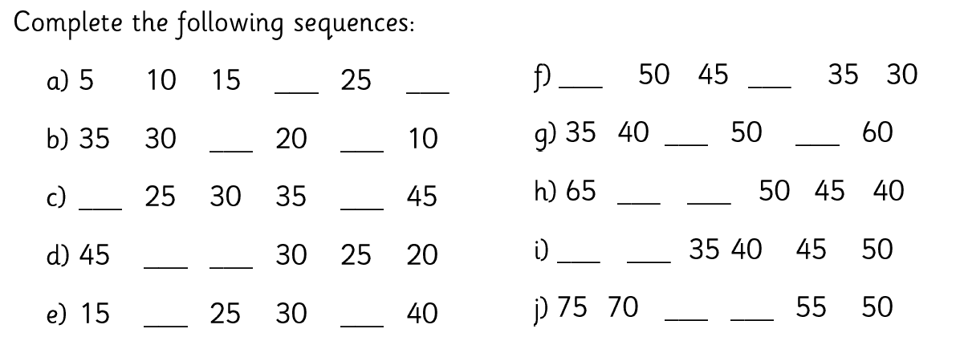
Wednesday 15th July
Maths | Lesson 3 - IALT: count in 10’s  Starter: - Daily count  Count to 20. Count to 50. Count in 10’s from 30 to 80.  Complete the following: 30, 40 ___ ____ _____ ______.  Let’s think??  Why is it important to count in 10’s?  YouTube: https://www.youtube.com/watch?v=7stosHbZZZg  Lesson: https://whiterosemaths.com/homelearning/year-1/  Activity  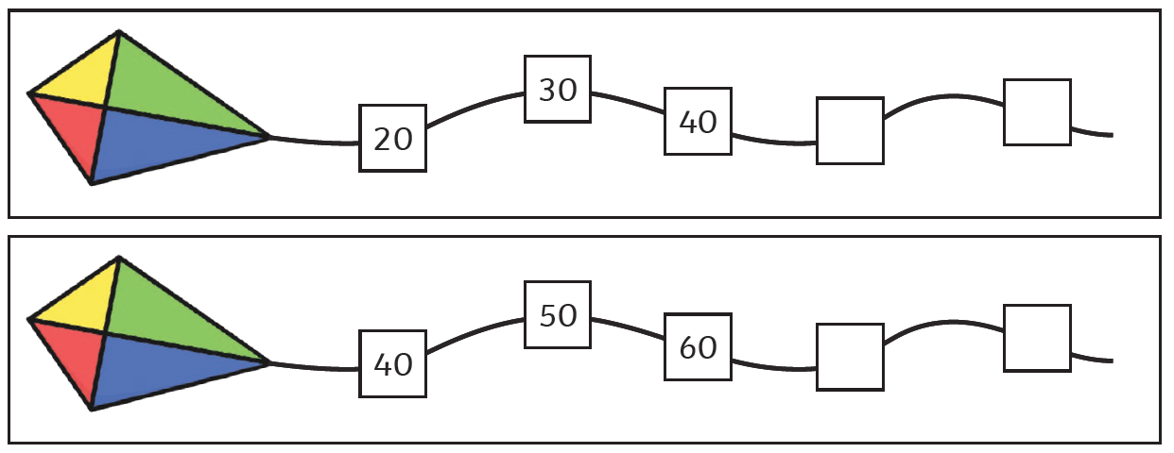  Can you create your own kite?

Thursday 16th July
Maths | Lesson 4 - IALT: add equal groups  Starter: - Daily count  Count to 20.  Count in 5s from 10 t0 50. Can you write the numbers down?  Is 20 in the 5 times table?  Let’s think?  Why is it important to add in equal groups? How can this help us with addition? Will knowing how to count in 2’s help?  Bitesize: https://www.bbc.co.uk/bitesize/tags/zjpqqp3/year-1-and-p2-lessons  Lesson: https://whiterosemaths.com/homelearning/year-1/  Activity:  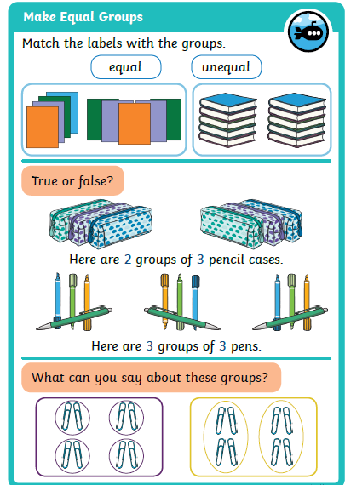

Friday 17th July
Maths | Lesson 5 – CHALLENGE FRIDAY  Starter: - Daily count  Count to 50. Count to 20 in 2’s. Count to 50 in 5’s. Count to 50 in 10’s.  Let’s think??  What have you learnt this week? What was your favourite maths topic?  Lesson: https://whiterosemaths.com/homelearning/year-1/  Activity:  https://whiterosemaths.com/homelearning/year-1/

