This week we will be completing, week commencing 1st June
The maths topics we are covering this week are, measuring and comparing height, length, mass and weight. The lesson can be found on: Https://whiterosemaths.com/homelearning/year-1/

Monday 6th July
Maths | Lesson 1 - IALT: Measure Mass  Starter: - Daily count Count forwards and backwards to 350. Can you count to 50?  How many number bonds to 20 can you make?  Let’s think?  What is mass? Why do we need to know what mass is?  YouTube: https://www.youtube.com/watch?v=Q3kX0di4UrM  Lesson: https://whiterosemaths.com/homelearning/year-1/  Activity:  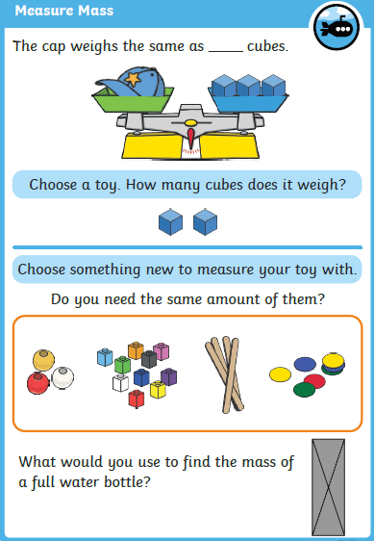
Tuesday 7th July
Maths | Lesson 2 - IALT: Compare Mass  Starter: - Daily count Count forwards and backwards to 22.  Complete the sequence, What number comes next? 22 _____ _____ _____ ______.  How many number bonds to 10 can you make?  Let’s think?  What is mass?  Youtube: https://www.youtube.com/watch?v=P_XA7MiH0ak&t=5s  https://www.youtube.com/watch?v=pEot9b07lnk  Lesson: https://whiterosemaths.com/homelearning/year-1/  Activity:  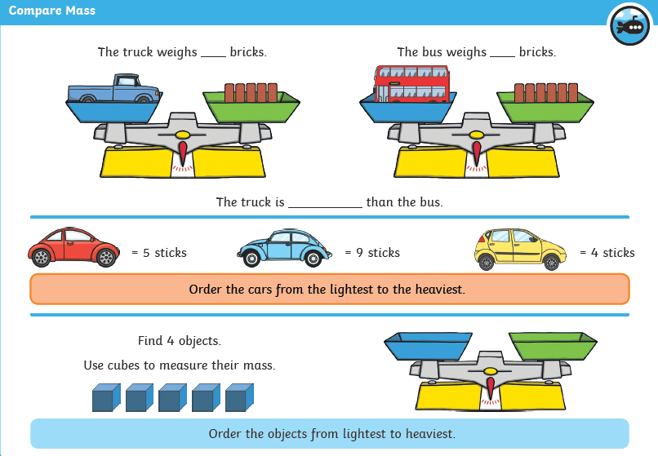
Wednesday 8th July
Maths | Lesson 3 - IALT: introduce capacity and volume  Starter: - Daily count  Count to 20. Count to 50. Count in 5’s from 30 to 80.  Complete the following: 30, 40 ___ ____ _____ ______.  Let’s think??  What do you think Capacity means? What do you think Volume is?  YouTube: https://www.youtube.com/watch?v=fXf4KdfNhF0  Lesson: https://whiterosemaths.com/homelearning/year-1/  Activity  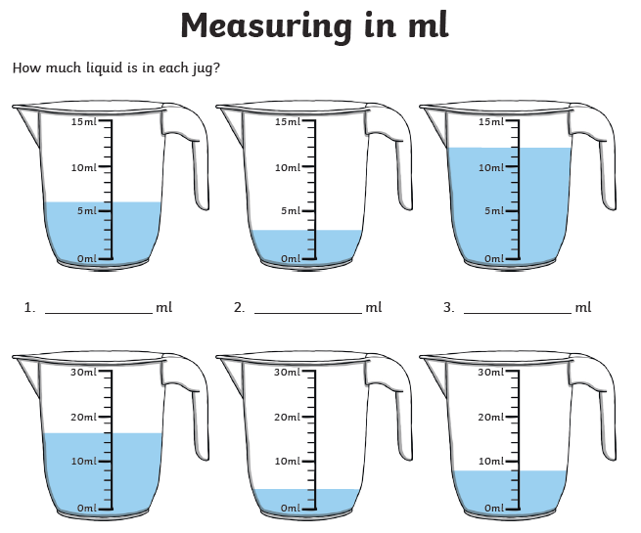  Go back and answer the questions now you have completed the lesson!  What do you think Capacity means? What do you think Volume is?

Thursday 9th July
Maths | Lesson 4 - IALT: measure capacity  Starter: - Daily count  Count to 20.  Count in 5s from 10 t0 50. Can you write the numbers down?  Is 20 in the 5 times table?  Let’s think?  Can you remember what capacity is? What do you think measure means?  Youtube: https://www.youtube.com/watch?v=wXTG04MxB-E  Lesson: https://whiterosemaths.com/homelearning/year-1/  Activity: You will need different containers, water and a measuring jug!  Have a guess on how much each container holds. Then Measure!  Did you get the answer correct?

Friday 10th July
Maths | Lesson 5 – CHALLENGE FRIDAY  Starter: - Daily count  Count to 50. Count to 20 in 2’s. Count to 50 in 5’s. Count to 50 in 10’s.  Let’s think??  What have you learnt this week? What was your favourite maths topic?  Lesson:https://whiterosemaths.com/homelearning/year-1/  Activity:  https://wrm-13b48.kxcdn.com/wp-content/uploads/2020/06/Family-Challenge-Friday-5th-June.pdf

