Week 6

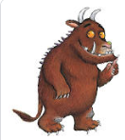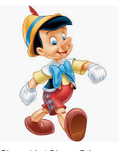

English

This week, we have decided to do something quite different and wanted to celebrate the two books that our Year 1 classes were named after.
We have shared these stories many times and so we hope you may enjoy some of the activities that we have collected for you to enjoy this week.
Perhaps you would like to make up your own version of these stories and send them in to us. You could change some of the characters or change the settings. Perhaps the Gruffalo would meet a monkey on his way through the woods or perhaps Pinocchio’s feet will grow when he tells a lie rather than his nose.

As always, we love to see the amazing work that you do at home. Please do have lots of fun working through the activities, showing off the great writing skills that you have learnt this year and enjoy acting out the story with your family.

Have a great week!

