English | MONDAY  This week, we are going to continue our journey with The Snail and the Whale. Today, you will be retrieving information from the book and answering questions in complete sentences.  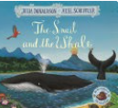  Starter: Please write the date in your book.  Monday 29th June 2020  Please correct this sentence and write it into your book:  tHUndeR crashed as LOWd as a lion  IALT: retrieve information from a story. Before we start our task, lets remind ourselves of this lovely story.  Click here for a link to the story: https://www.youtube.com/watch?v=x887mPO9X9c  Task: To read each question.  - Look at the picture to see if you can find the answer.  - Write your answer as a complete sentence.  - Check your work.  Example: The red cat is____________________.
TUESDAY
Today you are going to write a review of the story. We have some questions to help guide you or alternatively you can write your own review, saying what you liked or didn’t like about the story and why.

Starter: Write the date in your book.
Tuesday 30th June 2020

Please write this sentence correctly into your book:
I lick that the children helped the wail

IALT: write a review
Here are some questions to help guide you through writing your review or you can use the book review template that we have provided.
Who was your favourite character? Why?
What was your favourite part of the story? Why?
Which settings did you like?
Would you recommend the story to another person?
Task:
- Use the book review template or create your own.
- Include what you liked or maybe didn’t like about the book.
- Write in full sentences and check your work.

Example: My favourite character in the story was the snail because he was very brave and a good friend to the whale.

WEDNESDAY
English | Today, we are going to plan our own shared adventure story.  Starter: Write the date correctly.  Wednesday 1st July 2020.  Write this sentence correctly into your books.  thE wail sed fank you to the snayl.  IALT: plan a story  Today, you are going to plan your very own adventure for two friends. You will need to think about who the characters will be and what the main event of the story will be. This may help you to plan your ideas.  The goat and the chicken  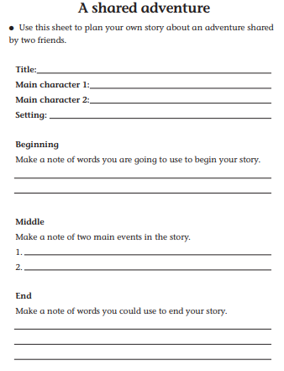 Farm  Your task  - Make a plan for a shared adventure between two friends.  - Describe the main characters – which one will be the hero?  - Describe where the story will take place.  - What problem will happen and how will they solve the problem?  - How will the story end.

THURSDAY
Today, you are going to write your shared adventure story using your plan from yesterday.

Starter: Write the date correctly:
Thursday 2nd July 2020.
Write this sentence correctly into your book:
hE stared at the see, the skigh and the golden sand.

IALT: write a short story.
Today, you are going to look at your plan from yesterday and use this to write your story about two friends having a shared adventure.
Think about how would you like your story to start. Here are some examples to help you:
One sunny day,
Once upon a time,
A long, long time ago,
Far, far away,

Your task:
- Write your shared friend adventure story
- Write in full sentences and use your phonics knowledge to write new words.
- Check that you have used Capital Letter, finger spaces and full stops.
- Read your work to make sure you have not left anything out.

We cannot wait to read your stories!!!

English | FRIDAY  Each week we will continue to practise learning some words that we may like to use in our writing.  Please choose from Mild, Spicy or Hot words and write them in your book 5 times.  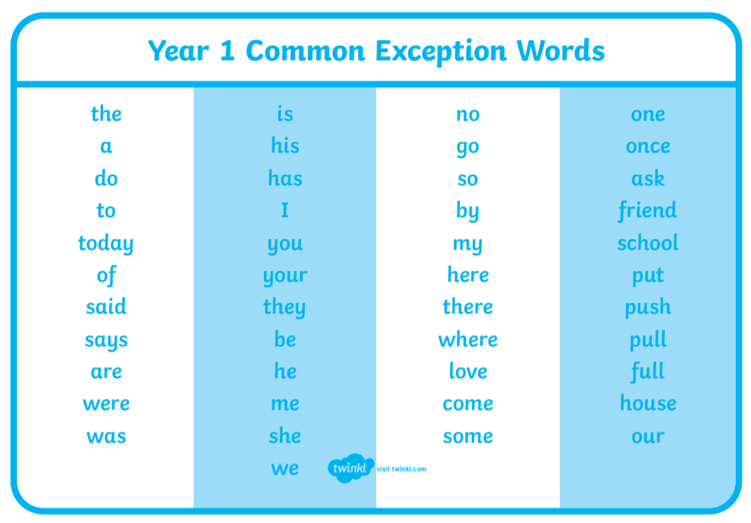  Task:  Mild: Spicy Hot  was said where  are once house  his your friend  has they come  Extension: Put each word into a sentence and write this into your book.

