English | MONDAY  PLEASE TAKE A LOOK AT THIS LINK TO THE BOOK ‘THE HIGHWAY RAT’. PERHAPS YOU COULD TRY TO READ ALONG WITH THE STORY.  https://www.youtube.com/watch?v=bkVoYeCLIXU  We hope that you enjoy this story about the Highway Rat. Who was the author of the story? What other books has she written?  Did you think of The Gruffalo, The Snail and the Whale or Stickman?  This week, our writing is going to be based on this story and we hope you enjoy writing about the Highway Rat.  Starter: Correct the spelling and punctuation and copy them into your book.  The raT tuk lots ov food from evrywon.  The rat was meen and not nis  IALT: answer questions about a story.  Today, we are going to try and answer some questions about the story?  We will try to answer questions that use these words into your book.  What? Where? Who? When? Why?  Task: Write the answer to each of these questions in your book?:  - What did the Highway Rat take from the squirrel?  - Where did the duck take the Highway Rat to?  - Who tricked the Highway Rat?  - Why did all of the animals have a party?  Extension: Make up some questions about the story using these words: How, why, when, where and what?
TUESDAY

Starter: Write the date in your book.
Tuesday 12th May 2020
(Remember to use capital letters for days of the week and months of the year)

IALT: write full sentences.
Today, we are going to try and return the food that the Highway Rat took
from the animals.

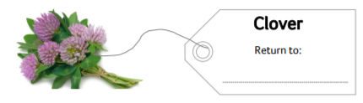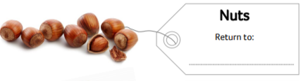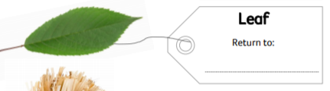

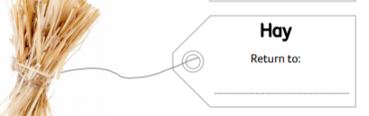

We will write down a sentence to say which items goes to which animal.
Example: The nuts belongs to the squirrel.

Before we start to write, let us remember the rules for writing sentences:
- Capital letters at the start of a sentence and for the name of a person
or place. ABCDE
- Finger spaces between our words to make it easy to read.
- Full stop at the end of a sentence.

Extension: Use an adjective to describe each piece of food.
Example: The crunchy nut belongs to the squirrel.

WEDNESDAY
English | Today, we are going to create a WANTED poster for the Highway Rat.  Starter: Write the date correctly.  Wednesday 13th May 2020.  IALT: use adjectives  What words do we call words that describe things? Yes, that is right, they are  called adjectives. Enjoy this song that we have sang many times in class:  https://www.youtube.com/watch?v=3JZi2oDvPs4  How would you describe the Highway Rat? Would you use any of these words:  Big small kind mean greedy helpful brave nasty  Your task 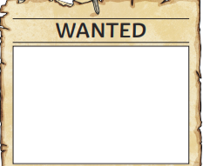  - Create a Wanted Poster for the Highway Rat (You can use the template on our website or draw this onto paper or into your book.  - Label the picture – use adjectives if you can!!  Extension: Write sentences to describe the Highway Rat.  We would love to see your work so please email it to Year1@civitasacademy.co.uk

THURSDAY
Today, we would like you to pretend to be the Highway Rat. We want the Highway
Rat to write a letter to say sorry to the animals that he stole from.

Starter: Write the date correctly:

Thursday 14th May 2020.
IALT: write a letter from the Highway Rat

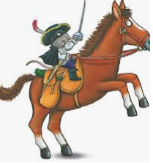
Your task:
- Pretend to be the Highway Rat and choose an animal to say sorry to.
- Write a sentence to say sorry to the animal.
- Write a sentence to say what you stole from the animal.
- Write a sentence to say why you are sorry.
- Write as sentence to ask if you can be friends.

Example: Dear Squirrel,
I am the Highway __________________________’
I am sorry that I ____________________________.

Extension: Use the conjunction ‘because’ in your writing today.
We would love to see your letters and postcards so please do send them to Year1@civitasacademy.co.uk.

English | FRIDAY  Each week we will continue to practise learning some words that we may like to use in our writing.  Please choose from Mild, Spicy or Hot words and write them in your book 5 times.  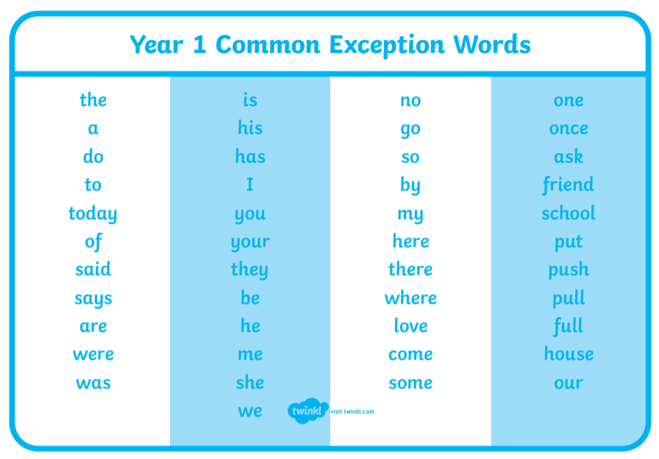  Task:  Mild: Spicy Hot  the your there  and were friend  was push house  is they come  Extension: Put each word into a sentence and write this into your book.

