This week we will be completing, week commencing 11th May
The maths topics we are covering this week are, addition by making 10, subtraction, comparing and word problems. The lesson can be found on: Https://whiterosemaths.com/homelearning/year-1/

Monday 22nd June
Maths | Lesson 1 - IALT: Adding by making 10.  Starter: - Daily count Count forwards and backwards to 50. Can you count to 100?  Let’s think??  What do you part-whole is? Can you remember using part-whole in class? Can you explain to an adult what it is?  Youtube: https://www.youtube.com/watch?v=q9h4skGoWJ8&t=150s  Lesson:  https://whiterosemaths.com/homelearning/year-1/  Activity:  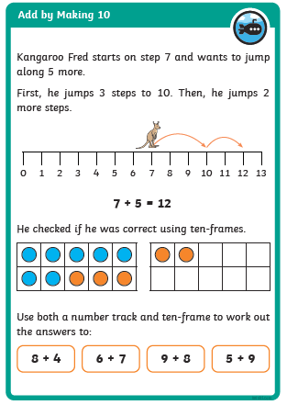
Tuesday 23rd June
Maths | Lesson 2 - IALT: Subtract within 20  Starter: - Daily count  Count forwards and backwards to 22 in 2s.  Complete the sequence, What number comes next? 41 _____ _____ _____ ______.  Let’s think??  How many different words for subtract do you know?  Can you write down your number bonds to 10.  Lesson:  https://whiterosemaths.com/homelearning/year-1/  Activity:  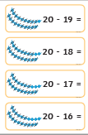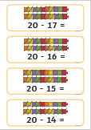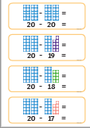  Challenge: Answer the following  30 – 17 = 30 – 6 = 30 – 22 =
Wednesday 24th June
Maths | Lesson 3 - IALT: add and subtract worded problems.  Starter: - Daily count  Count to 20. Count to 50.  Count in 10’s from 30 to 80.  Complete the following: 30 40 ___ ____ _____ ______.  Let’s think??  What do you think worded problem means?  Lesson:  https://whiterosemaths.com/homelearning/year-1/  Activity:  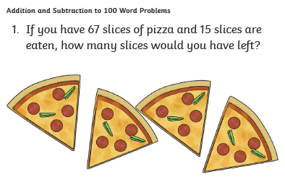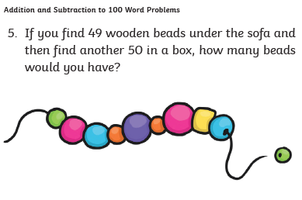  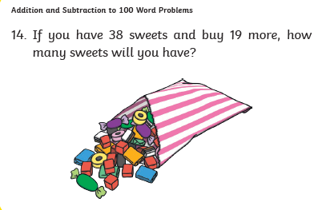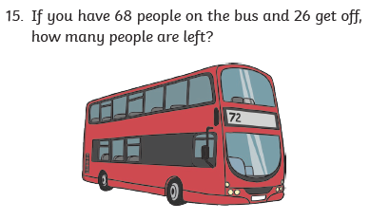

Thursday 25th June
Maths | Lesson 4 - IALT: compare number sentences.  Starter: - Daily count  Count to 50.  Count in 5s from 10 t0 40. Can you write the numbers down?  Is 23 in the 5 timestable?  Let’s think??  What do you think compare on means?  Youtube: https://www.youtube.com/watch?v=fd-Uw-uRGFE  Lesson:  https://whiterosemaths.com/homelearning/year-1/  Activity:  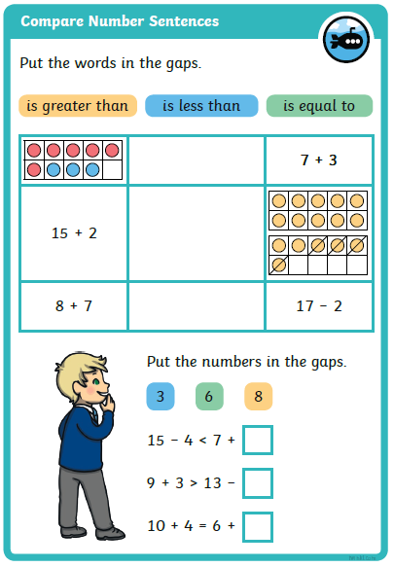

Friday 26th June
Maths | Lesson 5 – CHALLENGE FRIDAY  Starter: - Daily count  Count to 50. Count to 20 in 2’s. Count to 50 in 5’s. Count to 50 in 10’s.  Let’s think??  What have you learnt this week?  What was your favourite maths topic?  Lesson:  https://whiterosemaths.com/homelearning/year-1/  Activity:  https://wrm-13b48.kxcdn.com/wp-content/uploads/2020/05/Family-Challenge-Friday-15th.pdf

