Monday
English | PLEASE TAKE A LOOK AT THIS LINK TO THE BOOK ‘TANGLED’. PERHAPS YOU COULD TRY TO READ ALONG WITH THE STORY.  https://www.youtube.com/watch?v=MZc15_z2pJA  We hope that you enjoy this story about a special young lady who was not able to leave the castle and had to watch the world from a window. Well, we thought this week you could be our very own ‘Lockdown Princes and Princesses’. We hope that  You enjoy your learning and activities this week.  Starter: Correct the spelling and punctuation and copy them into your book.  Shee saw the bootiful woods outside tHE towur.  The ladee wanted to go Two the park.  IALT: ask questions  Today, we are going to try and think of what questions you would like to ask Rapunzel? First, let us remind ourselves of when we use a question mark?  https://www.youtube.com/watch?v=Ww4C71AWDWk  What question words did you hear in that song?  What? Where? Who? When? Why?  Task: Write a question for Rapunzel starting with each of these words.  Example: What did you have for lunch?  Extension: Write a sentence to answer each of your questions. Try to use the conjunction ‘because’ when you can.
Tuesday

Starter: Correct the spelling and punctuation
The magic croun was Golden?
Why did rapunZel feel sad.

IALT: write full sentences.
Today, we are going to practice writing correct sentences about our lockdown princess, Rapunzel. I would like you think about how Rapunzel feels when she is locked away? Do you think she is happy? Do you think she is lonely?

Before we start to write, let us remember the rules for writing sentences:
- Capital letters at the start of a sentence and for the name of a person
or place. ABCDE
- Finger spaces between our words to make it easy to read.
- Full stop at the end of a sentence.

Extension: Can you try using the conjunction ‘because’ in your sentences today.

Example:
Rapunzel was happy because______________________________
Rapunzel felt sad because__________________________________

These words may help you think of ways to describe how Rapunzel feels.

Lonely brave scared happy frightened loved powerful

Wednesday
English | Today, we want you to imagine you are either a ‘Lockdown Princess’ or a ‘Lockdown Prince’.  Starter: Correct the spelling and punctuation.  I live in a HOws wiv my familee  I can see a chree owt of The window  IALT: describe a setting  We want you to think about describing your home which is where you have been spending lots of time in recent weeks  Perhaps you could look out the window and describe what you see? Maybe cars, people, bikes, a tree, a signpost.  Or you can describe where you live. Do you share a room with anybody? Who do you live with?  Your task  - Draw either a room in your house or what you see when you look out of the window.  - Label the picture. What people are in it? What can you see?  Extension: Write sentences to describe what you see when you look out of a window in your home? Use adjectives to make your sentence even better!  We would love to see your work so please email it to Year1@civitasacademy.co.uk

English | THURSDAY  Today, we would like our ‘Lockdown Princes’ and ‘Lockdown Princesses’ to write a letter to Rapunzel.  Starter: What is wrong with these sentences? Write the sentences correctly into your books.  RapunZEl was a bootiful prinsess.  Where did Rapunzel live!  IALT: write a letter to Rapunzel  Your task:  - Draw a picture of things that you have enjoyed doing during lockdown.  - Label the picture and write a sentence to describe your favourite memory from lockdown.  Example: I loved baking cookies with my family.  - Write a letter or a postcard to Rapunzel. Tell her at least 3 things that you have enjoyed doing during the lockdown. Perhaps you could add a picture of one of your favourite activities.  (Templates are on the school website or you can draw this into your book or onto paper)  We would love to see your letters and postcards so please do send them to Year1@civitasacademy.co.uk.  Friday  Each week we will continue to practise learning some words that we may like to use in our writing.  Please choose from Mild, Spicy or Hot words and write them in your book 5 times.  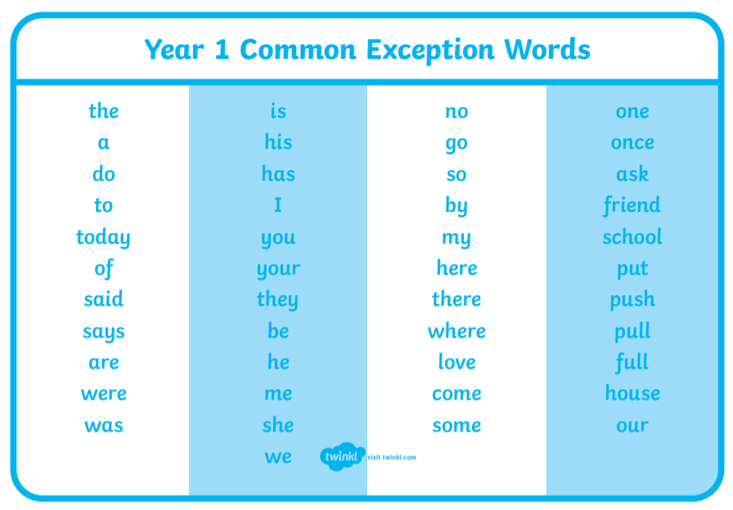  Task:  Mild: Spicy Hot  by ask friend  my they school  are some pull  has come where  Extension: Put each word into a sentence and write this into your book.

