Monday
English | PLEASE TAKE A LOOK AT THE CIVITAS YOUTUBE PAGES TO LISTEN TO MISS ARAM READING JAMES AND THE GIANT PEACH. ENJOY!!  Starter: Correct the spelling and punctuation and copy them into your book.  tHe clowd men were high in the skigH  MONday is the thirst day of the wik.  IALT: use WOW words in sentences  Today, we are going to try and think of some exciting WOW words that we can use to make our sentences even better.  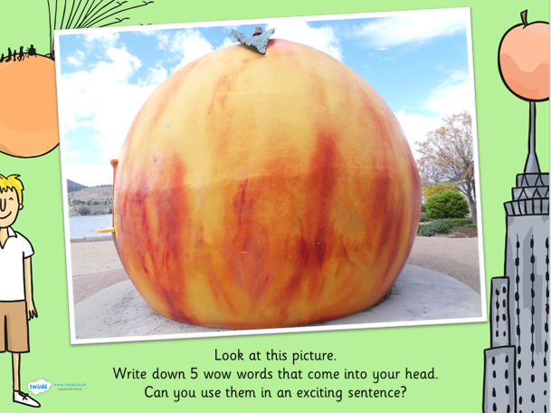  What words did you think of? Perhaps you thought of words such as:  Gigantic enormous  Task: Write a sentence using each of the 5 words that you wrote down to describe the picture.  Example: The gigantic peach was taller than a tree.  Extension: Use a simile in your sentence.  Example: The gigantic peach was as big as a tree.
English | Tuesday  Starter: Correct the spelling and punctuation.  jamEs sat on the joocee peech and looked at the see.  The Ladeeburd was very cind to jamEs.  IALT: Comprehension  As we start to come to the end of our story, we thought it would be fun to have a little quiz about the book.  Please write your answer in full sentences (Remember capital letters, finger spaces and full stops)  - What was the little boy’s name?  - What were his Aunties called?  - Which Auntie was tall and thin?  - Which creatures attacked the peach when it landed in the sea?  - What happens to the Earthworm when he arrives in New York?  Extension: Write down one interesting fact about your favourite characters in the book.  Example: James wrote a book about his adventures with the Giant Peach.

Wednesday
English | Starter: Correct the spelling and punctuation.  The giant peech landed in Noo Yorc  The peech landed on a big Toll building?  IALT: write a book review  As we come to the end of the story, we would like to find out whether you enjoyed the book and want you to write a book review.  Task: To write a Book Review  You can print out the copy of a book review that we have uploaded to our website or you can create your own. Please include the following information:  What did you like about the book?  I enjoyed ……………………..  Who was your favourite character?  My favourite character was the …………………  Where was the story set?  The story was set………………..  Would you recommend the story? Why?  I would recommend the story because………………………  We would love to see your book reviews so please email them to Year1@civitasacademy.co.uk

Thursday
English | Starter: What is wrong with these sentences? Write the sentences correctly into your books.  tHe boy had bloo shoos.  I ate some taste jellee yesterday.  IALT: Spell words correctly.  Each week we will continue to practise learning some words that we may like to use in our writing.  Please choose from Mild, Spicy or Hot words and write them in your book 5 times.  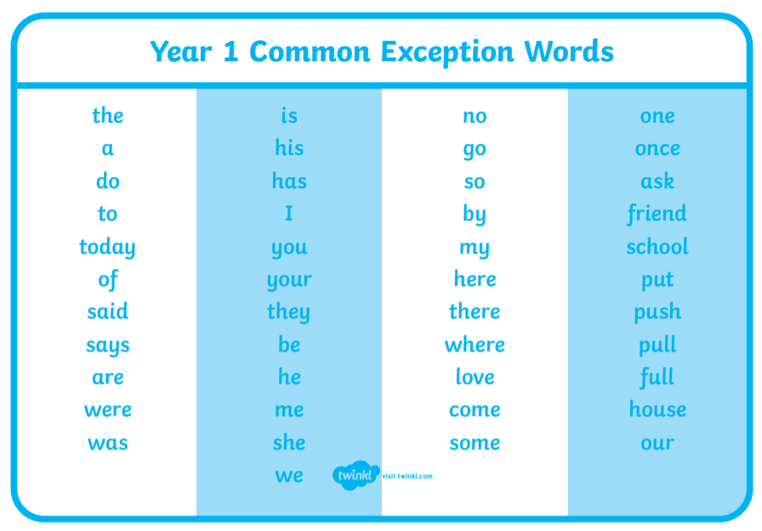  Task:  Mild: Spicy Hot  so was there  by once some  he ask come  she put house  Extension: Put each word into a sentence and write this into your book.

