MATHS

WOW
WORK!!!
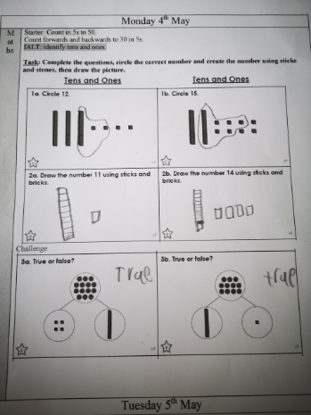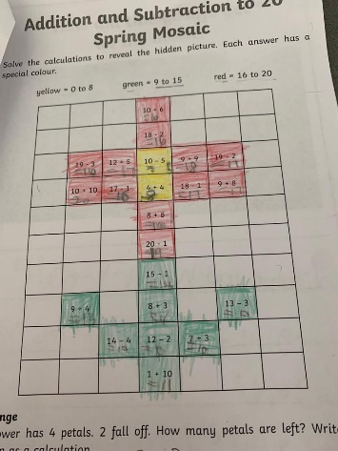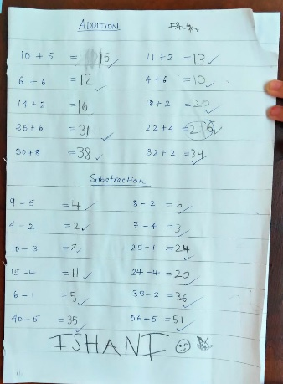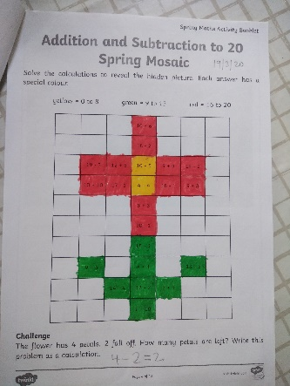
Amelia Aadhya Ishani Malav

Thank you so much for sharing your work. Please send things you would like to share to: year1@civitasacademy.co.uk
WRITING

WOW
WORK!!!
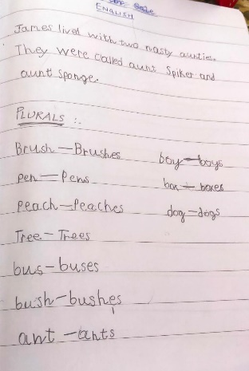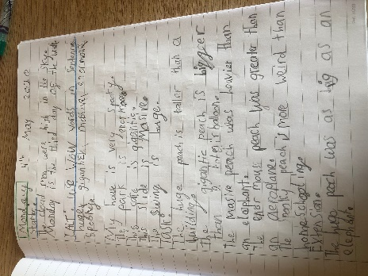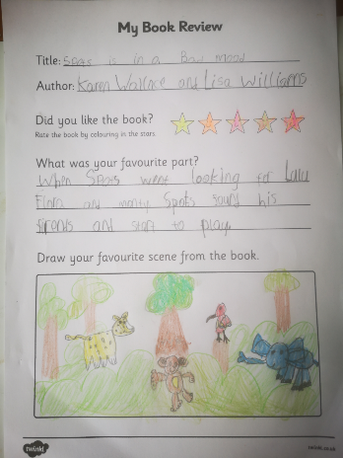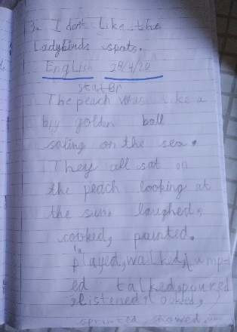
Ishani Latifa Amelia Malav

Thank you so much for sharing your work. Please send things you would like to share to: year1@civitasacademy.co.uk
TOPIC

WOW
WORK!!!
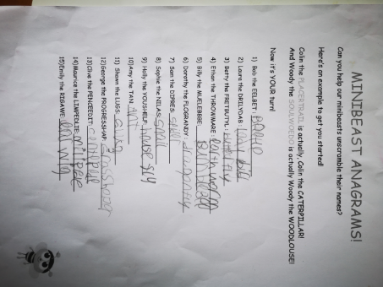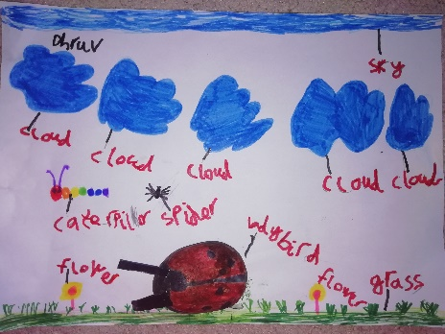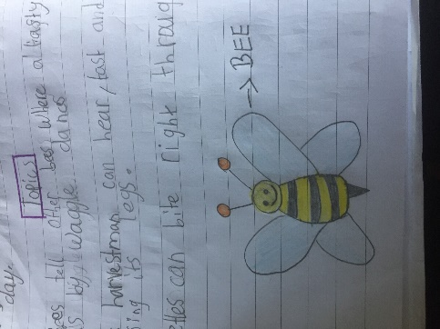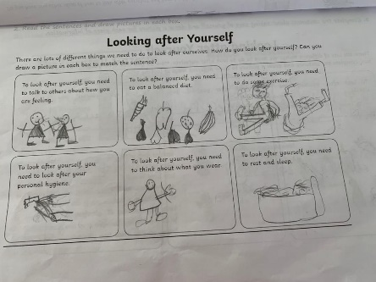
Amelia Dhruv Latifa Aadhya

Thank you so much for sharing your work. Please send things you would like to share to: year1@civitasacademy.co.uk
HOME

WOW
WORK!!!
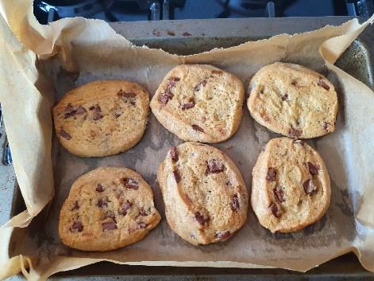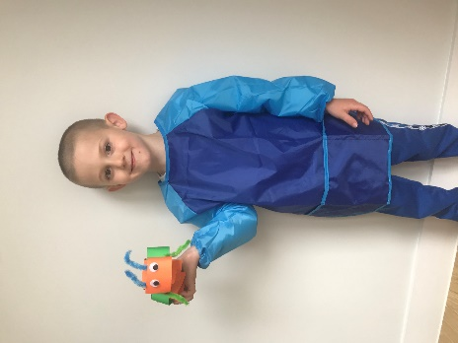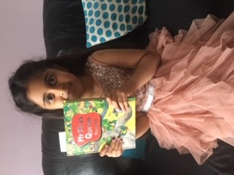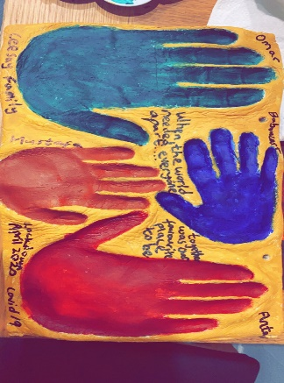
Sienna: Fabio: Arfa: Baboucarr &Moustafa
baking crafting reading Art and crafts

Thank you so much for sharing your work. Please send things you would like to share to: year1@civitasacademy.co.uk
ART

WOW
WORK!!!
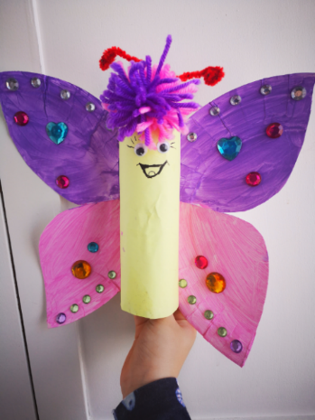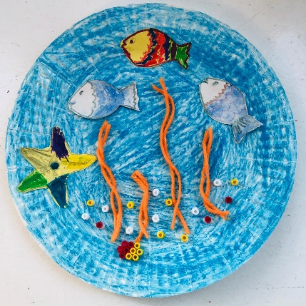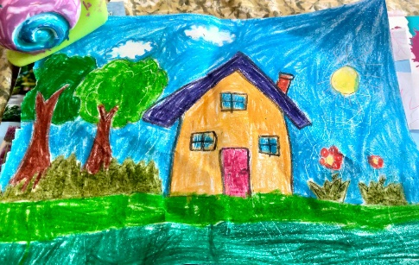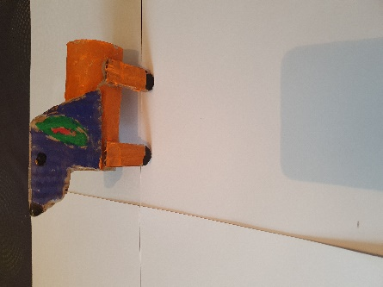
Amelia Varun Ishani Sandra

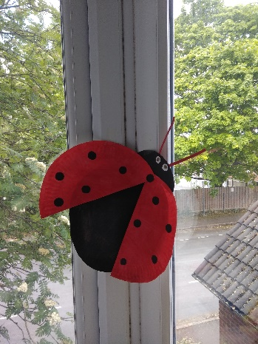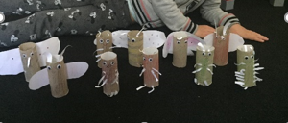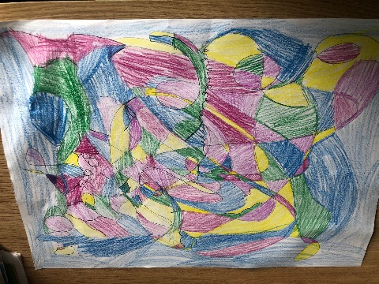
Malav Latifa Latifa

Thank you so much for sharing your work. Please send things you would like to share to: year1@civitasacademy.co.uk

