Monday
English | PLEASE TAKE A LOOK AT THE CIVITAS YOUTUBE PAGES TO LISTEN TO MISS ARAM READING JAMES AND THE GIANT PEACH. ENJOY!!  Starter: Correct the spelling and punctuation and copy them into your book.  tHe ladeeburd had lotsov spotes?  The foxs had bushee tailes.  Clue: Remember the plurals rule from last week!!!  IALT: use the suffix -ed .  What do we mean by past tense?  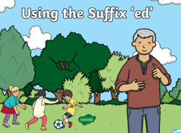  What is a suffix?  What suffix do we add to the end of a word when something has happened in the past?  Task: Write the past form for each of these words and put them into a sentence:  walk, talk, paint, play, wash  Josh walked to the park.  Extension: There are exceptions to the rule and some words change in different ways. Write the past tense for each of these words and put them into a sentence:  Swim eat run
English | Tuesday  Starter: Correct the spelling and punctuation.  tHe peech was likea Big goldenbAll sailing on the See.  They all Sat on tHe peech looking at the sUn?  IALT: use the suffix -ed  When do we add the suffix -ed to a word?  Enjoy this clip: https://www.youtube.com/watch?v=jxl28KQOHy4&list=RDQMN1McOihtoHM&start_radio=1  Change these words to the past tense: laugh cook paint  Task: Add the correct suffix to each of these words to make them past tense:  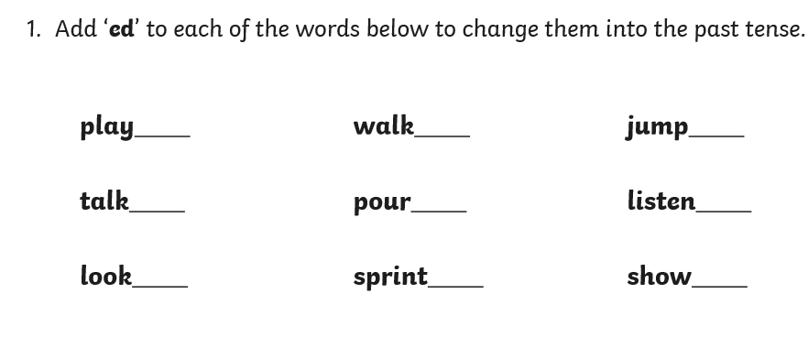  Extension: Find the errors in the text and write the passage correctly into your books.  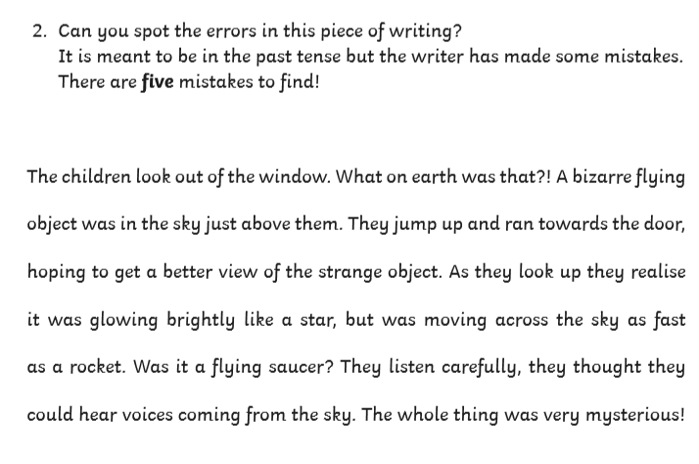

Wednesday
English | Starter: Correct the spelling and punctuation.  The boy walk to the park This morning?  The grasshopper paint a picture yesterDAy.  Clue: Remember to use -ed suffix  IALT: use time conjunctions  What is a time conjunction nor time adverbial? When do we use them?  Enjoy this clip: https://www.youtube.com/watch?v=OKhhElgZHAE  They help to put events in order and to make our writing make sense.  We are going to start planning how to write a diary entry today. We want you to think about the order that you do things during a day. Let us think about what a diary entry is. Watch this clip:  https://www.youtube.com/watch?v=RdfFL8UzR2U  Wow! So many things to think of. We want you to focus on these 2:  Time conjunctions: First, then, next, later, after, finally…  Past tense: writing actions that have happened in the past tense – adding the suffix -ed when needed.  Task:  My day  Please choose a day to write a diary entry about. This could be a special day that you would like to tell us about or it could be a typical day at home.  Remember to use Capital letters, finger spaces and full stops!!!  Example:  First, I woke up and got dressed and ate some breakfast. Then I went to the park with my family.  Extension: Try to write a sentence that you could use an exclamation mark in.

Thursday
English | Starter: Correct the spelling and punctuation.  The eARthwurm stood on his tayl and jumped wiv jOy.  The BottoM of the peech toucht the worta.  INDEPENDENT WRITE  Today, it is your turn to write independently. You will have 2 choices.  - You can write a diary entry for yourself (use your work from yesterday to help you)  - Pretend to be James and write a diary entry about the day you entered the peach and discovered the amazing creatures  Remember to include:  Capital letters: ABC  Finger spaces:  Punctuation: . ? !  Past tense: -ed  Time conjunctions: First, then, next, after, finally.  Alternative activity: You may prefer to draw a picture for 3 things you do throughout the day and write a sentence about each picture.  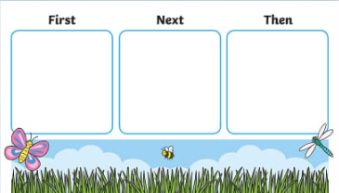  Extension: Make sure that you have used the correct ending for any plurals that may appear in your sentences.

Friday
English | Starter: What is wrong with these sentences? Write the sentences correctly into your books.  tHe boy had bloo shoos.  I ate some taste jellee yesterday.  IALT: Spell words correctly.  Each week we will continue to practise learning some words that we may like to use in our writing.  Please choose from Mild, Spicy or Hot words and write them in your book 5 times.  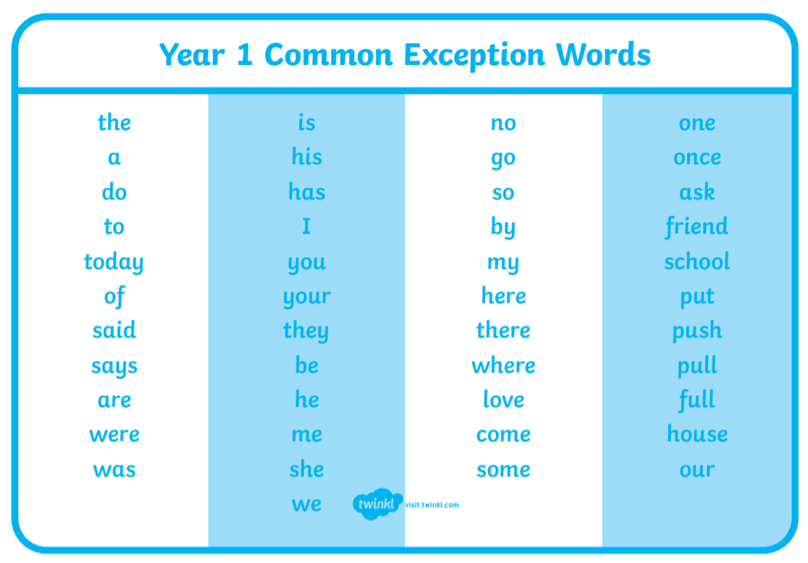  Task:  Mild: Spicy Hot  no here once  go your ask  my you friend  do are school  Extension: Put each word into a sentence and write this into your book.

