English | MONDAY  PLEASE TAKE A LOOK AT THIS LINK TO THE BOOK ‘SUPERTATO’. PERHAPS YOU COULD TRY TO READ ALONG WITH THE STORY.  https://www.youtube.com/watch?v=QlaMeNmTG6c  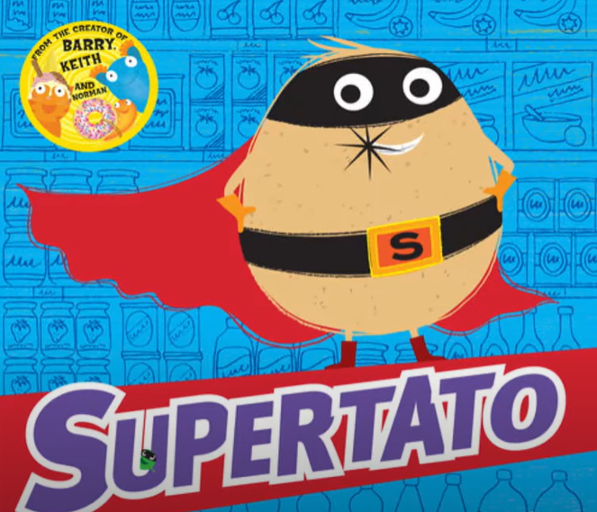  We hope that you enjoyed the story. This term our topic is Superheroes. We will be looking at fictional and real superheroes. What does fiction mean? Can you think of any real superheroes?  Starter: Write the date correctly into your book – Check Capital Letters. ABC  Monday 1st June 2020  IALT: answer questions about a story.  Today, we are going to try and answer some questions about the story?  We will try to answer questions that use these words into your book.  What? Where? Who? When? Why?  Task: Write the answer to each of these questions in your book?:  - What did the Evil Pea do to the broccoli?  - Where did the story take place?  - Who is the villain in the story?  - Why did the jelly taste of pea?  Extension: Make up some questions about the story using these words: How, why, when, where and what?
TUESDAY

Starter: Write the date in your book.
Tuesday 2nd June 2020
(Remember to use capital letters for days of the week and months of the year)

IALT: use adjectives
Today, we are going to think about words we can use to describe villains and superheroes. What do we call words that we use to describe things? That’s right
they are called ‘adjectives’.
Firstly, what is a villain? What is a superhero?

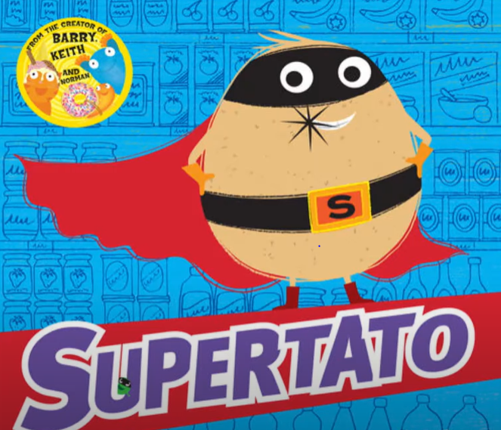

Task:
Draw a line down the middle of a page and write the title Villains at the top of one half and Superheroes on the other. Write as many ‘adjectives’ as you can think
Of to describe superheroes and villains.

Example:
Villain | Superhero
mean | helpful
nasty | brave
unkind | kind

Extension: Think of adjective that have the prefix ‘un’.
Example: Unkind.

WEDNESDAY
English | Today, we are going to create a WANTED poster for the Evil Pea.  Starter: Write the date correctly.  Wednesday 3rd June 2020.  IALT: use adjectives  What words do we call words that describe things? Yes, that is right, they are  called adjectives. Enjoy this song that we have sang many times in class:  https://www.youtube.com/watch?v=3JZi2oDvPs4  How would you describe the Evil Pea? Would you use any of these words:  unkind small kind mean greedy evil brave nasty  Your task 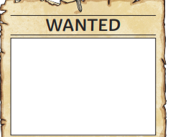  - Create a Wanted Poster for the Evil Pea (You can use the template on our website or draw this onto paper or into your book.  - Label the picture – use adjectives if you can!!  Extension: Write sentences to describe the Highway Rat.  We would love to see your work so please email it to Year1@civitasacademy.co.uk

THURSDAY
Today, we are going to use speech bubbles to frame the words that the characters in the story are saying.

Starter: Write the date correctly:
Thursday 4th June 2020.
IALT: use speech bubbles
When we use speech bubbles, we only put the words that are being spoken into the bubble.
HELP!!
Example:
MY NAME IS MRS CAREY

Your task:
- Look at each of these pictures.
- What do you think each character may say?
- Draw a speech bubble in your book.
- Write the words that the character may say in each speech bubble.

Example:

- 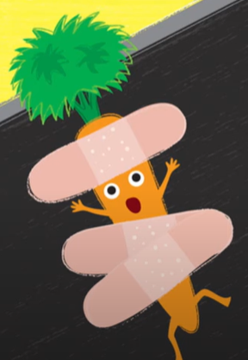
HELP!

- 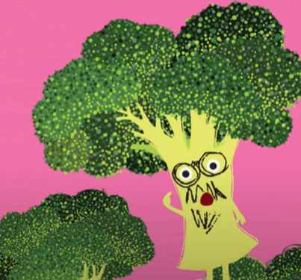 4)

- 5) 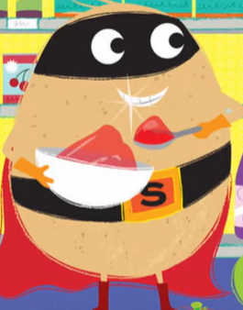

English | FRIDAY  Each week we will continue to practise learning some words that we may like to use in our writing.  Please choose from Mild, Spicy or Hot words and write them in your book 5 times.  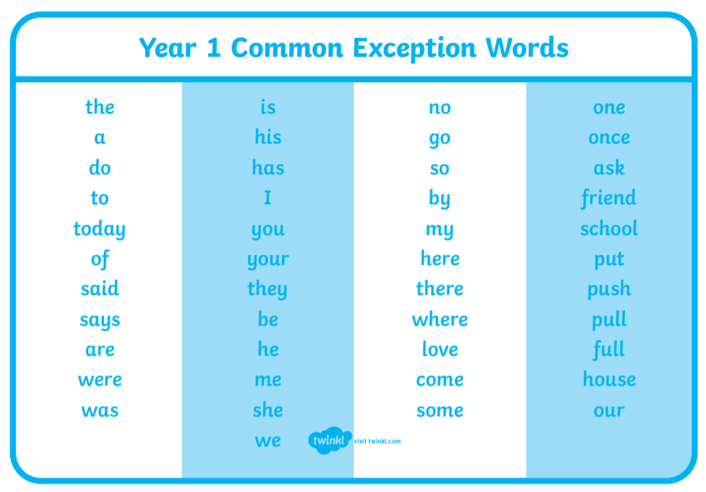  Task:  Mild: Spicy Hot  the your there  and were friend  was push house  is they come  Extension: Put each word into a sentence and write this into your book.

