MENTAL HEALTH WEEK
18 – 22 MAY 2020

Kindness Matters
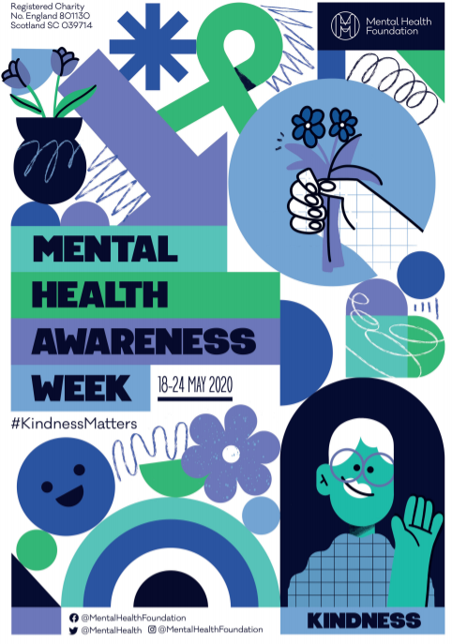

TOPIC | This is Mental Health Awareness Week.  This year, the theme is: Kindness Matters  We talk a lot about kindness in class. Tell your family what it means to be kind. Let’s think of ways that we can be kind to ourselves and to others.  Maybe you can say something kind to somebody or you can help somebody at home. Maybe you can ask somebody to play with you or you could draw a picture for somebody.  It is very important that we look after our mental health. Just like our body needs good food, exercise and sleep to be healthy, we also need to make sure we look after our mental health. This is when we think about how we feel.  How do you feel when you are kind to somebody or they are kind to you?  Kindness Passport Challenge  As this is Mental Health Week, we are going to be focussing on this all week. We have created a very special Kindness Passport for you to work through. Please add your name to the passport and start to fill it out each time you do a kind deed this week.  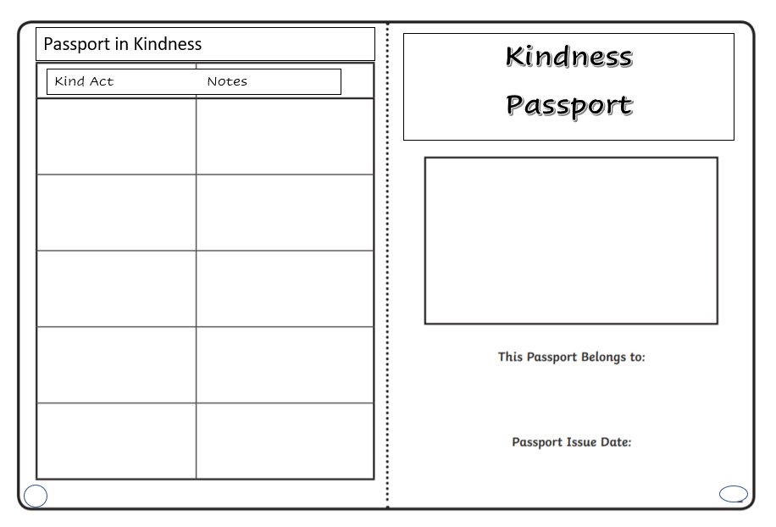  Try to put a kind activity into each box and either draw or write a few words to describe what you did.  To help you with this kindness challenge, we have collected lots of resources and ideas to share with you and these are available on our website.  You will find kindess calendars which have lots of lovely ideas of ways you can be kind to yourself and other people on our website together with lots of other ideas showing acts of kindness.  Perhaps you could try to add one kind deed from each of the following areas:  - Kindness to your family  - Kindness to yourself  - Kindness to your community  - Kindess to the planet  We would love to see what kind acts you choose to do so please email your kind acts to Year1@civitasacademy.co.uk  Here are some examples of things you may like to do:  - Write a postcard to somebody who is in isolation or on their own.  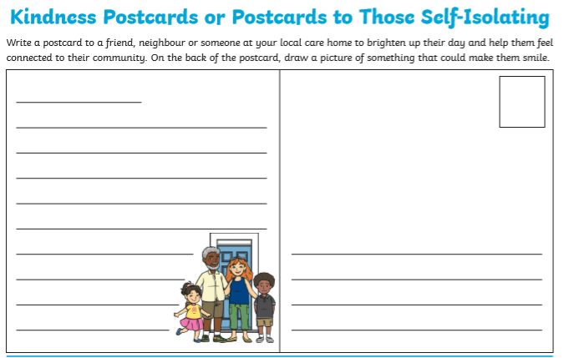  - Smile and say thank you to somebody.  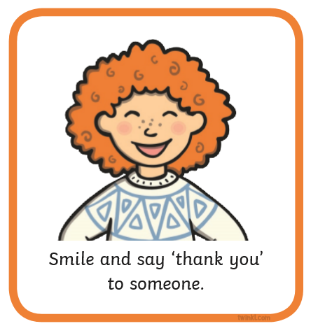  - Help your family to prepare a meal.  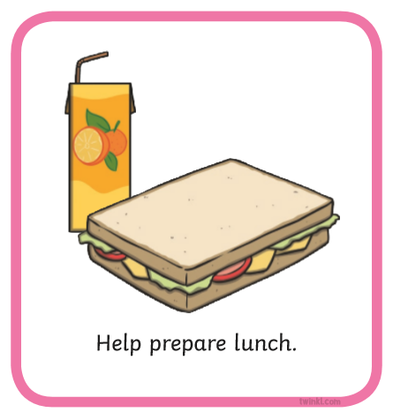  Challenge:  Design your own poster about Kindness.  How can we be kind?  How does it feel to be kind to somebody?

