TOPIC | Monday 4th May 2020  Monday and Tuesday – ART FOCUS  IALT create minibeast art  We are finishing our topic of minibeasts this week and as we have so many talented artists in Year 1 we thought it would be a good idea to celebrate the end of the topic with an Art Exhibition. Mrs Jain has very kindly collected a few ideas of minibeast crafts that you may enjoy making. You can choose any activities that you would like to do or perhaps you would like to make your own creation using things that you can find at home.  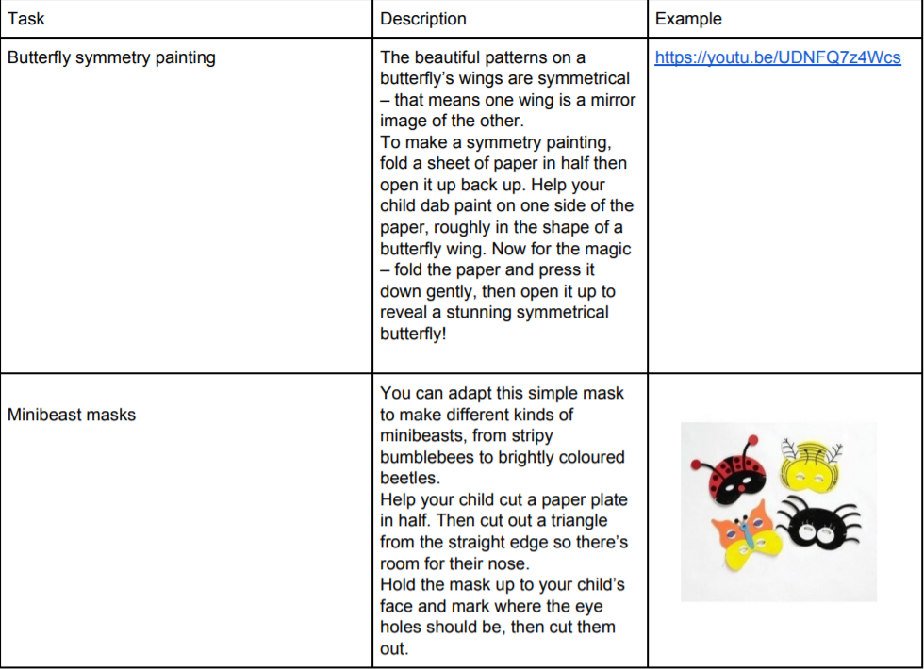  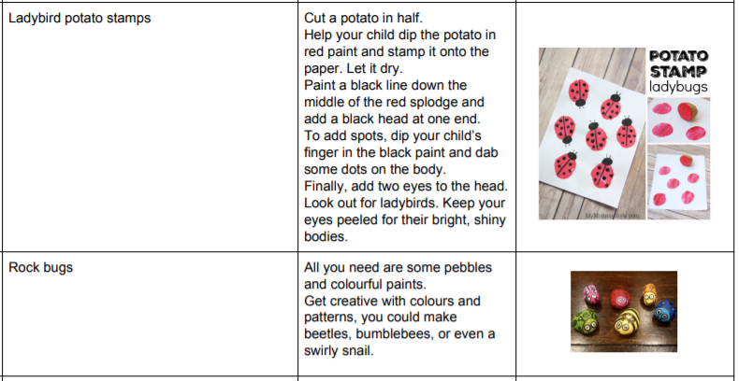  Please do take a photo of anything that you want to share with your  friends on our website and email it to: Year1@civitasacademy.co.uk

TOPIC | Tuesday 5th May  ART FOCUS – Pets  Today, we will continue our Art Focus by inviting you to choose any of these pet craft activities to complete. Again, if you would prefer to use things at home to create your own animal, that would be wonderful.  We can’t wait to see what creations you have made yesterday or today  and will post as many as we can on our website next week. Enjoy!  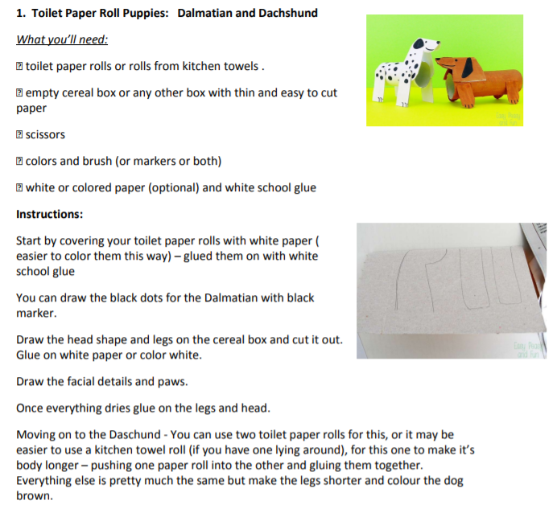  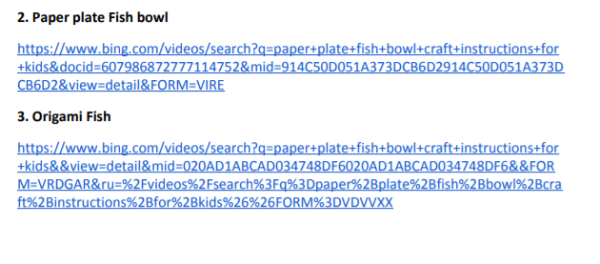  A special thanks to Mrs Jain for finding all of these fabulous creative activities for you to enjoy.

Wednesday
TOPIC | RE: Ramadan  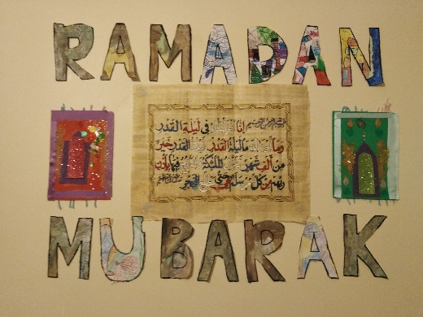  Some of your families will be fasting now as people of the Muslim faith have entered the special time of Ramadan. Here is a video which  explains what Ramadan means to Muslim people.  https://www.bbc.co.uk/bitesize/topics/zpdtsbk/articles/zjc2bdm  We would like to thank Aamina in Gruffalo Class for sharing the beautiful artwork that she created (pictures above). We always love to see what you are doing at home, so please do send in any of your work or things you have at home related to Ramadan.  As we have an art focus this week, we have selected some art activities  for you (documents on school website)  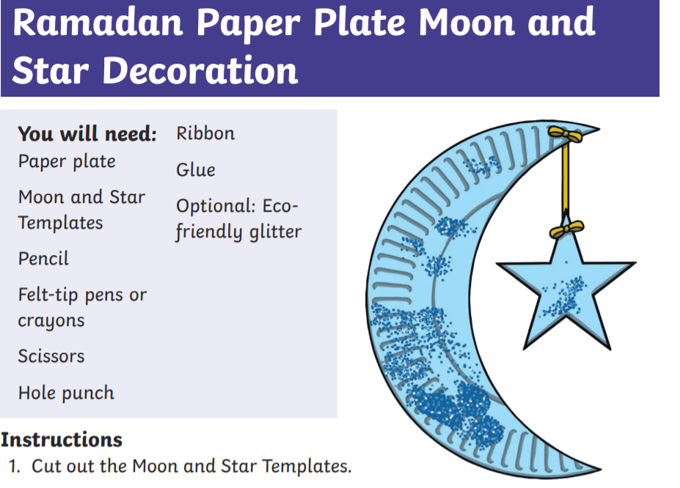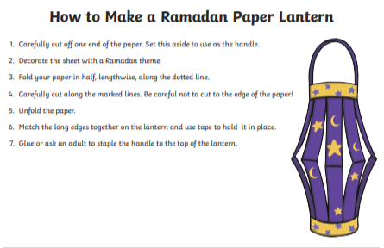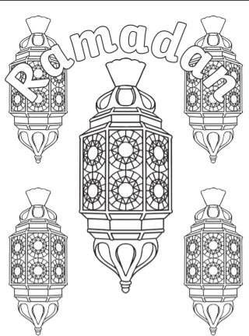

TOPIC | Thursday  RE: Ramadan  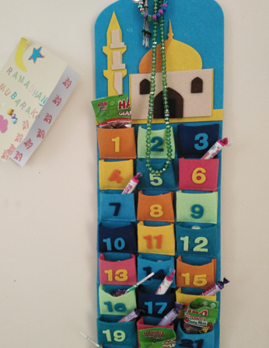  IALT: understand the significance of Ramadan to Muslim people.  Thank you again to Aamina for sending in this photo of a stunning calendar her family are using to countdown through Ramadan until  they reach the special celebration of Eid later this month.  We have uploaded a PP that gives you more information about Ramadan and has questions to discuss with your family as you read through each slide. Why is Ramadan an important time for Muslim people?  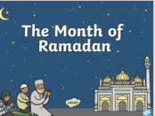  Task: Today, you can create your own Ramadan calendar – how would you decorate each number? What things can you find to use at home?  Try our online quiz to see how much you have learned about Ramadan  https://kahoot.it/challenge/01397826?challenge-id=04c68f2b-9824-467d-9ef9-49ef696c268c_1588177275292

