PHONICS Week 5
Monday 18th May IALT: recap phase 5 sounds and tricky sounds
Task: How many phase 5 sounds and tricky words can you remember!
Make a list then watch a video or check your phonics mats to see how many you remembered!

Tuesday 19th May IALT: blend words
Task: Get a book, look for diagraphs and trigraphs. How many can you find. Read the book out loud to your family.
Tell your family What is a triagraph? What is a diagraph? and What is a phoneme?
Challenge: Complete the game one phonics play.
https://www.phonicsplay.co.uk/SentSubPhase5a.html
Did you improve your score from last week?

Wednesday 20th May IALT: Phase 5 oe and au.
Task: Circle the sound oe and au. Write the sound 3 times. Can you put the sounds in a word?
Challenge: Put your word in a sentence?
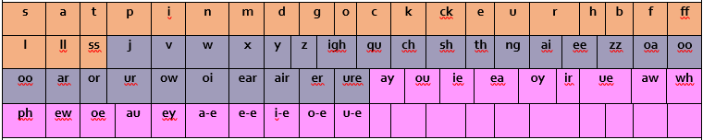

Thursday 21st May IALT: real or alien word.
Task: Play a different game this week and see if you can get all the alien words.
https://www.phonicsplay.co.uk/Phase5Menu.htm
Challenge: What is another word for an alien word?
Friday 22nd May IALT: sound of the day ey.
Task: Your sound of the day is ey, What words have the ey diagraph?
Can you find a youtube video/song with the digraph ey?
Challenge: Can you make up your own song with the diagraph ey.

Happy Half Term!

