PHONICS Week 4
Monday 11th May IALT: recap phase 5 tricky sounds
Task: How many phase 5 tricky sounds can you remember!
Make a list then watch the video. How many did you miss?
https://www.youtube.com/watch?v=DbcZnb2iz1c
Challenge: Play a game of buried treasure on phonics play.
https://www.phonicsplay.co.uk/BuriedTreasure2.html

Tuesday 12th May IALT: blend words
Task: Get a book, look for diagraphs and trigraphs. How many can you find. Read the book out loud to your family.
What is a triagraph?
What is a diagraph?
What is a phoneme?
Challenge: Complete the game one phonics play.
https://www.phonicsplay.co.uk/SentSubPhase5a.html

Wednesday 13th May IALT: Phase 5 Wh and Ph.
Task: Circle the sound Wh and Ph. Write the sound 3 times. Can you put the sounds in a word?
Challenge: Put your word in a sentence?
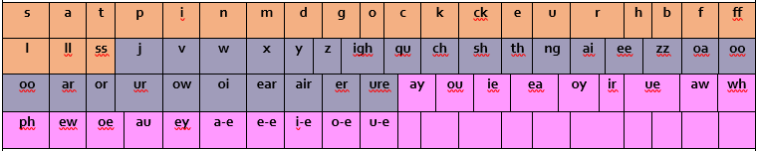

Thursday 14th May IALT: real or alien word.
Task: Play a different game this week and see if you can get all the sounds.
https://www.phonicsplay.co.uk/Phase5Menu.htm

Friday 15th May IALT: sound of the day ew.
Task: Your sound of the day is ew, What words have the ew diagraph?
Can you find a youtube video/song with the digraph ew?
Challenge: Can you make up your own song with ew sounds.

