PHONICS Week 3
Monday 4th May IALT: recap phase 5 sounds
Task: How many phase 5 sound can you remember!
Play a game of buried treasure on phonics play.
https://www.phonicsplay.co.uk/BuriedTreasure2.html

Tuesday 5th May IALT: Tricky words
Task: How many phase 5 tricky words do you know? Make a list before watching the video!
https://www.youtube.com/watch?v=WeIbtzh-ALM
Which words did you miss?

Wednesday 6th May IALT: Phase 5 ir and us.
Task: Circle the sound ir and ue. Write the sound 3 times. Can you put the sounds in a word?
Challenge: Put your word in a sentence?
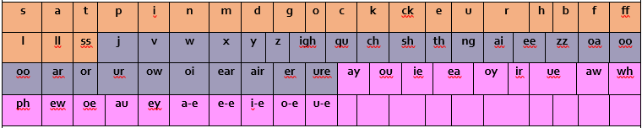

Thursday 7th May IALT: real or alien word.
Task: Play a different game this week and see if you can get all the sounds.
https://www.phonicsplay.co.uk/Phase5Menu.htm

Friday 8th May IALT: sound of the day au.
Task: Your sound of the day is oy, What words have the au diagraph?
Can you find a youtube video with the digraph au?
Challenge: Answer the following questions.
What is a triagraph?
What is a diagraph?
What is a phoneme?

