PHONICS Week 2
Monday 27th April IALT: recap phase 5 sounds
Task: How many phase 5 sound can you find in your bedroom. Can you make a list and draw the picture of the word?

Tuesday 28th April IALT: Tricky words
Task: How many phase 5 tricky words do you know? Make a list before watching the video!
https://www.youtube.com/watch?v=WeIbtzh-ALM
Which words did you miss?
Wednesday 29th April IALT: Phase 5 ea
Task: Circle the sound ea. Write the sound 3 times. Can you put the sound in a word?
Challenge: Put your word in a sentence?
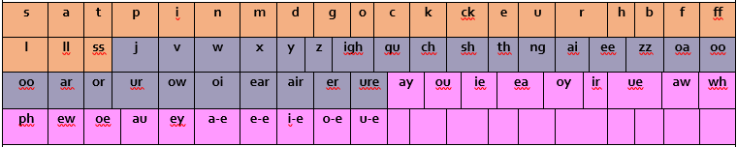

Thursday 30th April IALT: real or alien word.
Task: How many points can you get on the game! See if you can beat your adults score.
https://www.phonicsplay.co.uk/Phase5Menu.htm
Friday 1st May IALT: sound of the day oy.
Task: Your sound of the day is oy, What words have the oy diagraph?
Can you find a youtube video with the digraph oy?
Challenge: Answer the following questions.
What is a triagraph?
What is a diagraph?
What is a phoneme?

