PHONICS Week 1
Monday 20th April IALT: recap phase 5 sounds
Task: How many phase 5 sound can you find around your house. Can you make a list and write some down?

Tuesday 21st April IALT: Tricky words
Task: Can you draw a picture of the tricky word people. Now can you write the word? Finally, can you write it in a sentence?

Wednesday 23rd April IALT: Phase 5 ay
Task: Circle the sound. Write the sound 3 times. Can you put the sound in a word?
Challenge: Put your word in a sentence?
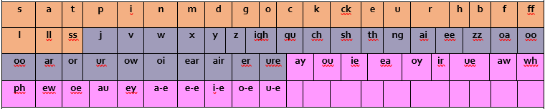

Thursday 24th April IALT: Sound of the day ou, tricky word Oh.
Task: Watch this video and count how many ou sounds you hear.
https://www.youtube.com/watch?v=I6_Twpffldk
Challenge: Put our tricky word in a sentence.

Friday 25th April IALT: add one more and one less.
Task: Your sound of the day is ie, What words have the ie diagraph?
Challenge: Answer the following questions.
What is a triagraph?
What is a diagraph?
What is a phoneme?

