WEEK 4 HOME LEARNING
TOPIC | MONDAY  Monday and Tuesday: We are going to the Zoo  Wednesday: P.E  Thursday: Den Challenge  Friday: Friendship bunting  IALT: find out interesting facts about animals at the zoo.  Today, we are off on a virtual trip to the Zoo. Marwell Zoo offers a virtual tour which means that even though we cannot go to the zoo, we can still see the amazing animals that live at the zoo. Make sure you bring a drink and maybe a snack to enjoy on your adventure. Have fun!  https://www.marwell.org.uk/zoo/explore/whats-at-marwell-zoo  Wow! That was amazing!. What animals did you see? Can you describe them?  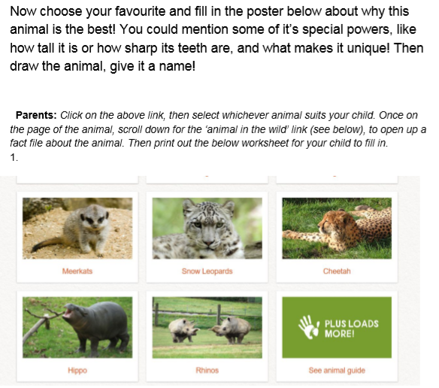  We can’t wait to see what posters you have created. Please send them to Year1@civitasacademy.co.uk
Tuesday 12th May
TOPIC | We thought that we would take another visit to the zoo. Can you remember what animals you saw yesterday?  Let us see if we can find out fun facts about new animals today.  https://www.marwell.org.uk/zoo/explore/whats-at-marwell-zoo  IALT: write facts about animals.  What animals did you look at today? Can you remember any interesting facts.  Task:  - Choose an animal you would like to read about on the zoo website.  - Pick some interesting facts you will include in your fact file.  - Add a sentence about why you like this animal.  Example: A giraffe has a long neck because it eats leaves from trees.  We would love to see your fact files. Please send them to year1@civitasacademy.co.uk
Wednesday
TOPIC |  | PE – Follow our PE challenges.  Civitasacademy.co.uk – Class pages, P.E.  YOUTUBE – JOE WICKS P.E LESSONS

Thursday
TOPIC | IALT: design a den  Today, we would like you to design a den in your home. What materials could you find to use? Maybe a sheet or towel? Some chairs or a table to use as walls. Perhaps you could use cushions to make it comfortable.  Remember to get creative!!  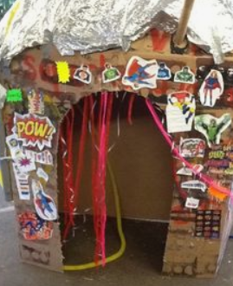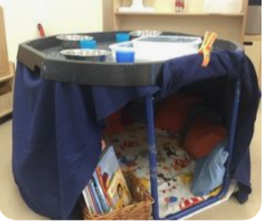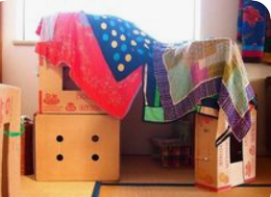  Extention: Can you draw a picture of your den and label all the different resources and materials that you used?  Remember to take a picture and email us your magical dens!

Friday 15th May
Topic | PSHE  Home Learning Diary  We love to hear about the things you have been enjoying with your family at home.  This week, we thought it would be a good idea for you to add another diary entry to your Home Learning Diary (you can put this on paper or in your home learning book).  What things have you enjoyed doing this week? Have you learnt anything new?  