Monday
TOPIC | Monday, Tuesday and Thursday:  IALT create a mini-beast song and dance.  Wednesday: P.E  Friday: PSHE  IALT: learn minibeast songs.  Task:  - Look on Youtube and see if you can find 3 songs about mini-beasts? Which was your favourite and why? Maybe you could try singing along to the songs.  - Do you know any of these songs?  The ants go marching …  https://www.youtube.com/watch?v=Pjw2A3QU8Qg&list=PLyitPFkxk2OV6mY_vDsa9KTq5Is92isEl  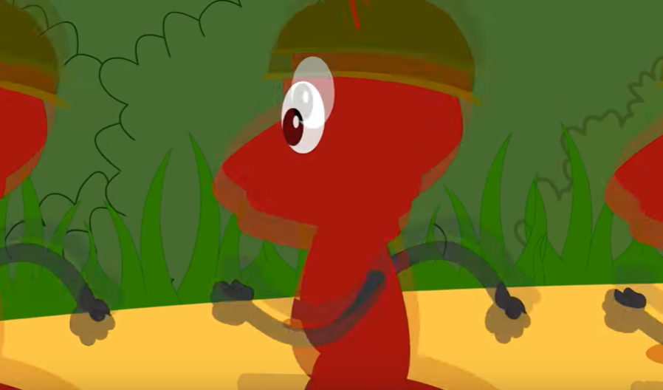  https://www.youtube.com/watch?v=RPAZHVNVJp0&list=PLyitPFkxk2OV6mY_vDsa9KTq5Is92isEl&index=4  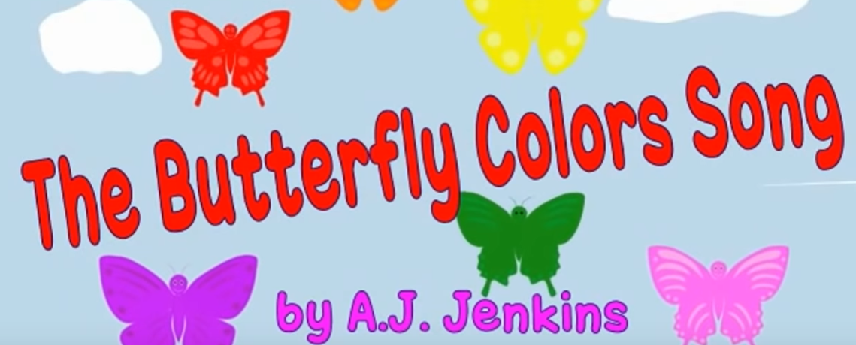  https://www.youtube.com/watch?v=1MxjGNA1igE&list=PLyitPFkxk2OV6mY_vDsa9KTq5Is92isEl&index=7  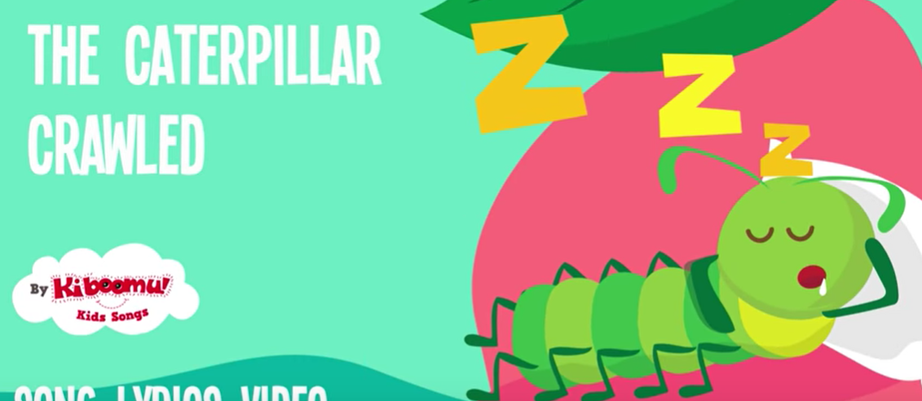
Tuesday
TOPIC | IALT: learn minibeast songs.  Have another listen to the songs from yesterday.  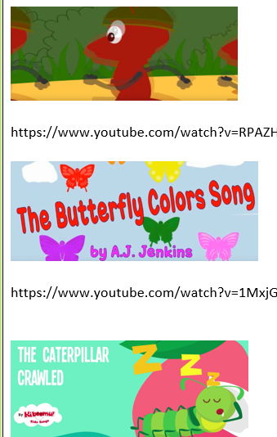  Task:  - Re-watch the mini-beast song you liked the best. Listen for the rhythm in each song. Clap along to the rhythm.  - Can you find anything else in your house to make music with?  Mrs Aram’s challenge: Fill an empty plastic bottle with some rice or dried beans and use this to join in with the songs about minibeasts. Keep to the rhythm!

Wednesday
TOPIC | PE – Follow our PE challenges.  Civitasacademy.co.uk – Class pages, P.E.  YOUTUBE – JOE WICKS P.E LESSONS

Thursday
TOPIC | IALT: learn minibeast songs  Task:  Practise joining in with the minibeast songs that you have been learning. Use the shaker you made or clap along.  Now, we want you to think about how the minibeasts would move and use this to help create a dance to go with one of the songs.  How would a worm move?  How would an ant dance?  Perform your dance and song to your family. Smile and enjoy!!

Friday
Topic | PSHE  Healthy Me!  What things can we do to keep healthy? Tell somebody at home how you can keep healthy. Why is it important to be healthy?  Visit this website to remind you of things we have discussed in class  https://www.bbc.co.uk/bitesize/topics/zchhvcw/resources/1  Task: Today we want you to show off what you have learnt about keeping healthy by designing a cover for a book called ‘Healthy Me’.  What could you include in your book cover?  Draw this into your Home Learning Book and write sentences about what we need to do to keep healthy!  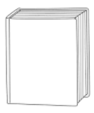  drink, exercise, medicine, keeping clea  Food, 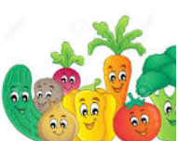 Drink, 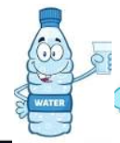 exercise 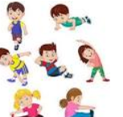  We can’t wait to see your designs!!!!  Keep healthy!!!

