Monday
Maths | Starter: Count in 2s to 30.  Count forwards and backwards to 30 in 2s.  What number comes next?  2 4 ___ 8 ______ 12  IALT: understand 10s and ones.  Task: We have looked at tens and ones in class, can you complete the work sheet? What can you use to help you?  Mrs Aram’s challenge: Would a ruler be better to use than a dice? Why?  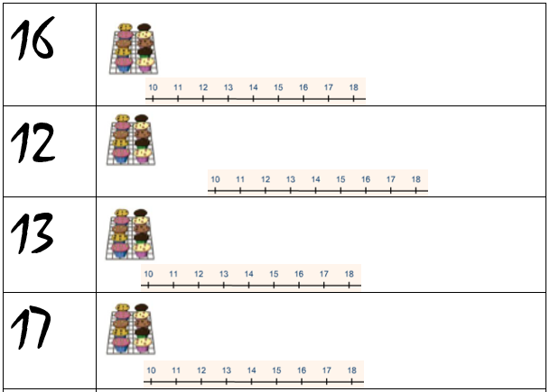
Tuesday
Maths | Starter: Count in 5s to 50.  Count forwards and backwards to 50 in 5s.  What number comes next?  15 20 ___ 30 ______ 40  IALT: add 1 more and subtract 1 less.  What does more mean? What does less mean?  Task: Over this week we will be adding one more and one less. Can you complete the work sheet? What can you use to help you?  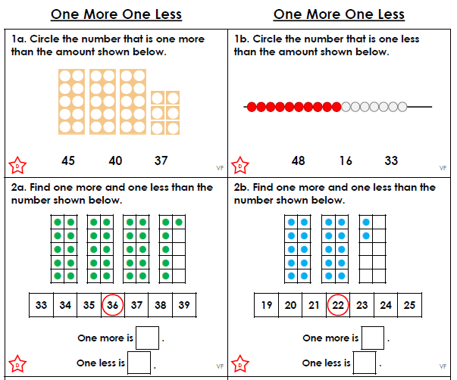  Mrs Aram’s challenge: Can you create your own question?

Wednesday
Maths | Starter: Count in 5s.  Count in 5s from 25.  Complete the following:  25 30 ___ 40 ______ 50  IALT: add one more and subtract one less  Over this week we will be adding one more and one less. Can you complete the work sheet? What do you notice about the questions?  Task:  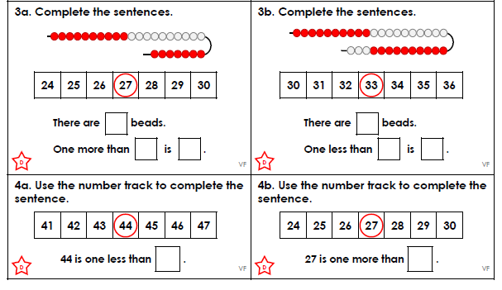  Extension: What is one more than / one less than these numbers?  44 19 38 22 49 1

Thursday
Maths | Starter: Count in 2s.  Count in 2s from 14.  Complete the following:  20 22 ___ 26 ______ 30  IALT: add one more/subtract one less  Task:  Over this week we will be adding one more and one less. Can you complete the work sheet? Can you explain why the questions are correct or incorrect?  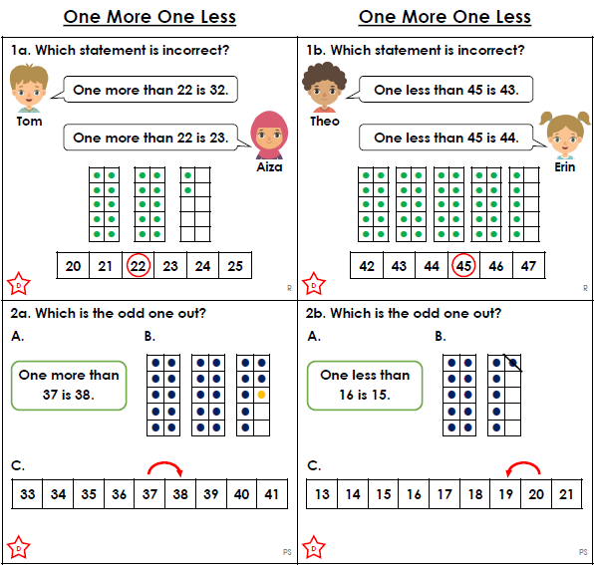

Friday
Maths | Starter: Count backwards in 5s.  Count backwards in 5s from 30.  Complete the following:  What is 5 more than 15?  IALT: add one more/subtract one less  Over this week we will be adding one more and one less. Can you complete the work sheet? What can you use to help you?  Mrs Carey’s top tip: Remember to explain your answer.  Task:  