Monday
English | PLEASE TAKE A LOOK AT THE CIVITAS YOUTUBE PAGES TO LISTEN TO MISS ARAM READING JAMES AND THE GIANT PEACH. ENJOY!!  Starter: Correct the spelling and punctuation.  james lived with too nastee aunties? they were called aunt spiker and aunt sPOnge?  Copy the correct sentence into your book.  IALT: use plurals .  What is a plural?  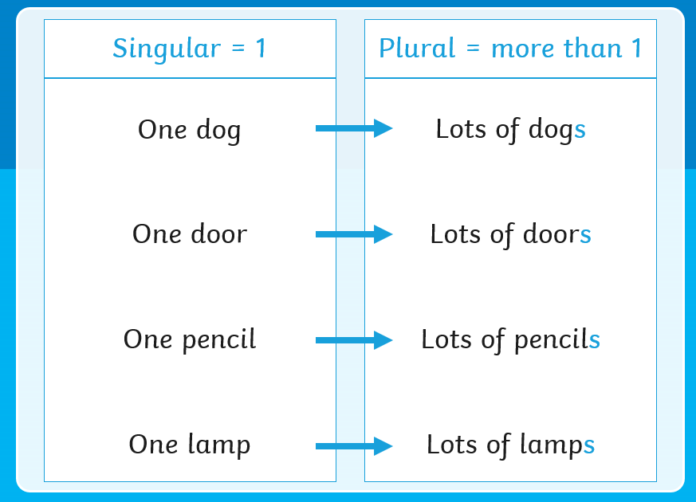  A singular is one and plural means more than one.  Example:  One tree - Lots of trees One pen - Lots of pens.  Have a look at the Plurals video: https://www.youtube.com/watch?v=lD1OaD4FBqM  If the word ends in one of the following sounds we add ‘es’ instead of ‘s’.  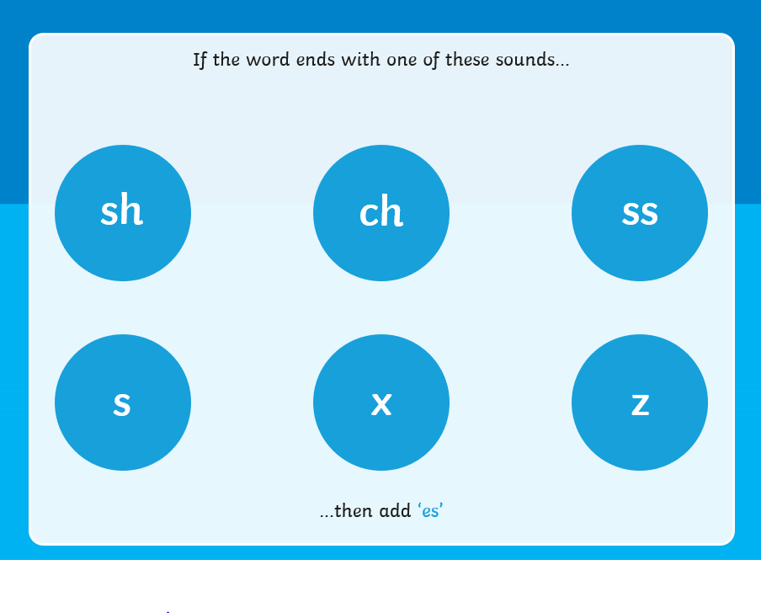  Task: Write the plural form for each of these 10 words:  Brush, pen, peach, tree, bush, ant, boy, box, dog, bus  Extension: Choose 3 words to put into a complete sentence.
Tuesday
English | Starter: Correct the spelling and punctuation.  Aunt sPonj had bigfAt stickee fingers.  aunt SpIKer was very meanto paw littleJames.  IALT: use adjectives to improve sentences.  What is an adjective?  Enjoy this clip: https://www.youtube.com/watch?v=QxoDGlPUmyU  What adjectives could you use to describe yourself?  What adjectives could you use to make this sentence even better?  James saw a peach on the tree.  Maybe you used adjectives such as: huge, enormous, delicious, gigantic.  Task: Add adjectives to each of these sentences and copy them into your book:  James saw a peach.  James had two aunties.  Aunt Sponge wanted to eat the peach.  The peach rolled down the hill.  Extension: Write sentences of your own to describe either Aunt Sponge or Aunt Spiker. Use adjectives in your sentences.

Wednesday
English | Starter: Correct the spelling and punctuation.  The grasshopper was as bigas a CaR?  The ladyburb had lots of spots.  IALT: use plurals  Let us recap on what a plural is.  Enjoy this clip: https://www.youtube.com/watch?v=7oPWiXt4CmQ  Can you remember what words we add ‘es’ to?  That’s right – if a word ends in SH, CH, SS, S, X or Z we add ‘es’.  Task:  Revolting Menu  Look at these lines from the Revolting Menu in James and the Giant Peach. Decide whether to add an ‘s’ or ‘es’ to the plural words. Copy the sentences into your book.  ‘For dinner on my birthday shall I tell you what I chose:  Hot noodle (s or es)made from poodle (s or es) on slice (s or es) of garden hose  And some rather smelly slime (s or es)  Made of armadillo’s toe (s or es)  The jellies are delicious but you have to hold your nose.  Extension: Add the correct plural suffix to these words:  Buzz dish fox

Thursday
English | Starter: Correct the spelling and punctuation.  The grasshopper was as bigas a CaR?  The ladyburb had lots of spots.  INDEPENDENT WRITE  Today, it is your turn to make up a revolting menu of your own.  Remember to use lots of adjectives to describe the yucky items on your menu and also to use the correct plural ending (s or es)  Task:  I have started my own revolting menu. You may use this to start your own writing and then continue to add yucky items to put on it.  I offer to you the most unusual dish  A fat caterpillar’s leg and the fin of a fish.  I can add a spectacular slimey snail’s house  Stirred round and round with the tail of a mouse….  Extension: Make sure that you have used the correct plural ending in your menu!

Friday
English | Starter: What is wrong with these sentences? Write the sentences correctly into your books.  MY favourite bookis the gruFFaloa  I like the mowse in the storee  IALT: Spell words correctly.  Each week we will continue to practise learning some words that we may like to use in our writing.  Please choose from Mild, Spicy or Hot words and write them in your book 5 times.  Task:  Mild: Spicy Hot  Is your here  his they love  I she come  You go some  Extension: Put each word into a sentence and write this into your book.

