Toys  On the next page is a picture of toys from 200 years ago. What games do you think were played with these toys? What are they made of? Do you have any toys like these? What is the difference between your toys and the toys in the picture? | Huntley and Palmers Factory  Huntley and Palmers where a biscuit factory in Reading. Research the types of biscuits that they made. Now design your own biscuit. Draw your biscuit and label the ingredients. If you can, try making your biscuit! | Jane Austen  Research:  Who was Jane Austen? What is her connection to Reading? Why is she famous?  What was her job?  Create a fact file about Jane Austen and draw a picture of her.
Forbury Lion  Have you seen the Forbury Lion before?  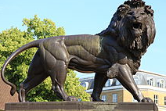  Find out everything you can about the lion. Who designed it? What material is it made of? When was it made? | History  Home Learning Choices | Seaside  On the next page is a picture of the seaside from 200 years ago and the seaside now. What is the same about these pictures?  What is different? What is the same/different about the clothes the people are wearing?
Historical Walk  Go for a historical walk around Reading. What landmarks do you see? See if you can find: Queen Victoria’s Statue, The Abbey, The Forbury Lion, Reading Town Hall. Write a list of things you saw on your wall.  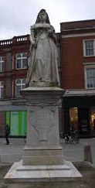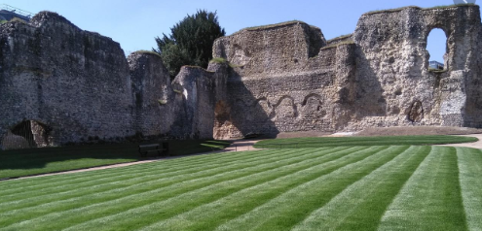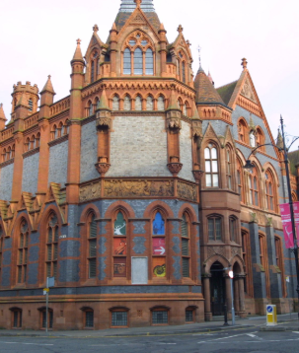 | International Women in Engineering Day  On 23rd June it is International Women in Engineering Day. What is an engineer?  Can you research a famous female engineer and write about them? | NHS  What do you know about the NHS? What does NHS stand for? When was it created? Did we always have the NHS?  Why is it so important? Why do we clap for the NHS on Thursdays? What jobs do people do when they work for the NHS?  Design a poster about the NHS.
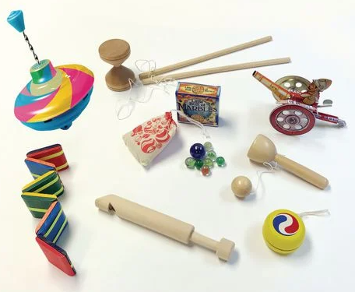
Toys

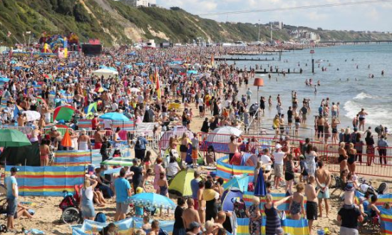
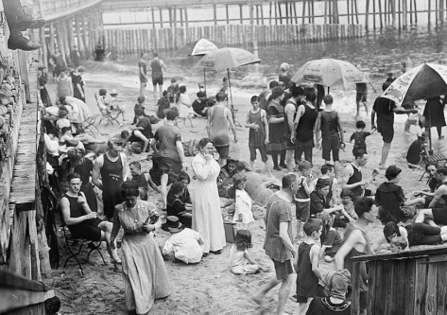
Seaside – 200 years ago Seaside - Now

