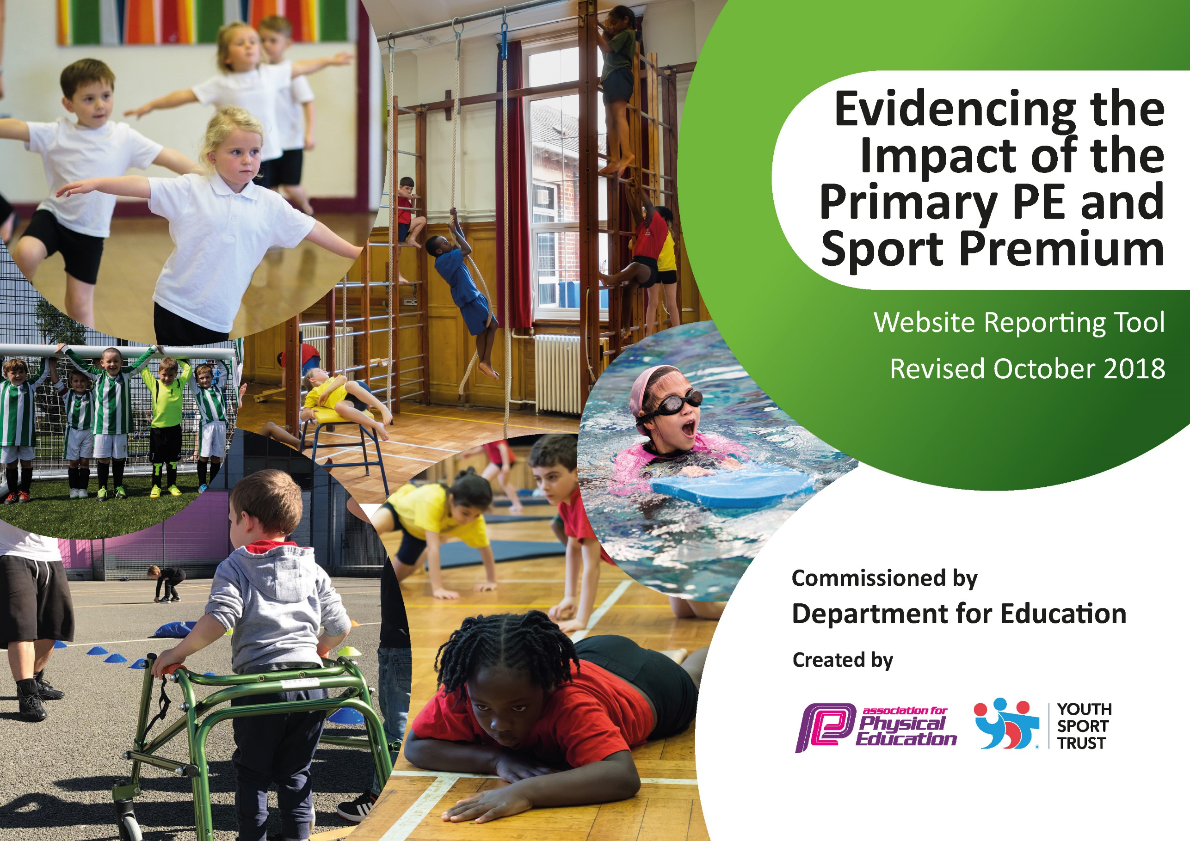
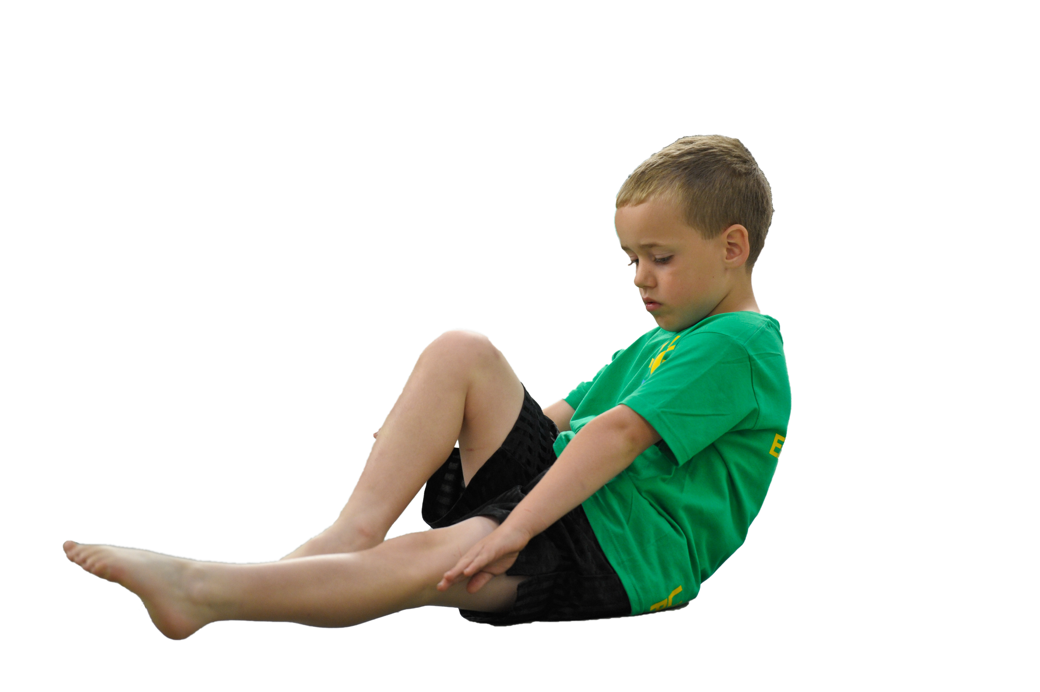
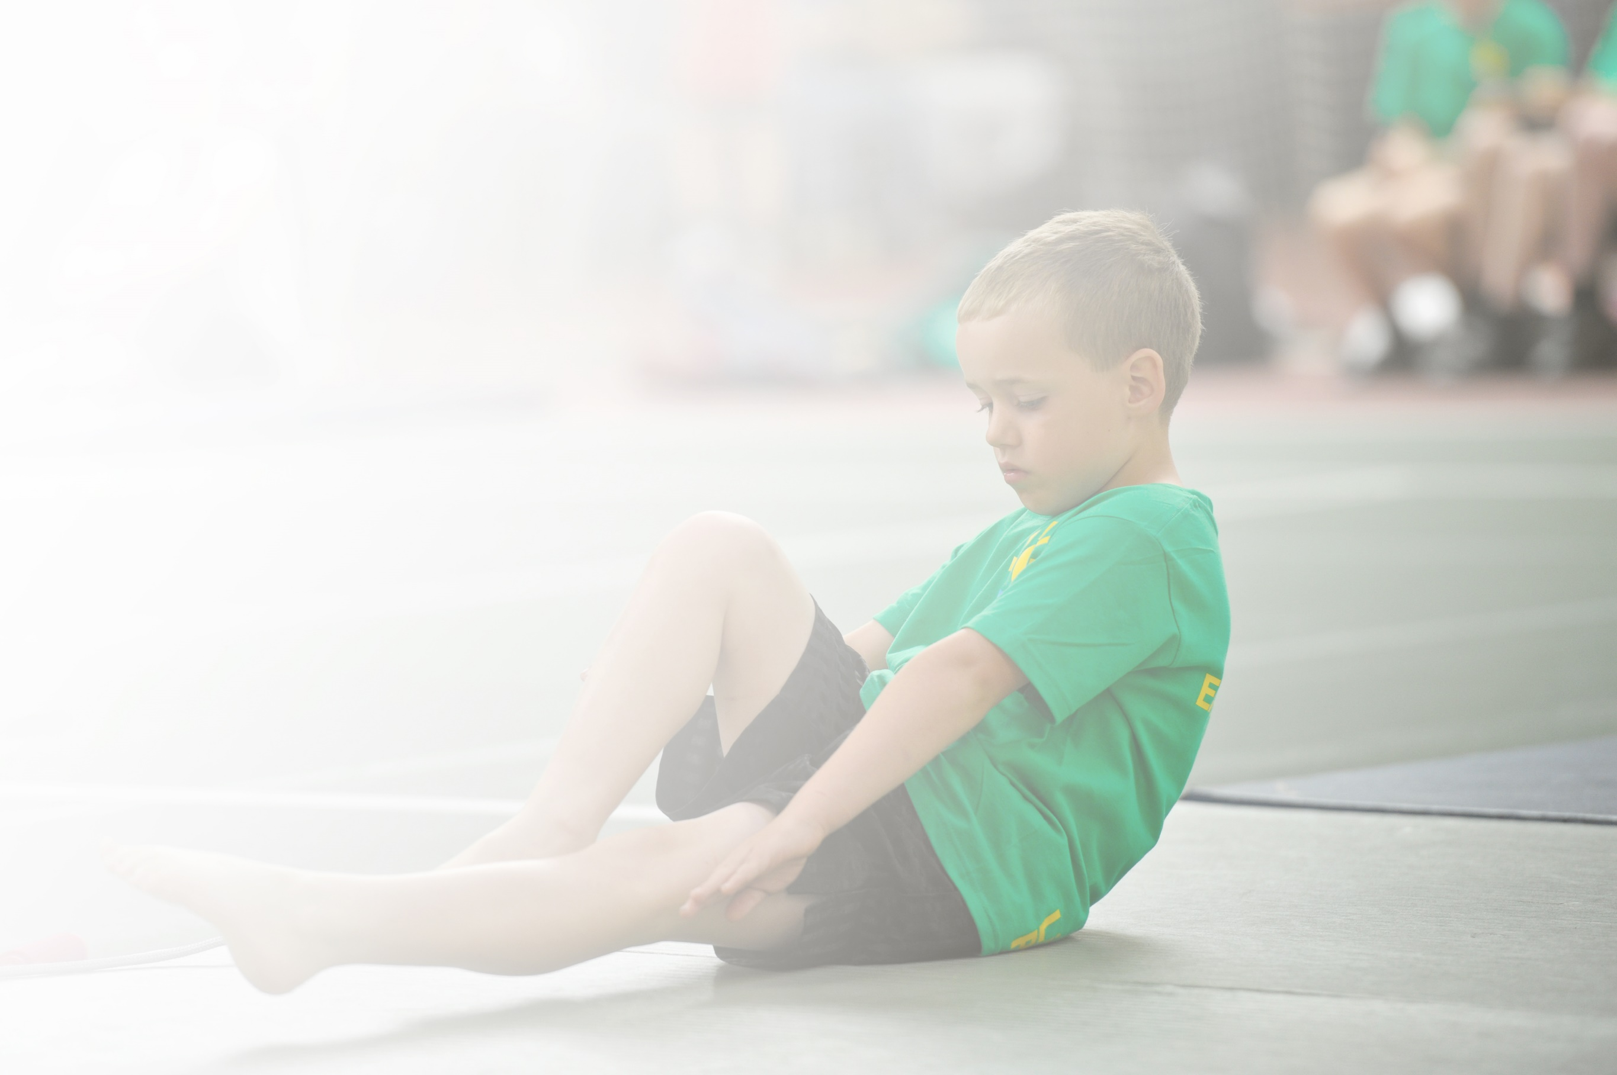
Schools must use the funding to make additional and sustainable improvements to the quality of Physical Education, Sport and Physical Activity (PESPA) they offer. This means that you should use the Primary PE and Sport Premium to:

- Develop or add to the PESPA activities that your school already offer
- Build capacity and capability within the school to ensure that improvements made now will benefit pupils joining the school in future years

Please visit gov.uk for the revised DfE guidance including the 5 key indicators across which schools should demonstrate an improvement. This document will help you to review your provision and to report
your spend. DfE encourages schools to use this template as an effective way of meeting the reporting requirements of the Primary PE and Sport Premium.

We recommend you start by reflecting on the impact of current provision and reviewing the previous
spend. Under the Ofsted Schools Inspection Framework, inspectors will assess how effectively leaders use the Primary PE and Sport Premium and measure its impact on outcomes for pupils, and how effectively governors hold them to account for this.

Schools are required to publish details of how they spend this funding as well as on the impact it has on pupils’ PE and sport participation and attainment by the end of the summer term or by 31 July 2019 at the
latest.
We recommend regularly updating the table and publishing it
on your website throughout the year, as evidence of your
ongoing review into how you are using the money to
secure maximum, sustainable impact. To see an
example of how to complete the table please
click HERE.

Support for review and reflection - considering the 5 key indicators from DfE, what development needs are a priority for your setting and your students now and why? Use the space below to reflect on previous spend, identify current need and priorities for the future.

Key achievements to date: | Areas for further improvement and baseline evidence of need:
- School Games Silver Award  - Two county finals in 2018-19  - 92% in extra-curricular clubs  - 98% competition participation in KS2  - Consistently good or better teaching of P.E. across the school | - School Games Gold Award  - Deploying P.E. Learning Support Assistant effectively  - Further increasing the range of clubs on offer

Meeting national curriculum requirements for swimming and water safety | Please complete all of the below:
What percentage of your current Year 6 cohort swim competently, confidently and proficiently over a distance of at least 25 metres?  N.B. Even though your children may swim in another year please report on their attainment on leaving  primary school. | N/a
What percentage of your current Year 6 cohort use a range of strokes effectively [for example, front crawl, backstroke and breaststroke]? | N/a
What percentage of your current Year 6 cohort perform safe self-rescue in different water-based situations? | N/a
Schools can choose to use the Primary PE and Sport Premium to provide additional provision for swimming but this must be for activity over and above the national curriculum requirements. Have you used it in this way? | N/a

Action Plan and Budget Tracking
Capture your intended annual spend against the 5 key indicators. Clarify the success criteria and evidence of impact that you intend to measure to evaluate for students today and for the future.

Academic Year: 2018/19 | Total fund allocated: £ | Date Updated:
Key indicator 1: The engagement of all pupils in regular physical activity – Chief Medical Officer guidelines recommend that primary school children undertake at least 30 minutes of physical activity a day in school |  |  |  | Percentage of total allocation:
 |  |  |  | 6%
School focus with clarity on intended impact on pupils: | Actions to achieve: | Funding allocated: | Evidence and impact: | Sustainability and suggested next steps:
Increase participation in PE lessons  Lunchtime Activities | Design and implement an engaging curriculum for EYFS, KS1 and KS2 pupils  Sports leaders from ks2 to run lunchtime activities  Lunch clubs run by school staff | £1,000 | Increased participation in lessons  More pupils bringing in PE kit  Children are active at lunchtimes  More pupils involved in physical activities for longer | Behaviour management systems in place for PE lessons to ensure more children are actively engaged in all lessons#  Year 4 pupils to lead activities during lunchtimes  PE LSA employed to run lunchtime clubs
Key indicator 2: The profile of PESSPA being raised across the school as a tool for whole school improvement |  |  |  | Percentage of total allocation:
 |  |  |  | 24%
School focus with clarity on intended impact on pupils: | Actions to achieve: | Funding allocated: | Evidence and impact: | Sustainability and suggested next steps:
PE Reward systems  PE displays  School council sports meetings  Links with local community  School Games Award application  Sports clubs | PE Stars of the Week  Sportsmanship awarded on a termly basis  Annual ‘Improver’ and ‘Sportsman/woman’ award  Displays from sporting events the school has attended  Meetings with the school councillors to discuss how we can become more physically active  Sports coaches from local clubs invited in to run taster sessions  School Games Silver Award applied for.  Extra-curricular sports clubs available to all children across the school. | £4,000 | More children bringing in PE kit and engaged in lessons.  Children aware of worldwide sporting events and sporting successed  Minutes from meetings have enabled the children to have a voice about lunchtime activities  Children joining out of school clubs and celebrating their success  Silver Award achieved  Children more active and engaged in physical activity | Keep record of those consistently not bringing in kit  Update the PE displays

Key indicator 3: Increased confidence, knowledge and skills of all staff in teaching PE and sport |  |  |  | Percentage of total allocation:
 |  |  |  | 33%
School focus with clarity on intended  impact on pupils: | Actions to achieve: | Funding  allocated: | Evidence and impact: | Sustainability and suggested  next steps:
Working closely with other Reach2 Reading schools to ensure quality of P.E. is high.  Supporting Learning Support Assistants increase in confidence delivering P.E. | Peer observations and feedback to improve practice of the P.E. teachers.  Learning Support Assistants to feel confident in supporting delivery of P.E. | £5,390 | All P.E. lessons at least good and in many areas outstanding.  Verbal feedback from Learning Support Assistants that they now feel confident in supporting the delivery of P.E. | Continue with peer to peer school reviews  Developing the newly appointed P.E. L.S.A.
Key indicator 4: Broader experience of a range of sports and activities offered to all pupils |  |  |  | Percentage of total allocation:
 |  |  |  | 31%
School focus with clarity on intended  impact on pupils: | Actions to achieve: | Funding  allocated: | Evidence and impact: | Sustainability and suggested  next steps:
Range of clubs to be available for pupils | Staff to plan and lead a range of clubs | £5,000 | 92% of children in at least one club across the whole year. | Continue run clubs – broader range across all year groups
Key indicator 5: Increased participation in competitive sport |  |  |  | Percentage of total allocation:
 |  |  |  | 6%
School focus with clarity on intended  impact on pupils: | Actions to achieve: | Funding  allocated: | Evidence and impact: | Sustainability and suggested  next steps:
Participation in a range of sporting events  House competitions introduced to all year groups  Inter-school competitions | Organise events both within school and inter-school. Attend Reading School Sports Partnership events.  Attend Berkshire School Games | £1,000 | Intra and inter-school events attended, more children motivated to represent the school, qualified Berkshire School Games in 2 events. | Fixtures against local schools and other RSSP events from Y1-4.

