Coronavirus (COVID-19): School reopening arrangements letter to parents

Dear Parents and Carers,

I would like to begin by offering a huge ‘thank you’ for supporting the school over recent weeks and for supporting your child with their home learning.

Re-opening schools: preparation and arrangements

We recognise that some of you may have some concerns about your child returning to school and that for some children another change will be unsettling for them. We also understand that the past weeks will have been challenging for many families.

I am therefore writing to share with you the arrangements we have implemented to ensure the safety of all staff, pupils and parents. These arrangements have been put into place following a full risk assessment process which in line with guidance from the Department for Education. They will be kept under constant review and should there be any changes we will inform parents at the earliest possible opportunity.

If you would like to talk to us about your child and any concerns you have about their return to school, please contact Mr Wieder to discuss.

If your child has an EHC plan please contact the school SENCO, Mrs Slade, who will support you and your child with their return to school.

Both can be contacted via the office@civitasacademy.co.uk email address.

Staggered Start: opening dates for different year groups

In order to ensure arrangements are as safe and secure as possible we will be operating a staggered start where in the first instance, we will increase the numbers of Y1 children attending school alongside the current childcare service.

We will start by opening the school to selected pupils in Year 1 on Monday 8th June. Please note that the current maximum capacity of the school is 40 pupils. This number may change in the future if more staff become available or social distancing restrictions are relaxed further.

We will then review arrangements each week to confirm whether it is safe to open the school to additional year groups in the following weeks. This decision will be based on risk assessment, taking into account pupil numbers and available staff, so that we are sure we can operate as safely as possible. Re-opening to additional year groups will need to be approved at Trust Level.

As we have 58 pupils in Y1, we are unable to confirm the start date of any other year groups at this point. Depending on the amount of Y1 pupils taking up places, we may be able to open to additional year groups in coming weeks, but are unable to confirm at this stage.

As with all other arrangements we will keep this approach under constant review and we will not take any action without being sure it is as safe as possible to do so.

School staff

As like many organisations, not all staff are able to return back to school at this stage. We will also have a maximum of 10 pupils per class in school. This means that class teachers and support staff will be allocated to specific groups and it will be unlikely that your child will have the same teacher and support staff as before. Classes will also be mixed into their individual bubble group that they will need to stay in at all times. Please note that there will be no mixing of bubble groups throughout the school day.

Maintaining a safe school environment

I would like to take this opportunity to remind you of the preventative measures the school has put in place in order to minimise the spread of infection.

As per the advice from the government, the following actions for infection control remain in place:
- Displaying coronavirus infection control measures information posters around the school
- Encouraging good hygiene by promoting the importance of handwashing for at least 20 seconds with warm water and soap in the following circumstances:
  - Before leaving home
  - On arrival at school
  - After using the toilet
  - After breaks and sporting activities
  - Before food preparation
  - Before eating any food, including snacks
  - Before leaving school
  - At regular intervals throughout the day
- Ensuring pupils and staff understand that they must cover their cough or sneeze with a tissue, then throw the tissue away
- Ensuring frequently touched objects and surfaces are cleaned and disinfected more regularly than usual
- Calling NHS 111 if someone becomes unwell, isolating any unwell people in a separate room, and providing a separate bathroom, where possible
- Telling staff to stay at home for seven days if they develop symptoms of coronavirus
- Providing staff training on PPE, rubbish disposal, mental health and well-being
As an important part of our school community, I would ask that you continue to encourage good infection control practices, such as thorough handwashing, at home and keep your child informed about the things they can do to discourage the spread of infection.

In line with the current NHS and government advice, you should keep your child at home if they develop coronavirus symptoms for a period of seven days. Symptoms include a high temperature or a new, continuous cough. Where symptoms continue after seven days, or begin to worsen, you should call 111. If someone in your child’s household has symptoms, your child must self-isolate for 14 days from the day the other person’s symptoms started. This is because it can take 14 days for symptoms to appear. More information regarding symptoms and actions can be found on the NHS website (https://www.nhs.uk/conditions/coronavirus-covid-19/).

If you think your child may have been exposed to or has coronavirus, or if your child receives a positive test result for coronavirus, please contact the school on 0118 467 6720 at the earliest opportunity. The bubble group and staff in the group will then quarantine for 14 days if there is a positive test result.

Arrangements for the start and end of the school day

The beginning and end of the school day are the busiest times for children and adults congregating together in one place and maintaining safe distances within normal arrangements can be a challenge. We have implemented the following measures for when pupils return to school:
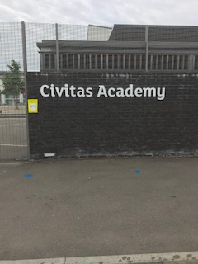

Entrance and exit will be via the gate. At the start of the day, each family should wait on the blue dot and then move to the next blue dot (2m apart) as the next family moves forward. The blue dots are on Hodsoll Road only. In the event of the queue extending beyond Hodsoll Road, families should queue on the school side of Great Knollys Street.

We will not be able to allow any parent to enter the site and your child will need to walk and enter the classroom door to their bubble room. Unfortunately, from Monday 8th June, we will no longer have cycle/ scooter storage available on site.

Group times will also be staggered. It is essential that families arrive on time for the drop off and collection arrangements relevant to their group:

Group Name | Arrive Between: | Collection Time Between:
Rainbow (Childcare) | 8:45-9:00 | 3:15-3:30
Y1 Green Group | 9:00-9:15 | 3:00-3:15

At collection time, please wait on the blue spots outside the gate and you will be called forward to collect your child from the gate.

Arrangements for break times and lunchtimes

We recognise the importance for all pupils to have a break from learning and to enjoy time outside during the school day. Reconnecting with friends will be an important aspect of pupils settling back into school life, but we have made some adjustments to break and lunch times.

Break and lunchtimes will be staggered throughout the day. Each bubble will have an allocated area of the playground to play in and specific equipment that will be wiped down after each use. Children will not be allowed to play contact games such as tag.

Children will be provided with a packed lunch by our catering company- Crumbs. This will be eaten inside the classroom. Children may bring in their packed lunch if they prefer and this will need to be stored under their table.

No equipment from home should be brought into school.

Bubbles will not be allowed to mix. Each bubble will have their own separate toilet.

The school day

To minimise the number of pupils and staff assembling for periods of time, we have made the following changes to the school day:

The classrooms have been remodelled to fulfil social distancing restrictions. All seats have been measured for 2m gaps and a red cross marked on the floor, where the child’s seat should be located.

They each have their own individual and desks and tray for personal equipment e.g. pencils, books etc.

Movement around the school will be limited as children stay in their own bubble. There will be no assemblies as children from other bubbles should not come together.

Each bubble group will have a timetable, which will cover the home learning alongside PSHE and wellbeing activities designed by the group leader.

On the next page, I have included some photographs of the layout of one of the classrooms. You will note that all other furniture has been removed in order to fit 10 socially distanced places.
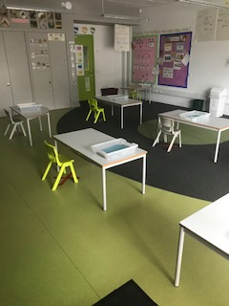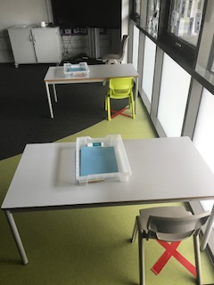
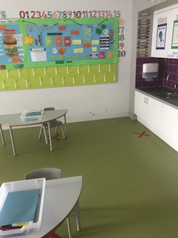

School Events

Please note that all events scheduled this academic year have been cancelled.

School trips

There will be no school trips taking place in the foreseeable future. This will be reviewed as the situation changes.

Support for pupils and families

We do not underestimate how difficult the recent weeks have been for us all and we all will have been touched in some way by the coronavirus pandemic. We recognise the need to focus on pupils’ emotional wellbeing as well as their return to learning. This is why a significant amount of time will be spent on supporting children through PSHE and wellbeing activities.

Parents may wish to seek support for themselves from the following support agencies:

- Samaritans – call free 24 hours a day on 116 123
- National Domestic Abuse Helpline – call for free and confidential advice, 24 hours a day on 0808 2000 247
- Shelter provide free confidential information, support and legal advice on all housing and homelessness issues if you call 0330 0536 083 (please note, this is not a free phone number and your call will be charged). A free webchat is available at https://england.shelter.org.uk/get_help/webchat

I hope that these arrangements provide you with the information you need to support your child to return to school.

Yours faithfully,

Mark Wieder
Head of School

