Cut out these pictures and retell the story of Pinocchio.

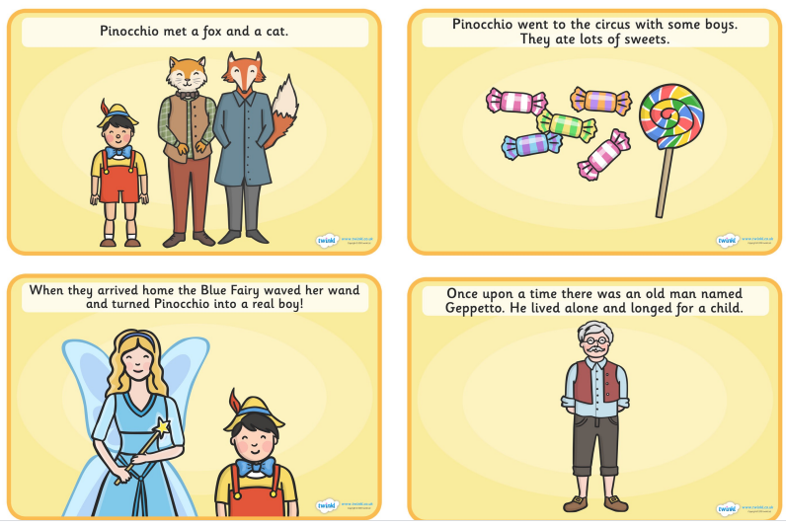
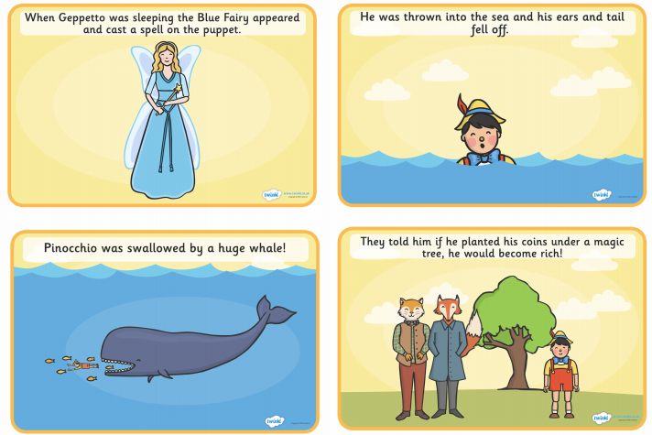

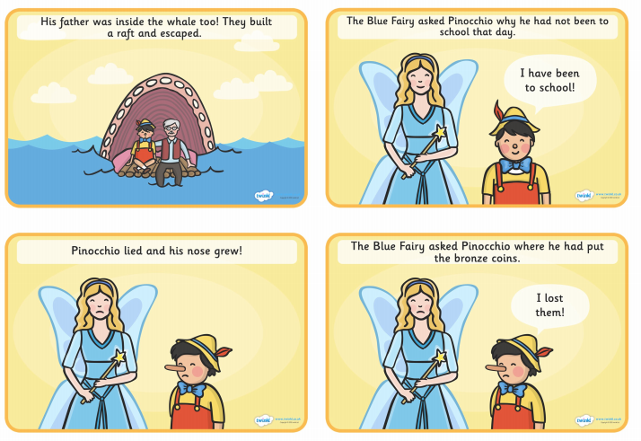

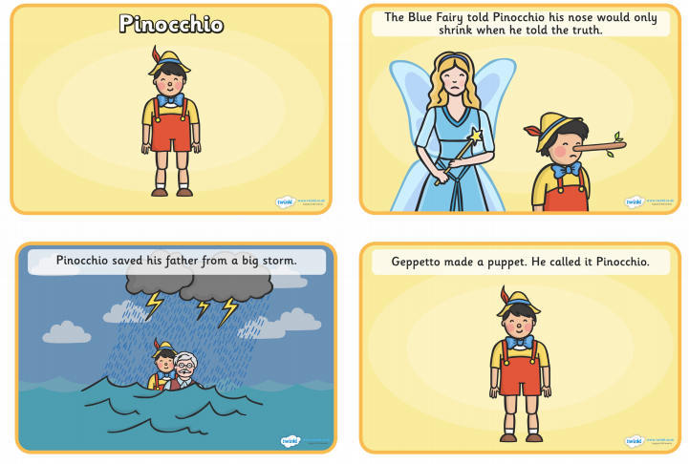

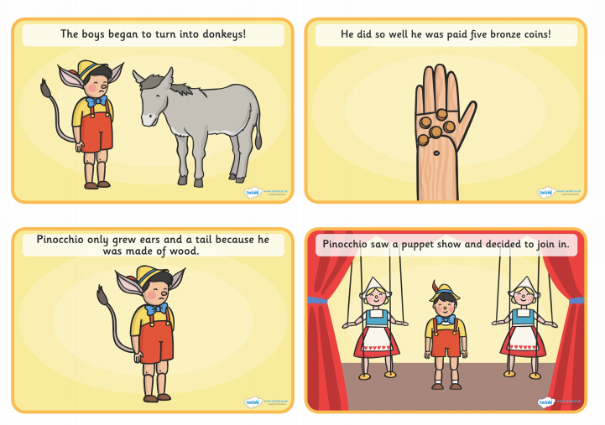

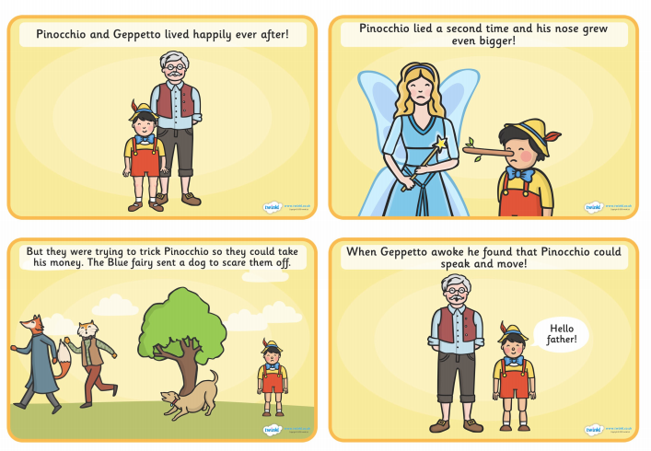
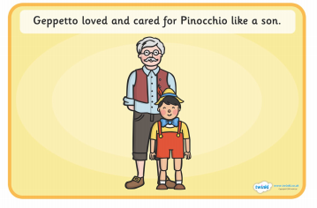

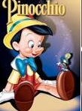 Design a Wanted Poster for Pinocchio.

- Draw a picture of Pinocchio on the poster.
- Label the picture using exciting adjectives.
- Write a sentence to describe why you want to find him.
- Offer a reward for finding him.

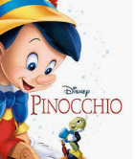

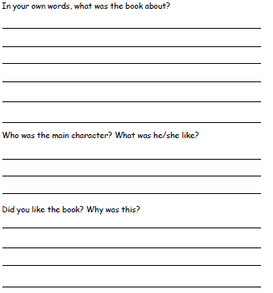

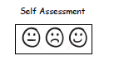

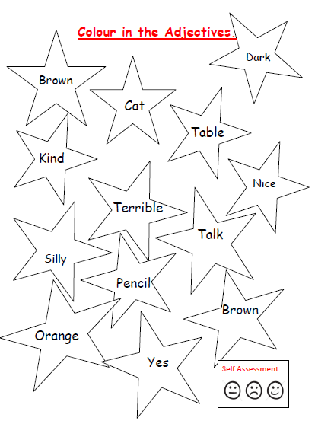

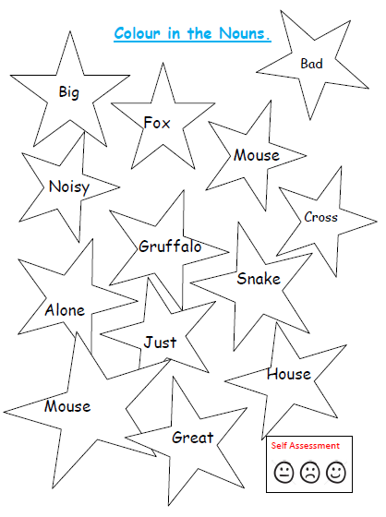

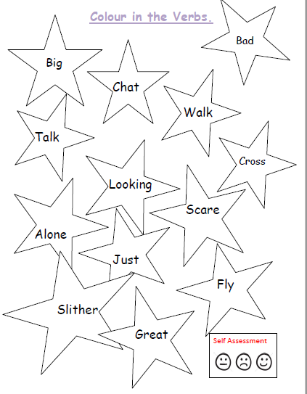

Which of these words would you use to describe Pinocchio? Try to put them in a sentence.

Kind brave clever tall wooden

Hero naughty scared mean happy

Make up your own version of the Pinocchio story.
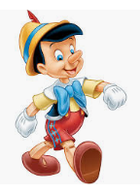
You may wish to change Pinocchio to a robot instead of a wooden puppet or perhaps Pinocchio is a girl.

Perhaps you can change the ending of the story.
We can’t wait to see what amazing ideas you have.

