Complete a kindness diary.  Try and do something kind for another person once a day for a week. Draw pictures or write about what you did.  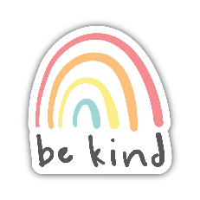  At the end of the week, think about how it made you feel. | Visit  https://www.royalmail.com/thumbsup  to complete a ‘Thank you’ thumbs up design for your postman or postwoman. | Try some meditation.  Search ‘kids meditation’ on Youtube to find videos- you can be guided if you haven’t tried this before. Try to switch off and try some peaceful relaxing.  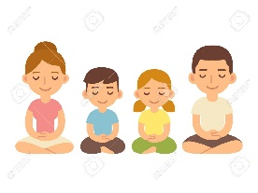
Belly breathing  Ask an adult to help you put on some calm, relaxing music. Lie on your back and put a small toy or object onto your tummy. Focus on the music and see whether you can keep still enough for the object to stay on your tummy until the music finishes. | PSHE  Home Learning Choices | Worry Monsters.  These are great as they read your worries and munch them up so you don’t have to worry about them anymore. What could you use to make your own?  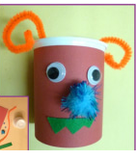
Watch this advert  https://www.teachingideas.co.uk/video/Rock-Paper-Scissors  What messages can we learn from this?  Can you write a story about it to teach other children about friendship?  Can you draw a picture from this story? Label the characters.  Can you create your own story using different characters? 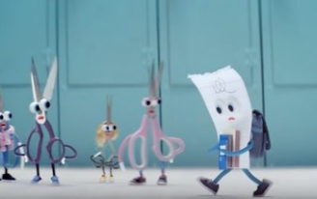 | Positive Paper Chains.  Take time to think of some positive messages that you can put onto pieces of paper. Remember all the things that make you feel happy and special. Put these onto pieces of paper and decorate them before joining them together to make a wonderful positive paper chain.  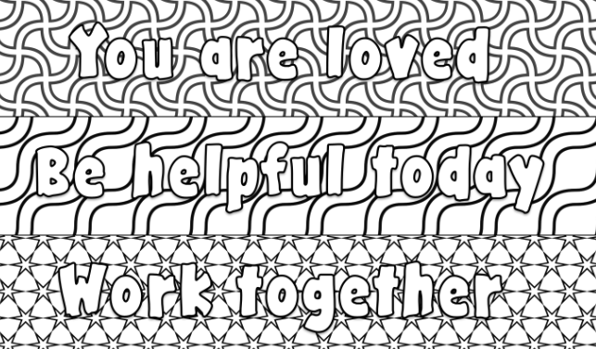 | Create a Dreams Jar/Pot  There are lots of things we want to do at the moment but we can’t as we need to stay safe. Make a list of things you want to do when Covid 19 is over and cut them up and put them in a jar or pot. Keep adding to this to build it up and when we are safe again you can complete them with your friends and family!  