Friday 3rd April 2020 PSHE: Healthy Choices

It is very important that we do everything we can to keep ourselves healthy and strong.

Why?
Can you remember what foods we should eat to stay healthy? 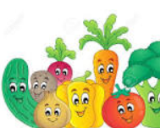

What should you drink? 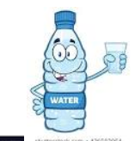

What exercises can you do? 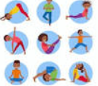
Do you have any other ideas of how to look after ourselves and keep healthy? 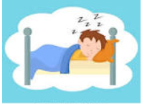 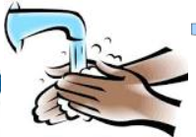

There are 3 activities to choose from:

Mild: Draw pictures of things you can do to keep healthy.
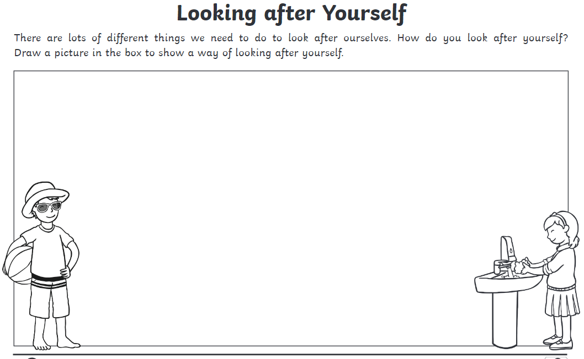

2. Read the sentences and draw pictures in each box.
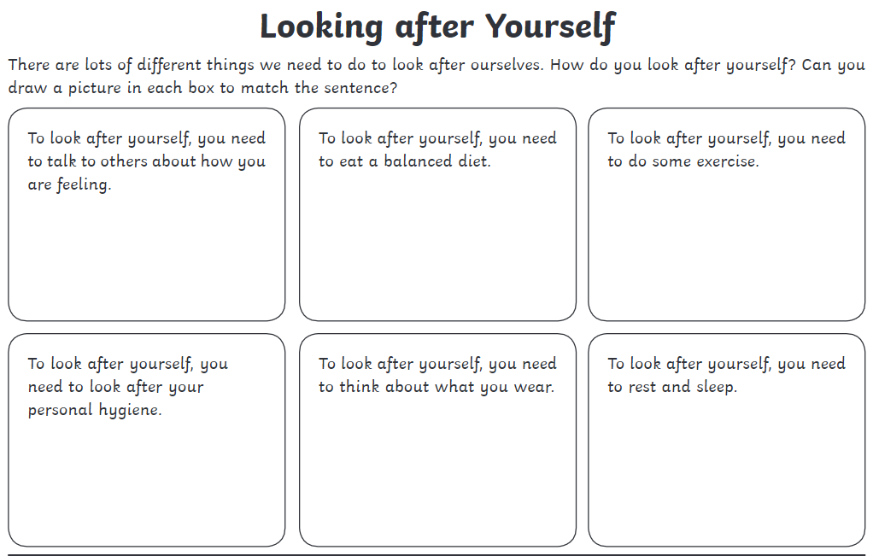

3. Complete the sentences about taking care of yourself and draw a picture for each piece of information.
