Monday 27th April
TOPIC | Monday, Tuesday and Thursday:  IALT create a mini-beast poster.  Wednesday: P.E  Friday: PSHE  IALT: use the internet to find some facts about mini-beasts.  Task:  - Look at mini-beast facts for children on the internet with an adult.  - https://www.woodlandtrust.org.uk/blog/2019/05/minibeast-facts/  - Write 3 facts about mini-beasts. Can you use an adjective?  - Can you draw a picture to go with your facts.  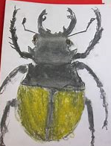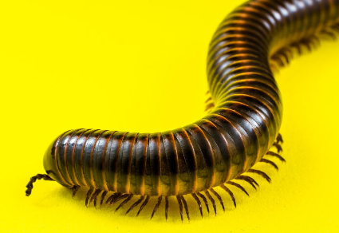
Tuesday 28th April
TOPIC | 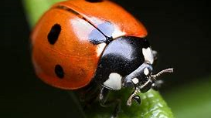  IALT: look at some living mini-beasts.  How many mini-beasts can you name?  Task:  - Look at some real life video’s off some mini-beast’s. Why don’t you look outside and see if you can see any.  - Complete the questions?  - Which mini-beast is your favourite? Explain why?  - What mini-beast’s did you watch or see?  - What did you like or not like about them?
Wednesday
TOPIC |  | PE – Follow our PE challenges.  Civitasacademy.co.uk – Class pages, P.E.  YOUTUBE – JOE WICKS P.E LESSONS

Thursday
TOPIC | IALT: learn about minibeasts  Task:  Can you create a poster of your favourite mini-beast and write down the facts you know.  Remember to get creative!!  Extention: Can you use a recycled box to make a mini-beast?  Remember to take a picture and email us your masterpieces!  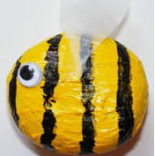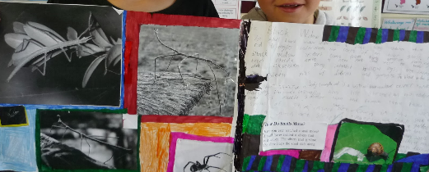

Friday 1st May
Topic | PSHE  Home Learning Diary  We would love to hear about the things you have been enjoying with your family at home. We thought it would be a good idea for you to keep a little diary each Friday to stop and think about things that you have enjoyed or experienced during the week. There is a template on the website or you can make your own. Please do let us know how you are and what things you have been getting up to. We look forward to the time when we can share these all together in school. There are some ideas on the diary template to help you.  