Monday 27th April
Maths | Starter: Count in 2s to 30.  Count forwards and backwards to 30 in 2s.  What number comes next?  12 14 ___ 18 ______  IALT: add one more and one less.  Task: Over this week we will be adding one more and one less. Can you complete the work sheet? What can you use to help you?  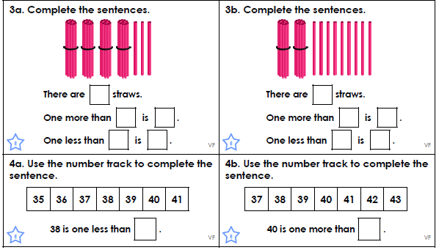  Mrs Aram’s challenge: Can you create your own question?
Tuesday 28th April
Maths | Starter: Count in 5s to 50.  Count forwards and backwards to 50 in 5s.  What number comes next?  25 30 ___ 40 ______ 50  IALT: add 1 more and subtract 1 less.  What does more add? What does less mean?  Task: Over this week we will be adding one more and one less. Can you complete the work sheet? What can you use to help you?  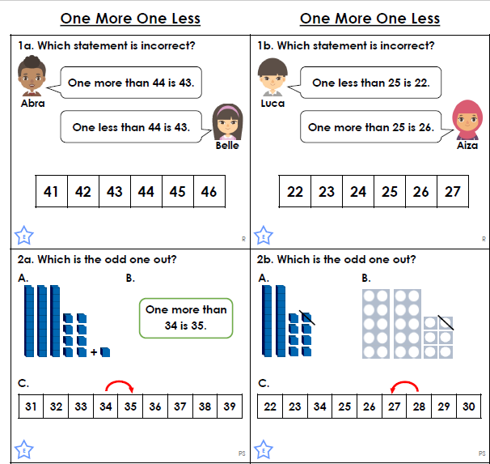
Wednesday 29th April
Maths | Starter: Count in 5s.  Count in 5s from 25.  Complete the following:  25 30 ___ 40 ______ 50  IALT: add one more and subtract one less  Can you think of another word you can use instead of more? Or less?  TasK: Over this week we will be continuing to add one more and one less. Can you complete the work sheet? What do you notice about the questions?  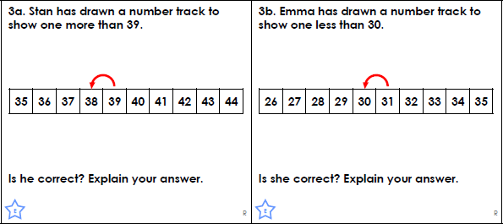  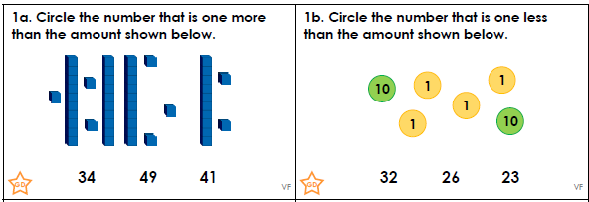

Thursday 30th May
Maths | Starter: Count in 2s. Count in 2s from 14.  Complete the following:  24 ___ 28 ______ 32  IALT: add one more/subtract one less  Task:  Over this week we will be continuing to add one more and one less. Can you complete the work sheet? Can you explain why the questions are correct or incorrect?  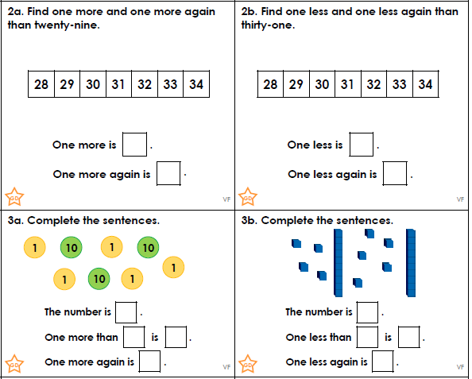  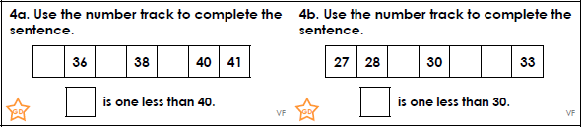

Friday 1st May
Maths | Starter: Count backwards in 5s.  Count backwards in 5s from 30.  Complete the following:  What is 5 more than 15?  IALT: add one more/subtract one less  Over this week we will be adding one more and one less. Can you complete the work sheet? What can you use to help you?  Mrs Carey’s top tip: Remember to explain your answer.  Task:  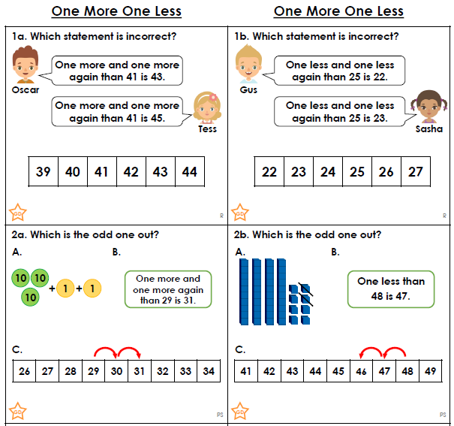

CHALLENGE TIME:
Can you tell me what one more and one less is?
12 22 34 8 49 41 37

