Monday 18th May
Maths | Starter: Count in 2s to 20.  Count forwards and backwards to 20 in 2s 5s and 10s  Do you notice any patterns when counting?  IALT: count in 2s  Complete the questions. What do you notice?  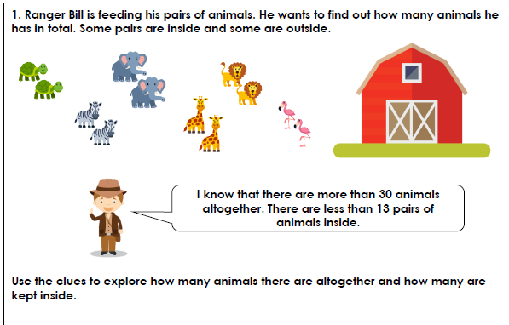  Challenge:  Can you create your own question using different animals? See if someone at home can answer the question.
Tuesday 19th May
Maths | Starter: Count in 2s to 40. Count forwards and backwards to 30 in 2s.  IALT: count in 2s  Song: https://www.youtube.com/watch?v=OCxvNtrcDIs  Did you know that numbers can be put in to many different groups? We are going to put them in to odd and even! Do you know that an Even number always ends in a 0, 2, 4, 6 or and 8! What do you notice about these numbers?  Odd numbers are not in the multiples of 2 they can not be split down the middle!!  https://www.youtube.com/watch?v=uuD5JlrMnAk  Task: Play a game with a friend at home!  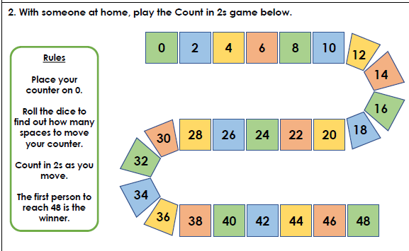  Challenge: What can you use if you do not have a dice?
Wednesday 20th May
Maths | Starter: Count in 5s.  Count in 5s from 25.  Complete the following: 20 _____ 40 50 _____  IALT: count in 2s  Can you think of another word you can use instead of more? Or less?  What does even and odd mean?  https://www.youtube.com/watch?v=E3uxBI9npas  https://www.youtube.com/watch?v=-kHtGbnYKGc  Task: Can you count to 20 in 2's?  Can you write the numbers to 20 and colour in all the multiples of 2. What do you notice about the numbers you have coloured?  Mrs Aram and Mrs Carey’s challenge:  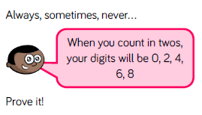

Thursday 21st May
Maths | Starter: Count in 2s. Count in 2s from 14.  Complete the following: 16 ___ 20 ______ 24  Spot the mistake: 22, 24, 25, 27, 28 , 30, 32. 34  Spot the mistake: 14, 15, 16, 18, 20 , 22, 24.  IALT: identify multiples of 2  Write down all the multiples of 2 up to 20. Explain what you notice about the numbers?  What do you think multiple means?  Complete the questions, Can. Explain how you got the answer.  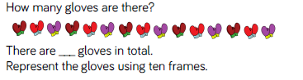  What else could you use instead of gloves?  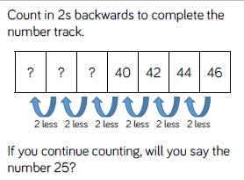

Friday 22nd May
Maths | Starter: Count backwards in 5s.  Count backwards in 5s from 50.  Complete the following: What is 5 more than 20? What is 5 less than 20?  What is 5 more than 40? What is 5 less than 40?  IALT: count in 5s  Song: https://www.youtube.com/watch?v=Sh8YmvJuJ8A  Task: Complete the questions. Explain your answers.  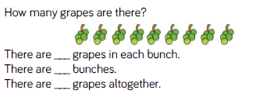  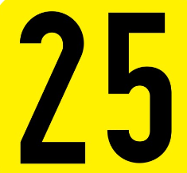  - How many 5’s in 25?  - How many ones?  - How many 10’s?  Mrs Aram’s challenge: Can you create your own question about the number 25?

