Monday 11th May
Maths | Starter: Count in 2s to 30.  Count forwards and backwards to 30 in 2s.  What number after 12? What number comes before?  IALT: identify tens and ones  Task: Complete the questions. What do you notice? How many straws are left?  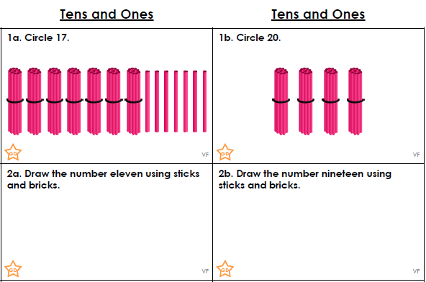  Challenge  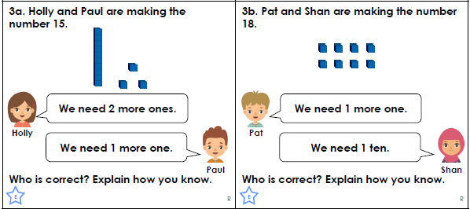
Tuesday 12th May
Maths | Starter: Count in 5s to 50.  Count forwards and backwards to 50 in 5s.  What number comes next? 25 30 ___ 40 ______ 50  Spot the mistake: 10, 15, 20, 30, 40, 50  IALT: identify tens and ones  What does true mean? What does false mean?  Task: Complete the questions. True or False  - There are 6 tens in 16.  - There are 6 ones in 16.  - There is 1 ten in 16.  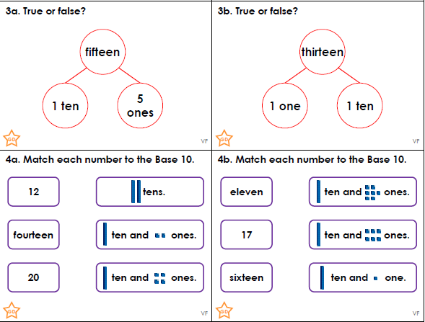
Wednesday 13th May
Maths | Starter: Count in 5s.  Count in 5s from 25.  Complete the following: 20 _____ 40 50 _____  IALT: identify tens and ones  Can you think of another word you can use instead of more? Or less?  Task: Complete the questions.  What do you notice? Can you create your own question?  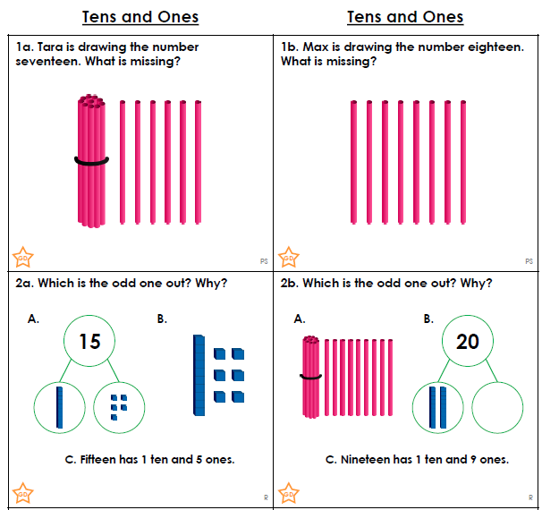  Mrs Aram’s challenge: What other resources can you use to help you answer the questions?

Thursday 14th May
Maths | Starter: Count in 2s. Count in 2s from 14.  Complete the following: 26 ___ 30 ______ 34  Spot the mistake: 22, 24, 25, 26, 28 , 30.  IALT: identify tens and ones  Task: Complete the questions, Can you make the questions correct. Explain how you made the answer.  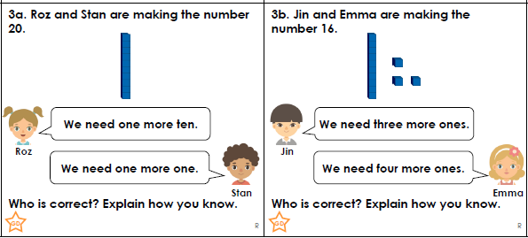  Can you complete the following number sentence?  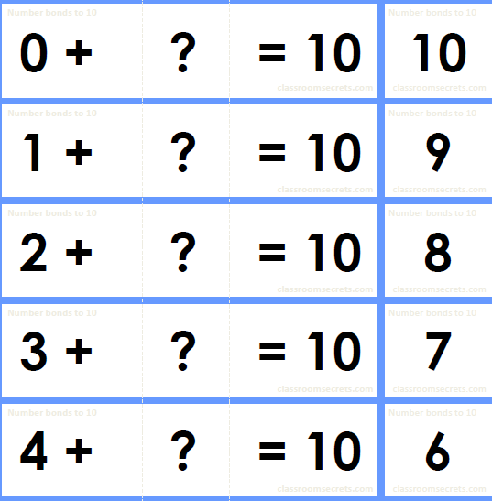

Friday 15th May
Maths | Starter: Count backwards in 5s.  Count backwards in 5s from 50.  Complete the following: What is 5 more than 35? What is 5 less than 35?  IALT: recognise 2D shapes  Task: Complete the sheet then can you create your own question about shape? Do you know what vertices is? What is your favourite shape and why?  