Dear Parents,

This week’s work is around a story called Alan’s Big Scary Teeth. If you have the book at home please read it to your child. Alternatively there is a link to YouTube on Monday’s activity grid and we will be uploading the story to tapestry too. If you are able you may want to print this off and stick the learning in the children’s book, but that is not necessary. If you do not have a printer, look at the guidance slip and talk to you child about the activity then complete it on a page in the book.

The children in reception are all at different stages in their development, at this time it is really difficult for us to differentiate their learning. Some children may only hear a few sounds in the words they write (their work won’t be perfect.) It is vital that you encourage them and celebrate any writing they do, being dissatisfied will only lead to frustration and they will learn to hate writing. If your child’s sentence is too long (6+ words) suggest a shorter version. Some children may need more support than others this might be: remembering the sentence, reminding them about finger spaces, sounding out words together, looking at the phonics mat and tricky word mat. Showing them where to start writing, sitting letters on the lines.

Our number one rule in reception is no copying, you must allow them to listen and write. You can write tricky words for them to copy. If you are getting frustrated or your child cannot concentrate I would suggest a break such as a wake and shake on YouTube or a walk outside in the fresh air.

This literacy work should take no more than 15- 20 min a day. There is a challenge for those who would like some extra work but it’s not compulsory.
Wow Read Monday- IALT: retell a story.
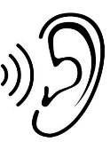  1.Listen to the story on tapestry or YouTube:  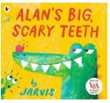 | 2. Talk about the story.  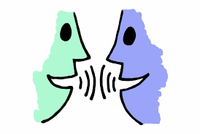 | 3. Ask questions:  What was your favourite part and why?  Was Alan a kind alligator?  Who stole Alan’s teeth?  Why did Alan have false teeth? |  | 4. Retell the story.  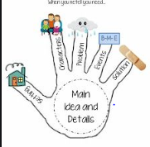  Retell the story- you could take a video and upload it to tapestry. Use the pictures to help you if you need them.
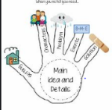  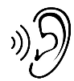 |  |  | Tick it if you can do it.

Wow Write Tuesday - IALT: draw a story map.
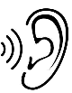  1.Listen to the story again on tapestry or YouTube: | 2. Draw out the beginning - middle and end of the story.  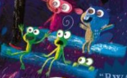  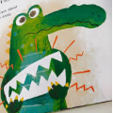  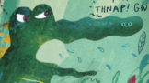  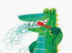  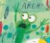  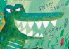 |  | 3. Use your phonics to add in labels.  t ee f  Remember: listen to what you can hear it doesn’t need to be spelled correctly you are learning!
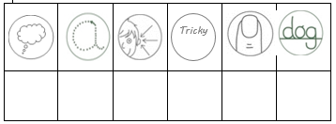 |  | Tick it if you can do it.
 |  | Draw a different ending.

Wow Write Wednesday- IALT: write a sentence about Alan.
1. Think about your sentence and hold it in your head. Start small! | 2. Break down the words.  3  1  2  Alan is scary. | 3. Listen to the sounds, one word at a time then write them.  a l a n | 4. Put in a finger space in-between your words.  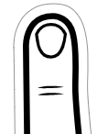 | Put a full stop at the end of your sentence.
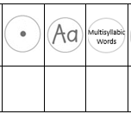 |  | Tick it if you can do it.
 |  | Write a story about Alan.

Wow Write Friday - IALT: describe Alan’s teeth.
1. Think about your sentence and hold it in your head. Start small! | 2. Break down the words.  Alan’s teeth are sharp. | 3. Listen to the sounds, one word at a time then write them.  a l a n | 4. Put in a finger space in-between your words. | Put a full stop at the end of your sentence.
 |  | Tick it if you can do it.
 |  | Write a several sentences.
Wow Write Thursday- IALT: draw a keep your teeth clean poster.
1. Think and talk about how you look after your teeth. | 2. Draw pictures about your ideas.  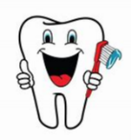  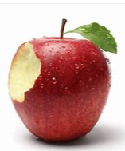 | 3. Label your pictures.  b r u sh  Remember: listen to what you can hear it doesn’t need to be spelled correctly you are learning!
 |  | Tick it if you can do it.
 |  | Write instructions on how to brush your teeth.

