Dear Parents,

This week’s work is around a story called Jolly Olly Octopus by Tony Mitton. If you have the book at home please read it to your child. Alternatively, there is a link to YouTube on Monday’s activity grid and we will be uploading the story to tapestry too. If you are able you may want to print this off and stick the learning in the children’s book, but that is not necessary. If you do not have a printer, look at the guidance slip and talk to you child about the activity then complete it on a page in the book.

The children in reception are all at different stages in their development, at this time it is really difficult for us to differentiate their learning. Some children may only hear a few sounds in the words they write (their work won’t be perfect.) It is vital that you encourage them and celebrate any writing they do, being dissatisfied will only lead to frustration and they will learn to hate writing. If your child’s sentence is too long (6+ words) suggest a shorter version. Some children may need more support than others this might be: remembering the sentence, reminding them about finger spaces, sounding out words together, looking at the phonics mat and tricky word mat. Showing them where to start writing, sitting letters on the lines.

Our number one rule in reception is no copying, you must allow them to listen and write. You can write tricky words for them to copy. If you are getting frustrated or your child cannot concentrate, I would suggest a break such as a wake and shake on YouTube or a walk outside in the fresh air.

This literacy work should take no more than 15- 20 min a day. There is a challenge for those who would like some extra work but it’s not compulsory.
Wow Read Monday- IALT: read and discuss the story Jolly Olly Octopus
1.Talk about what might happen in this story. Think about:  Have you read this story before?  What is this story about?  What do you think will happen in the end? | 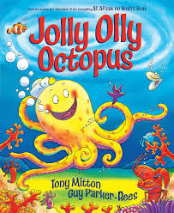  2. Listen to the story on YouTube.  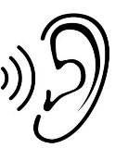 | 3. Ask questions:  What was your favourite part and why?  What numbers did you hear? Was there a pattern?  Which animal did you like the most?  Why do you think Jolly Olly was happy at the end?
 |  | Tick it if you can do it.

Wow Write Tuesday - IALT: identify rhyming words and alliteration
1.Watch the video to help introduce this topic:  Alliteration is where words start with the same sound.  Rhyme is where words end with the same sound. |  | 2. Can you match which words start with the same sounds? Try and sound out these words.  clam shark  ship coral  crab shimmer | 3. Can you match which words end with the same sounds? Try and sound out these words.  shell wish  dash fell  fish splash
 | Tick it if you can do it.
 | Write a sentence with rhyming words

Wow Write Wednesday IALT: discuss and write about octopus facts
1.Talk the pictures and think see if you can work out the octopus facts:  8  3  2 |  | 3. Ask questions. If you are not sure of the answer, you can do some research by looking in books or on the internet.
 | Call a friend or family member and tell them a fun octopus fact | Tick it if you can do it.

Wow Write Thursday- IALT: write about what a marine biologist does
1. Watch the video. Write a sentence about what a marine biologist does. Start small! | 2. Break down the words.  3  1  2  They help fish | 3. Listen to the sounds, one word at a time then write them.  h e l p | 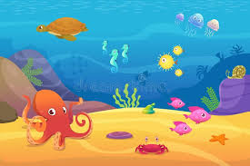  4. Draw a picture of the animals a marine biologist looks after. Colour it in to make it look really lovely!
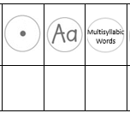  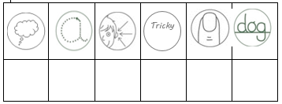 |  | Tick it if you can do it.
 |  | Write another fact you learn from the video

Wow Act Friday- IALT: present a TV show about marine biology
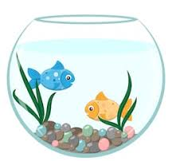  1. Choose the scene and get your props!  Where you think a marine biologist would like to present their show?  What do you think a marine biologist will need for their show? | 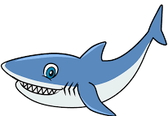  2. Plan what you would like to say. What have you learnt about animals over the week? | 3. Present your show! Ask your mummy or daddy to film your TV show.

