Dear Parents,

This week’s work is around a story called The Rainbow Fish by Marcus Pfister. If you have the book at home please read it to your child. Alternatively, there is a link to YouTube on Monday’s activity grid and we will be uploading the story to tapestry too. If you are able you may want to print this off and stick the learning in the children’s book, but that is not necessary. If you do not have a printer, look at the guidance slip and talk to you child about the activity then complete it on a page in the book.

The children in reception are all at different stages in their development, at this time it is really difficult for us to differentiate their learning. Some children may only hear a few sounds in the words they write (their work won’t be perfect.) It is vital that you encourage them and celebrate any writing they do, being dissatisfied will only lead to frustration and they will learn to hate writing. If your child’s sentence is too long (6+ words) suggest a shorter version. Some children may need more support than others this might be: remembering the sentence, reminding them about finger spaces, sounding out words together, looking at the phonics mat and tricky word mat. Showing them where to start writing, sitting letters on the lines.

Our number one rule in reception is no copying, you must allow them to listen and write. You can write tricky words for them to copy. If you are getting frustrated or your child cannot concentrate, I would suggest a break such as a wake and shake on YouTube or a walk outside in the fresh air.

This literacy work should take no more than 15- 20 min a day. There is a challenge for those who would like some extra work but it’s not compulsory.
Wow Read Monday- IALT: read and discuss the story The Rainbow Fish
1.Talk about what might happen in this story. Think about:  Have you read this story before?  What do you think will happen in the end? | 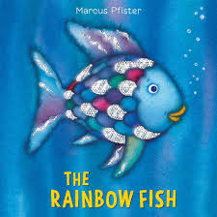  2. Listen to the story on YouTube. | 3. Ask questions:  What was your favourite part and why?  How do you think the Rainbow Fish felt before he had friends?  How did the Rainbow Fish feel once he had made friends?  What kind thing could you do to make your friends feel happy?
 |  | Tick it if you can do it.

Wow Write Tuesday- IALT: Write a thank you letter to the Rainbow Fish
1. Think of the sentence and hold it in your head. | 2. Break down the words.  4  3  5  2  1  Thank you for the gift | 3. Listen to the sounds, one word at a time then write them.  th a n k | 4. Put in a finger space in-between your words.  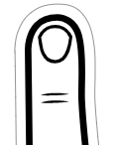 | 5. Put a full stop at the end of your sentence.
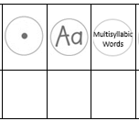  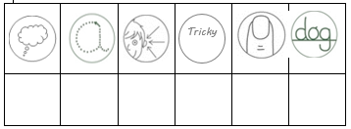 |  | Tick it if you can do it.
 |  | Write a letter back from the Rainbow Fish to say how happy he is to have new friends.

Wow Write Wednesday- IALT: write about my most prized possession
1. Think of a sentence and hold it in your head. Start small! | 2. Break down the words.  3  1  2  My teddee bair | 3. Listen to the sounds, one word at a time then write them.  t e dd ee | 4. Draw a picture of your most prized possession. Colour it in to make it look really lovely!
 |  | Tick it if you can do it.
 |  | Write about why it is your most prixed posession

Wow Write Thursday- IALT: complete a sentence about a picture
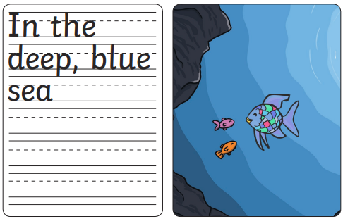
1. Can you finish these sentences:

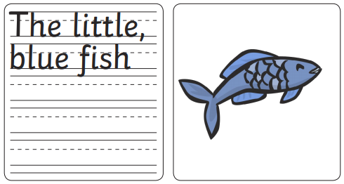

Tick it if you can do it.
Write your own sentence about the story

Wow Write Friday- IALT: write about what makes a good friend
1. Think of the sentence and hold it in your head. | 2. Break down the words.  3  1  2  Cind and fun. | 3. Listen to the sounds, one word at a time then write them.  c i n d | 4. Put in a finger space in-between your words. | Put a full stop at the end of your sentence.
 |  | Tick it if you can do it.
 |  | Write a letter to your friend to tell them why they are a good friend.

