Lifecycle of a Butterfly

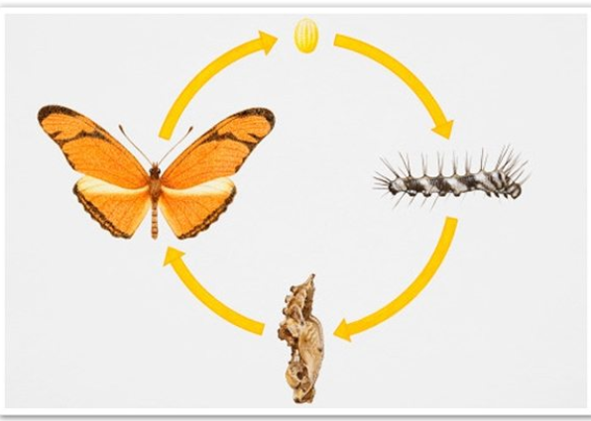

Hello Year 1,

We have some exciting new for you. Look what has happened to our caterpillars!!!!

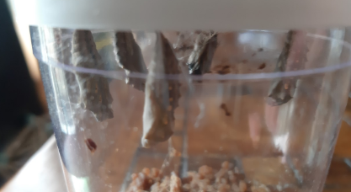

Write the date in your Home Learning Book and try to answer the following questions:

- What has happened to our caterpillars?

- Describe what you see?

- What will happen next?

- Draw a picture of the chrysalis and label it.

Challenge: What do you think will happen next?

Vocabulary to help you:
Caterpillar chrysalis butterfly

Cocoon change life cycle

Enjoy this information about the lifecycle of a butterfly:
https://www.natgeokids.com/uk/discover/animals/insects/butterfly-life-cycle/

